

**DOCUMENT HISTORY**

**DOCUMENT SOFTWARE**

|  | **Package** | **Version** | **Filename** |
| --- | --- | --- | --- |
| **Document** | Cameo System Modeler | #24092 | TM library_Requirements.mdzip |
| **Document** | Cameo System Modeler | 18.SKA9 | MBSEPlugin-v18SKA9.mdzip |

**ORGANISATION DETAILS**

|  |  |
| --- | --- |
| Name | National Centre for Radio Astrophysics |
| Registered Address | National Centre for Radio Astrophysics  Tata Institute of Fundamental Research,  Pune University Campus,  Post Bag 3, Ganeshkhind,  Pune 411007,  Maharashtra,  India |
| Phone | Tel: +91 20 25719000, +91 20 25719111  Fax: +91 20 25692149 |
| Website | www.ncra.tifr.res.in |

**Table of Contents**

1. ABBREVIATIONS #

2. Introduction #

2.1. Terms and definitions #

2.2. Purpose of the document #

2.3. Scope of the document #

2.4. System Description #

2.4.1. TM LOW Overview #

2.4.2. Context #

2.4.2.1. TM LOW in the Observatory PBS #

2.4.2.2. TM LOW deployment #

2.4.2.3. TM LOW Functional Context #

2.4.2.3.1. TM Relationships within SKA environment #

2.4.2.4. User need presentation #

2.4.3. Life cycle description #

2.4.4. Functional Breakdown #

2.4.5. External interfaces identification #

2.4.5.1. External Interfaces within SKA1 Observatory #

2.4.5.2. External Interfaces with systems outside the SKA1 Observatory #

2.5. Conventions #

2.5.1. Imperative Usage #

2.5.2. Codes used for Attributes of Requirements #

3. References #

3.1. Applicable documents #

3.2. Reference documents #

4. Requirements #

4.1. Functional Requirements #

4.1.1. Required States and Modes #

4.1.1.1. State Functionality #

4.1.1.2. State transition triggers #

4.1.2. Execute Telescope Operations #

4.1.2.1. Manage Telescope Observations #

4.1.2.1.1. Modes of Observation #

4.1.2.1.2. Conduct Observing #

4.1.2.1.2.1. Conduct Short Term Scheduling #

4.1.2.1.2.2. Observe Schedule #

4.1.2.1.2.3. Cancel Execution of Scheduling Blocks #

4.1.2.1.2.4. Respond to VO Events #

4.1.2.1.2.5. Manage Sub-array Observing #

4.1.2.2. Monitor and Control Telescope #

4.1.2.2.1. Handle Alarms #

4.1.2.2.2. Handle Failure Indications #

4.1.2.2.3. Accept Manual User Commands #

4.1.2.2.4. Coordinate Telescope Control #

4.1.2.2.5. Perform Observational Telescope Control #

4.1.2.2.5.1. Configure Telescope #

4.1.2.2.5.2. Pointing Control #

4.1.2.2.5.3. Frequency Control #

4.1.2.2.5.4. Pulsar Timing Control #

4.1.2.2.5.5. Quality Assurance Support #

4.1.2.2.6. Assist Understanding and Interpretation of Telescope Behaviour #

4.1.2.2.7. Protect Assets #

4.1.2.2.7.1. Telescope Shutdown #

4.1.2.3. Monitor and Control Telescope Manager LOW #

4.1.2.3.1. Detect internal failures #

4.1.2.3.2. Handle TM Alarms #

4.1.2.3.3. Monitor internal Performance Measures #

4.1.2.3.4. Produce internal Logs #

4.1.2.3.5. Monitor internal status #

4.1.2.3.6. Report Version information #

4.1.2.3.7. Report Serial Numbers #

4.1.2.4. Supply Telescope information to Elements #

4.1.3. Support Telescope Operation #

4.1.3.1. Assist Logistic Support #

4.1.3.1.1. Assist on-line fault-finding #

4.1.3.2. Assist Performance Measuring #

4.1.3.3. Assist Information Management #

4.1.3.3.1. Support Upgrades #

4.1.3.3.2. Manage Instrumental Configuration #

4.1.3.3.3. Handle Calibration Information #

4.1.3.3.4. Manage pulsar Information #

4.1.3.3.5. Manage historical Telescope information #

4.1.3.3.6. Manage External Information #

4.1.3.4. Evaluate Telescope effectiveness #

4.1.3.5. Assist RFI Management #

4.1.3.6. Assist Frequency offset configuration #

4.1.3.7. Support Displaying #

4.1.3.8. Assist Telescope Power Management #

4.1.3.9. Assist Equipment Administration #

4.1.4. Support TM #

4.1.4.1. Persist Data #

4.1.4.2. Authorise User Access #

4.2. Non-functional Requirements #

4.2.1. Reliability #

4.2.2. Maintainability #

4.2.3. Availability #

4.2.4. Environmental Conditions #

4.2.4.1. Storage #

4.2.4.2. Operation #

4.2.4.3. Transportation #

4.2.5. Transportability #

4.2.6. Materials and Processes #

4.2.7. Electromagnetic Compatibility #

4.2.8. Nameplates and Product Markings #

4.2.9. Producibility #

4.2.10. Interchangeability #

4.2.11. Safety and Security #

4.2.12. Human Factors Engineering #

4.3. Interface Requirements #

4.3.1. External Interfaces within the SKA1 Observatory #

4.3.2. External Interfaces with Systems outside of the SKA1 Observatory #

4.4. Design and Construction #

4.4.1. Design Constraints #

4.4.1.1. Location of equipment #

4.4.1.2. Simultaneous Control and Monitoring #

4.4.1.3. Electrical Power Consumption #

4.4.1.4. Alarm Constraints #

4.4.1.4.1. Alarm Attributes #

4.4.1.4.2. Alarm Functionality #

4.4.1.4.3. Alarm HMI #

4.4.1.4.4. Alarm Maintenance #

4.4.1.5. Synchronisation Constraints #

4.4.1.6. Standardisation #

4.5. Precedence and criticality of requirements #

5. Outstanding Actions #

5.1. List of TBC’s #

5.2. List of TBD’s #

5.3. List of Outstanding Actions #

**List of Figures**

2.1. TM LOW External Composition #

2.2. TM LOW deployment context #

2.3. TM LOW relationships within SKA environment #

2.4. SKA1_Low TM LOW Functional Context Diagram #

2.5. TM LOW Third party interfaces #

2.6. TM Functional Breakdown - Main features #

2.7. Telescope Online Operations Management Structure #

2.8. TMO Functional Breakdown - Main features #

2.9. Handle Proposals #

2.10. Conduct Telescope Operations #

2.11. Auxiliary Functions #

4.1. TM State Diagram #

4.2. Change Power Demand State functionality #

4.3. standby #

4.4. TM states to TANGO device states mapping #

4.5. Model showing the structure of observation modes #

4.6. Start Observation Scenario #

4.7. End Observation Scenario #

4.8. Monitor Sub-array During Observation Execution #

4.9. respond to VO events scenario #

4.10. Conceptual Illustration of the difference between Alarms and Events #

4.11. Failure Detection Scenario #

4.12. Pointing Control Scenario #

4.13. Shutdown SKA1-Low Telescope Scenario #

4.14. Distribute Telescope Information Scenario #

4.15. Online Fault-finding Scenario #

**List of Tables**

1.1. Diagram TM abbreviations #

2.1. Diagram Requirements Glossary #

2.2. Diagram External Interfaces TM Low #

2.3. Diagram Interfaces between SKA1-Low, SKA1-Mid and SKA1-Common #

2.4. Diagram Third party interfaces TM Low #

3.1. Diagram Applicable Documents #

3.2. Diagram Reference Documents #

4.1. Diagram reqTable_State Functionality #

4.2. Diagram reqTable_State transition triggers #

4.3. Diagram reqTable_Modes of Observation #

4.4. Diagram reqTable_Conduct Short Term Scheduling #

4.5. Diagram reqTable_Execute Scheduling Blocks #

4.6. Diagram reqTable_Monitor Scheduling Block Execution #

4.7. Diagram reqTable_Cancel Execution of Scheduling Blocks #

4.8. Diagram reqTable_Respond to VO Events #

4.9. Diagram reqTable_Manage Sub-array Observing #

4.10. Diagram reqTable_Handle Alarms #

4.11. Diagram reqTable_Handle Failure Indications #

4.12. Diagram reqTable_Accept Manual User Commands #

4.13. Diagram reqTable_Coordinate Telescope Control #

4.14. Diagram reqTable_Configure Telescope #

4.15. Diagram reqTable_Pointing Control #

4.16. Diagram reqTable_Frequency Control #

4.17. Diagram reqTable_Pulsar Timing Control #

4.18. Diagram reqTable_Quality Assurance Support #

4.19. Diagram reqTable_Assist Understanding and Interpretation of Telescope Behaviour #

4.20. Diagram reqTable_Telescope Shutdown #

4.21. Diagram reqTable_Detect internal failures #

4.22. Diagram reqTable_Handle Alarms #

4.23. Diagram reqTable_Monitor internal Performance Measures #

4.24. Diagram reqTable_Produce internal Logs #

4.25. Diagram reqTable_Monitor internal status #

4.26. Diagram reqTable_Report Version information #

4.27. Diagram reqTable_Report Version information #

4.28. Diagram reqTable_Supply Telescope information to Elements #

4.29. Diagram reqTable_Assist on-line fault-finding #

4.30. Diagram reqTable_Assist Performance Measuring #

4.31. Diagram reqTable_Support Upgrades #

4.32. Diagram reqTable_Manage Instrumental Configuration #

4.33. Diagram reqTable_Handle Calibration Information #

4.34. Diagram reqTable_Manage Pulsar information #

4.35. Diagram reqTable_Manage historical Telescope information #

4.36. Diagram reqTable_Manage External Information #

4.37. Diagram reqTable_Evaluate Telescope effectiveness #

4.38. Diagram reqTable_Assist RFI Management #

4.39. Diagram reqTable_Handle Calibration Information #

4.40. Diagram reqTable_Support displaying #

4.41. Diagram reqTable_Assist Power Management #

4.42. Diagram reqTable_Assist Equipment Administration #

4.43. Diagram reqTable_Persist Data #

4.44. Diagram reqTable_Authorise User Access #

4.45. Diagram reqTable_Reliability #

4.46. Diagram reqTable_Human Maintainability #

4.47. Diagram reqTable_Availability #

4.48. Diagram reqTable_Storage Requirements #

4.49. Diagram reqTable_Operation #

4.50. Diagram reqTable_Transportation #

4.51. Diagram reqTable_Electromagnetic Compatibility #

4.52. Diagram reqTable_Nameplates and Product Markings #

4.53. Diagram reqTable_Safety and Security #

4.54. Diagram reqTable_Human Factors Engineering #

4.55. Diagram reqTable_External Interfaces within the SKA1 Observatory #

4.56. Diagram reqTable_External Interfaces with Systems outside of the SKA1 Observatory #

4.57. Diagram reqTable_Location of equipment #

4.58. Diagram reqTable_Simultaneous Control and Monitoring #

4.59. Diagram reqTable_Electrical Power Consumption #

4.60. Diagram reqTable_Alarm Attributes #

4.61. Diagram reqTable_Alarm Functionality #

4.62. Diagram reqTable_Alarm HMI #

4.63. Diagram reqTable_Alarm Maintenance #

4.64. Diagram reqTable_Synchronisation Constraints #

5.1. Diagram List of TBC’s #

5.2. Diagram List of TBD’s #

**Chapter 1. ABBREVIATIONS**

| **#** | **name0** | **documentation0** |
| --- | --- | --- |
| 1 | AA | Array Assembly |
| 2 | AAA | Authentication, Authorization and Auditing Trail |
| 3 | ADS-B | Automatic Dependent Surveillance-Broadcast |
| 4 | AIV | Assembly, Integration and Verification |
| 5 | API | Application Programming Interface |
| 6 | BW | Bandwidth |
| 7 | CIN | Configuration Item Number |
| 8 | CPF | Central Processing Facility |
| 9 | CSP | Central Signal Processor |
| 10 | DDE | Direction-dependent Effect |
| 11 | DDT | Director’s Discretionary Time |
| 12 | DG | Director General of the SKA |
| 13 | DMH/m | Direct Maintenance Hours per month |
| 14 | EMC | Electromagnetic Compatibility |
| 15 | GPS | Global Positioning System |
| 16 | GUI | Graphical User Interface |
| 17 | HTML | Hyper Text Mark-up Language |
| 18 | HTTP | Hyper Text Transfer Protocol |
| 19 | ICD | Interface Control Document/Dossier |
| 20 | ICRS | International Celestial Reference System |
| 21 | ID | Identifier |
| 22 | IERS | International Earth Rotation and Reference Systems Service |
| 23 | ILS | Integrated Logistic Support |
| 24 | IPS | Ionosphere Prediction Service |
| 25 | IVOA | International Virtual Observatory Alliance |
| 26 | LFAA | Low Frequency Aperture Array |
| 27 | LINRA | Local Infrastructure |
| 28 | LMC | Local Monitoring and Control |
| 29 | LRU | Line Replaceable Unit |
| 30 | LSA | Logistic Support Analysis |
| 31 | M&C | Monitoring and Control |
| 32 | NA | Not Applicable |
| 33 | OBSMGT | Observation Management |
| 34 | OSO | Observatory Science Operations |
| 35 | PBS | Product Breakdown Structure |
| 36 | PDU | Power Distribution Unit |
| 37 | PI | Principal Investigator |
| 38 | QA | Quality Assurance |
| 39 | RAM | Reliability, Availability, Maintainability |
| 40 | RFI | Radio Frequency Interference |
| 41 | RTN | Return to Normal |
| 42 | SADT | Signal and Data Transport |
| 43 | SB | Scheduling Block |
| 44 | SDP | Science Data Processor |
| 45 | SIMBAD | Set of Identification, Measurements, and Bibliography for Astronomical Data |
| 46 | SKA | Square Kilometre Array |
| 47 | SOC | Science Operations Centre |
| 48 | SRU | Shop Replaceable Unit |
| 49 | TAC | Time Allocation Committee |
| 50 | TBC | To Be Confirmed |
| 51 | TBD | To Be Determined |
| 52 | TEC | Total Electron Content |
| 53 | TELMGT | Telescope Management |
| 54 | TFR | Time and Frequency Reference |
| 55 | TM | Telescope Manager |
| 56 | TM LOW | Telescope Manager LOW |
| 57 | TM MID | Telescope Manager MID |
| 58 | TMC | Telescope Manager Consortium |
| 59 | TMO | Telescope Manager Observatory |
| 60 | TOO | Target Of Opportunity |
| 61 | UTC | Coordinated Universal Time |
| 62 | VLBI | Very Long Baseline Interferometry |
| 63 | VO | Virtual Observatory |
| 64 | XML | Extensible Mark-up Language |

**Table 1.1. Diagram TM abbreviations**

**Chapter 2. Introduction**

**2.1. Terms and definitions**

| **#** | **Term** | **Definition** |
| --- | --- | --- |
| 1 | alarm | An alarm is an audible and/or visible means of indicating to the operator an equipment malfunction, process deviation, or abnormal condition ​requiring a timely response [RD38]. |
| 2 | alarm Event | Synonym of Alarm |
| 3 | Alarm Severity Level | Perceived severity as assessed at the originator of the Alarm. |
| 4 | Dataset | The data collected from the processing of a single Scheduling Block  TBD - this interacts with the Science Data Processor (SDP) and Central Signal Processor (CSP) domain so a more precise definition will emerge from the discussions between the groups. |
| 5 | Element | In this document, Element means any of the following (including instances of them): CSP, Dish, MeerKAT Dish, LFAA, SDP, SADT and TM. |
| 6 | Line Replaceable Unit (LRU) | A product that may be replaced using procedures, skills, tools and facilities available on site, i.e. without the removal of a higher level product that incorporates it. |
| 7 | Measures of Telescope Effectiveness | A collection of indications of the effectiveness of a Telescope. These measures are:  1.      utilisation factor,  2.      availability factor,  3.      power consumption. |
| 8 | Observing Cycle | Observing Cycle A given time period during which the Scheduling Blocks from the approved proposals will be observed.  The assumption we make here is that an Observing Cycle is a period of time, typically of length 6 to 18 months, during which observations are made of the Projects generated from Observing Proposals submitted and accepted some time earlier against a specified set of Telescope Capabilities (number of antennas and their baselines, receivers, observing modes available, etc.) |
| 9 | Observing Sequence | An ordered list of Observing Tasks to be carried out as part of the Scheduling Block. For each Observing Task this would also contain any parameters, or references to parameters for the task to be executed as part of the Scheduling Block execution. There may be predefined Observing Sequences or templates for generating Observing Sequences for standard Scheduling Blocks. |
| 10 | Observing Task | The lowest level of observing instruction in the domain of the Observation Management (OBSMGT) sub-system of the TM. Consists of a list of one or more lower level tasks together with the necessary parameters or parameter references for those tasks. These can be considered as predefined parametrised scripts. |
| 11 | Product Breakdown Structure (PBS) | A hierarchical structure of a product, defining how an item is decomposed into lower level items. Each item in this structure is associated with a set of requirements. Product interfaces are defined between items in the PBS. |
| 12 | Scan | An atomic unit of execution during which data taking is normally continuous, but can be briefly paused for an operational reason. The Telescope Configuration stays the same during a scan. There are different types of Scan depending on the Telescope motion pattern on the sky: tracking celestial object, raster from start position to end position at a specified rate, series of pointings around a celestial position, etc. |
| 13 | Scheduling Block | A Scheduling Block is an atomic unit of observing from the viewpoint of scheduling. Scheduling will be performed on the Scheduling Block level. A Scheduling Block consists of a series of instructions to the control system of a given Telescope (namely, TM) that are required in order to carry out a series of tasks that, when performed together, result in the taking of a Dataset. In the Square Kilometre Array (SKA) data model this is known as the Observing Sequence. A Scheduling Block may be stopped and cancelled, and it can be paused and resumed. A Scheduling Block will be executed on a single Sub-array, which may include the full array. |
| 14 | Shop Replaceable Unit (SRU) | A product that may be replaced using procedures, skills, tools and facilities available in a workshop of the SKA maintenance organisation. |
| 15 | Sub-array set | A collection of resources (dishes, stations or receptors in general) capable of collecting electromagnetic signals in a specified direction and in a coherent and consistent manner, used to perform independent observations on. |
| 16 | Telescope Information | In this document, Telescope Information refers to any information that is acquired and stored by the TM to be provided to users or other Elements of a specific Telescope. Below is a data structure for Telescope Information:  1. Environment        1.1. Natural environment        1.1.1. Geodetic model        1.1.2. Geometric model        1.1.3. Earth orientation parameters        1.1.4. Total Electron Content (TEC)        1.1.5. Ionospheric conditions (via Ionospheric Prediction Service)        1.1.6. Site Weather conditions (wind, temperature and humidity) (meso & micro meteorological scale)        1.1.7. Observable astronomical events (Targets Of Opportunity (TOOs), transient events, etc. via Virtual Observatory, other SKA telescopes and custom experiment hardware)  1.2. Man-made environment        1.2.1. Satellite data (trajectories, emissions, owner)        1.2.2. Commercial flight data        1.2.3. RFI sources  2. Telescope        2.1. Instrumental Configuration Data              2.1.1. Telescope configuration                    2.1.1.1. Receptor positions (including integrated precursor dishes)                    2.1.1.2. As-built configuration                    2.1.1.2.1. equipment fitted/not fitted status                    2.1.1.2.2. equipment serial numbers                    2.1.1.2.3. software/firmware versions                    2.1.1.3. CSP configuration parameters                    2.1.1.4. SDP configuration parameters                    2.1.1.5. DSH configuration parameters                    2.1.1.6. LFAA configuration parameters                    2.1.1.7. SADT configuration parameters                    2.1.1.8. INFRA configuration parameters                    2.1.1.9. TM configuration parameters              2.1.2. Pointing/steering models                    2.1.2.1. Dish Pointing models                          2.1.2.1.1. Dish structural model                          2.1.2.1.2. Dish thermal model                    2.1.2.2. Aperture array beam steering models                          2.1.2.2.1. model for Element and Logical Station Beam’s as a function of azimuth, zenith angle, frequency and polarization                    2.1.2.3. reference pointing model                    2.1.2.4. refraction model              2.1.3. Delay and phase models for beam forming, pulsar timing, etc.             2.1.3.1. per Dish sampler clock offset configuration,             2.1.3.2. applied phase corrections (incl. commanded and applied tied array beam pointing delays)              2.1.4. Imaging model                    2.1.4.1. Direction dependent effects model              2.1.5. Long term System Calibrations that influence data capture and on-line processing of data (e.g. Dish pointing, beam steering model parameters)              2.1.6. Anticipated and actual RFI models derived from measurements and from external data sources (e.g. aircraft, satellite transit data)              2.1.7. Equipment power usage per Observation Resource Unit              2.1.8. RFI configuration        2.2. Dynamic Status              2.2.1. Schedulable Resource’s Allocation and Sub-array configurations              2.2.2. Element power level status              2.2.3. Alarms              2.2.4. Failure indications              2.2.5. Performance measures              2.2.6. other monitoring data        2.3. Integrated Logistic Support Data              2.3.1. Equipment in-maintenance status        2.4. Observation Data              2.4.1. Scheduling Blocks (including Operator logs and Scheduling Block status)             2.4.2. Program Blocks              2.4.2. Sub-array configuration        2.5. Telescope system management data              2.5.1. Measures of Telescope Effectiveness                    2.5.1.1. Utilisation factor                    2.5.1.2. Power consumption        2.6. Administrative Data              2.6.1. Alarm configuration              2.6.2. Authorisation and authentication: User credentials |
| 17 | Telescope Performance Measures | A collection of metrics that indicate the degree of effectiveness to which the Telescope is currently performing its functions, including current states and modes and quantitative measures of performance of key functions. |
| 18 | Traceability | For a TM requirement, traceability is the project-unique identifier of the Telescope requirement from which the TM requirement has been derived. If the requirement is not derived from a Telescope requirement, it may be traced from the TM design. |
| 19 | Active Schedule | See Schedule |
| 20 | Admin Mode | See to [RD60] par. 5.8. |
| 21 | Alarm attribute | setting for an alarm within the process control system [RD38]  Example: alarm setpoint |
| 22 | alarm deadband | change in signal from the alarm setpoint necessary for the alarm to return to normal [RD38] |
| 23 | alarm group | set of alarms with common association (e.g., process unit, process area, equipment set, or  service) [RD38] |
| 24 | alarm off-delay | time a process measurement remains in the normal state before the alarm becomes inactive [RD38] |
| 25 | alarm on-delay | time a process measurement remains in the alarm state before the alarm is annunciated [RD38] |
| 26 | alarm priority | relative importance assigned to an alarm within the alarm system to indicate the urgency of  response (e.g., seriousness of consequences and allowable response time) [RD38] |
| 27 | Alarm record | set of information which documents an alarm state change [RD38] |
| 28 | alarm setpoint | threshold value of a process variable or discrete state that triggers the alarm indication [RD38] |
| 29 | alarm type | alarm attribute which gives a distinction of the alarm condition [RD38]    Example: Low process variable alarm, high process variable alarm, or discrepancy alarm. |
| 30 | alert | Notification of an operator or other personnel, of an existing or probable future condition, with the purpose of attracting attention to ensure that the condition is evaluated when time allows. |
| 31 | Assessor | A human user who is a member of the SKA Time Allocation Committee (refer [RD43] par. 6.3.4), and who is authorised to rank, assess, approve and allocate time to Proposals, and to control Proposal submission. |
| 32 | Astronomical Coordinates | The position of objects in the sky, considered as a celestial sphere. That position can be defined in different reference systems, depending of the choice of the centre point, its poles, and primary direction. The main astronomical coordinate system for the SKA is the International Celestial Reference System (ICRS). |
| 33 | azimuth | The angle in the horizon coordinate system with true North defined as 0o and with East defined as +90o. |
| 34 | baseline | Makes reference to a pair of entities which are coherently combined. Stations for SKA1_Low, Dishes for SKA1_Mid. |
| 35 | Beam Reference Frame | A reference frame for a Station Beam, centred in the average vector sum of the x, y, z geocentric coordinates of the antennas/tiles contributing to the beam, with the azimuth plane perpendicular to it, and with azimuth zero in the direction of true North. Elevation is counted from horizon (0o) to zenith (+90o). |
| 36 | cadence | For periodic observations, the time between repeated observations of the same Target. |
| 37 | Calibration Information | Information in the form of parameters and values allowing a Telescope processes to enhance the accuracy of measuring a phenomenon by reducing errors made by components not being part of the phenomenon. As such Calibration Information will not include all information (known and unknown) contributing to errors but only an approximated subset as close as practically possible. Calibration Information may either be self-contained in the measuring process (i.e. measured and applied during and within the same process continuously) or handled externally (i.e. measured separately by the same or different process and applied as controlled input to the measuring process). The handling of Calibration Information shall also determine the structure of its life cycle (e.g. a generated, stored and in-use state) and its location in particular systems and applications (i.e. externally to the system or only within the system itself). |
| 38 | Central Processing Facility | A building of closely associated group of buildings, including associated infrastructure and services, whose primary function is to accommodate the Central Processing functions of SKA telescopes (c.f. CSP). |
| 39 | Commensal observations | Two or more Scheduling Blocks that simultaneously utilise the same resources that result in two or more Science Data Products. The Scheduling Blocks may originate from the same, or different, projects. The Telescope resources can be dishes/stations/beams, signal and data processing bandwidth, or data processing resources. There is no sharing of the elapsed time between commensal projects, i.e. if 6 hours elapsed time are used executing an observation for two commensal projects, they are each charged with 6 hours (not 3).  See also Concurrent Observations, Data Commensality, Observing Commensality, and Multiplexed Commensality. |
| 40 | Compound Scheduling Block | A scheduling construct that contains a set of Scheduling Blocks to be executed in parallel on a defined set of compatible Sub-arrays within the context of a single Project.    The Compound Scheduling Block is scheduled as a whole, but the contained Scheduling Blocks are executed in parallel. The Compound Scheduling Block also includes special tasks to configure the required Sub-arrays and recombine afterwards. |
| 41 | configuration | Predefined resource usage identified during observation preparation to simplify the representation of the resources required for individual Scheduling Blocks.    Example usage is to support the definition of Telescope sub-arrays or SDP processing recipes to which resource constraints and effects can be directly applied to minimise the overall complexity of the scheduling resource model. |
| 42 | constraint | A limitation on when, or if, a Scheduling Block can be scheduled.    Constraints can be classified as:   1. Environmental Constraints - such as weather, or measured RFI profile 2. Timing Constraints limitations on when the Scheduling Block can be executed due to visibility of the Target Field; seasonal RFI profile, sequencing or periodicity at Program Block level. 3. Resource Constraints availability of equipment or other resources required to support the observation. 4. Instrumental constraints - performance limits of the Telescope (minimum and maximum ranges of entities that are configured by TM) 5. Prioritisation of the Scheduling Block 6. Event Linkage response to TOO events. 7. Constraints are defined at observation preparation time and applied during observation planning and scheduling. |
| 43 | Data product | In the context of the SKA, a Data Product is a dataset, which when combined with other (SKA originated) datasets provides spectrally, temporally and/or spatially resolved measurements of phenomena of astronomical interest or of sectors of the celestial sphere. Typically a Data Product arises from the operation of a processing pipeline on a datastream of finite duration. SKA Data Products are very specific to the capabilities and performance of SKA telescopes and to the processes employed in the pipelines implemented in SKA Science Data Processing. For each SKA1 observation use case, they are identified, defined and described in a Level 1 Data Products document (to be written). See also other entries marked as (Data Product). |
| 44 | deployment environment | a [potentially virtual] hardware platform supporting a particular operational context and/or use case of Telescope manager software. Each Deployment Environment has its own dedicated resources and multiple copies may exist to support separate use cases in parallel (e.g. live operations, validation or test) or to provide high level redundancy. |
| 45 | Dynamic Priority | See Priority |
| 46 | elevation | The angle in the horizon coordinate system with the local horizon defined as 0o and with the zenith defined as +90o. |
| 47 | Executable Schedule | See Schedule |
| 48 | Execution Record | Once a Scheduling Block Instance has been ingested into the Active Schedule any updates to its timing or status are recorded as execution records in Schedule history. Execution records also apply at Program Block and Project levels. |
| 49 | Field Node | An LFAA Field Node consists of 16 co-located LFAA Tiles.  Each LFAA Tile physically couples 16 LFAA antennas via an RFoF link. |
| 50 | field of view | Area of sky visible to an instrument at a Target position. |
| 51 | Historic Data Requester | A non-specific human user that belongs to Science Operations or Engineering Operations, and interacts with the TM via a user interface to request historic data that was stored by the TM, for example: Telescope information, site weather data, satellite data, commercial flight data. |
| 52 | Horizon Coordinate System | The celestial coordinate system that uses the observers local horizon as the fundamental plane. |
| 53 | Inherent Availability | The  probability  that  the  telescope  is  operationally  capable  at  any  point in time when used in an ideal support environment, i.e., one  in which repair commences instantaneously upon failure [RD27] |
| 54 | instance | When a Scheduling Block is placed in a plan or Schedule, a Scheduling Block instance is created to hold any parameter values and specific timing constraints. There may be multiple instances for a given Scheduling Block Definition. |
| 55 | instrument diagnostic alarm | alarm generated by a field device to indicate a fault (e.g., sensor failure) [RD38] |
| 56 | Latching Alarm | An Alarm that remains in Alarm state after the process has returned to normal (RTN) and requires and operator reset before it will clear. |
| 57 | Late Binding Data | Target definition, parameters or other data required by a Scheduling Block that is not available at Proposal submission time, but is supplied by the PI close to execution time. |
| 58 | Logical Station Beam | LFAA Antennas are grouped into Tiles.  Each Tile consists of sixteen antenna assemblies and connects via an optical interface to a single Tile Processing Module (TPM).  This configuration is the smallest unit that provides a complete end-to-end signal path.  The antenna assembly to TPM signal path is fixed and therefore any antenna assembly is associated with a specific Tile.  Each Tile combines the sixteen antenna signals into a “partial tile beam”.  Tile beams are summed progressively by linking the outputs of TPMs to create “logical station” beams (which could vary from 1 to N antennas).  Usually 16 Tiles will be aggregated (which is equivalent to 256 antennas) together.  This aggregation is known as a LFAA Logical Station Beam.  These beams (512 off with a 300 MHz bandwidth) are transported to the CSP for further processing.  A logical beam can be formed using one antenna or any number of N antennas.  However it is important to note that the LFAA will always send 512 logical beams to the CSP. |
| 59 | Monitoring Data | Non-science related measurements and metric samples, acquired from either within TM, or from other Elements, including:   1. Failure events and other events, 2. logs, 3. equipment status, 4. functional status, 5. operational states and modes (including TANGO device state [RD60] par. 5.8), 6. health status expressed as healthState (refer [RD60] par. 5.8), 7. measured and calculated process variables, controller outputs, and equipment status indicators to support condition monitoring, fault finding and failure prediction, 8. adminMode (refer to [RD60] par. 5.8) as reported by Elements, Sub-elements and LRUs. |
| 60 | observability window(s) | A period of time when a given target field is visible to an SKA Telescope within the current scheduling period. |
| 61 | Observatory | The SKA Observatory is a collective term for all the SKA Telescopes and includes the SKA Global HQ as well as the Telescope sites. |
| 62 | priority | Prioritisation reflects the ranking applied to proposals during evaluation and is the mechanism by which scheduling conflict is resolved. Where two or more scheduling blocks have conflicting timing and/or resource constraints in a schedule, then priority level will be used to allocate telescope time, typically resulting in lower priority blocks being dropped from the schedule. Static priorities are assigned to scheduling blocks as result of proposal evaluation ranking. In accordance with policy, the run-time dynamic priority may be raised or lowered during scheduling to reflect operational needs. |
| 63 | process area | physical, geographical or logical grouping of resources determined by the site [RD38] |
| 64 | program block | A series of related observations within a single Project.  The Program Block holds the details of an entire series of Scheduling Blocks, such as a list of target fields or the cadence of observations, which may imply additional constraints on the scheduling of individual observations.  The current status of the Program Block is also maintained and recorded in schedule history. |
| 65 | Project | Accepted observing proposals will be represented within the observation management system as Projects. Typically each Project corresponds to a single Proposal, but if Proposals are merged during the evaluation process, then a single Project may correspond to more than one Proposal.  The Project forms the top-level container for a series of related observations represented as Scheduling Blocks grouped into one or more Program Blocks.  Projects are defined during the observation preparation process.  Projects may also be defined to support technical operations of the Telescope that are independent of any observing Proposal.  See also Science Project. |
| 66 | Proposal | also observation Proposal or observing Proposal    A formal request for observatory resources.  A Proposal is made by one or more Investigators, (at least) one of whom takes the position of Principal Investigator. It consists of a Science Case and a series of proposed observations.    For Proposal types and sub-types, refer to [RD43] par. 6.3. |
| 67 | Proposal Cycle | The period of time over which the scheduling blocks from a set of approved observing proposals will be observed. The Proposal submission process is run periodically to accept  proposals for the next Observing Cycle. The term Semester can be synonymous for Proposal Cycle.  The expected duration of an SKA Proposal Cycle is 6-18 months. |
| 68 | Receptor | The ensemble of receiving passive element or elements, optics, electronics for detection, amplification, and electronic pointing, that provides digital data streams that can be correlated.  Either SKA1-Mid Dish, Meerkat Dish, LFAA Station used to capture electromagnetic signals at a specified direction and frequency bandwidth. |
| 69 | recipes | A standard Science Data Processor (SDP) processing pipeline that can be selected during Proposal submission, or defined to support a Project during observation preparation.  It is linked to resource modelling of the SDP in the context of scheduling and is a special case of a configuration. |
| 70 | Resource profile | The result of propagating resource values over the period of an observation plan or schedule, taking into account external availability data and resource effects associated with scheduling blocks marked for execution in the plan/schedule. |
| 71 | resource-effect | A consequence of executing a Scheduling Block in terms of resource availability.  (Note: this is sometimes just referred to as ‘an effect’ in the context of resource scheduling) |
| 72 | RTN | Returned to normal ; A condition for a process that triggered an alarm. It is an indication that the alarm condition has transitioned to the normal state. |
| 73 | SB script | Defines the sequence of telescope operations to be performed during observation execution. The SB Script itself invokes a series of high level telescope operations defined by the Telescope Management function as telescope scripts. |
| 74 | Schedulable Resource | Telescope equipment or other finite resource required by a Scheduling Block.    The execution of a Scheduling Block is both constrained by the availability of the resource [a resource constraint] and may also consume the resource during execution [a resource effect]. In the context of scheduling, a resource corresponds to an abstract representation of state that can be propagated over the duration of a plan or Schedule by taking into account external availability data (such as maintenance plans) or the content of the plan itself (through defined effects).    Specific resource that can be engaged in observations are:   1. individual discrete frequency band per SKA1-Mid Dish instance, 2. individual discrete frequency band per MeerKAT Dish instance, 3. LFAA Station Beam’s (with minimum frequency band extent), 4. CSP correlation capacity, expressed as number of baselines, 5. CSP pulsar search capacit,y expressed as number of beams, 6. CSP pulsar timing capacity, expressed as number of beams, 7. CSP VLBI processing capacity, expressed as number of beams, 8. SDP continuum imaging capacity, 9. SDP imaging transient search capacity, 10. SDP package VLBI beam capacity, 11. SDP pulsar timing capacity, 12. SDP pulsar search capacity, 13. SDP spectral line imaging capacity, 14. SDP dynamic spectrum capability. |
| 75 | Schedule | (noun)    also executable schedule or active schedule.    The sequence of Scheduling Blocks currently loaded for execution over the next scheduling period (typically 3-7 days, but may contain Scheduling Blocks from the Medium-term Plan).  The Schedule is periodically updated by loading [replacing] or merging a new Short-term Plan into the active schedule. The active schedule is also dynamically adjusted to take into account real-time status of the Telescope and Scheduling Blocks and TOO events. |
| 76 | Scheduling Block definition | Scheduling data defined during observation preparation. Applies to projects, program blocks, scheduling blocks and resources.    Scheduling blocks may be single use, or designed for repeated use through parameterisation |
| 77 | Science Project | Science Projects are a sub-set of Projects (see Project), comprising of Key Science Projects and Principal Investigator observing programmes. Non-science Projects are open time Projects and Director’s discretional time Projects |
| 78 | SKA observatory | See Observatory |
| 79 | Source | An astronomical body with a known position.  (Compare with Target) |
| 80 | Static Priority | See Priority |
| 81 | Station | A logical, usage construct.  A configuration of a LFAA Field Node which produces 1 to 8 beams from all 256 of the antenna elements of the LFAA Field Node. |
| 82 | Station Beam | A beam produced by a Station. LFAA antennas are grouped into “tiles”. Each tile consists of sixteen antenna assemblies and connects via an optical interface to a single Tile Processing Module (TPM). This configuration is the smallest unit that provides a complete end-to-end signal path. The antenna assembly to TPM signal path is fixed and therefore any antenna assembly is associated with a specific tile. Each tile combines the sixteen antenna signals into a “partial tile beam”. Tile beams are summed progressively by linking the outputs of TPMs to create “station” beams (which could vary from 1 to N antennas). Usually 16 tiles will be aggregated (which is equivalent to 256 antennas) together. This aggregation is known as a LFAA “station beam”. There are 256 40 GbE physical links between LFAA and the Central Signal Processing (CSP) system. Each link carries two data streams, known as “beams” (4096 beams with a maximum of 300 MHz bandwidth) which are transported to the CSP for further processing. The data streams will be configured in accordance the observation template. |
| 83 | Sub-array | See Sub-array Configuration |
| 84 | Sub-array Configuration | A restricted set of Telescope resources which can be used to support a defined subset of scheduling blocks. Also see configuration. Needs to have at least one instance of CSP and one instance of SDP processing per Sub-array set. |
| 85 | Sub-array Control Authority | An operations staff member who has the authority to control a Sub-array.  This includes maintenance users. |
| 86 | Sub-station | A configuration of a Station which produces a beam from fewer than all 256 the antenna elements that belong to a single Field Node.  The minimum number of antennas that can form a Sub-station is 1. |
| 87 | tag | unique identifier assigned to a process measurement, calculation, or device within the control system [RD38] |
| 88 | target | A celestial position to be observed, defined by a set of co-ordinates (e.g. right ascension and declination).It should be noted that while the target may be an identified source, the target coordinates may also be supplied directly by the PI.(Compare with source) |
| 89 | target field | A field of view centred around a specified target. |
| 90 | TECU | Total Electron Content Unit, unit of electron density, equivalent to a column density of 10^16 electrons per square metre. |
| 91 | Telescope | An SKA Telescope is a single scientific instrument of the SKA Observatory that can operate as a coherent system independently of other telescopes, but may share resources with other telescopes.    The following telescopes are included in the Phase 1 Observatory:    SKA1-Low array [Australia: Murchison Radio Observatory]  SKA1-Mid array [South Africa: Karoo Radio Astronomy Reserve]    Some SKA documents may also make reference to SKA1-Survey array [Australia: Murchison Radio Observatory]. This Telescope no longer forms part of Phase 1 of SKA |
| 92 | Telescope Control Authority | An operations staff member who has the authority to control the Telescope. |
| 93 | telescope mode | SKA telescopes are required to support a number of observing modes:   1. Continuum Imaging 2. Spectral Line Imaging 3. Pulsar Search 4. Pulsar Timing 5. VLBI |
| 94 | Telescope Power Load Configuration | Estimated power consumption per power demand state per Telescope equipment. Equipment granularity is determined by levels of reporting and command for power states as agreed on in the ICDs between TM and each Element. |
| 95 | telescope script | Definition of a high level Telescope operation. Telescope scripts are themselves configurable such that they can be refined to evolve Telescope capabilities. |
| 96 | Tile | LFAA Antennas are grouped into Tiles.  Each Tile consists of sixteen antenna assemblies and connects via an optical interface to a single Tile Processing Module (TPM).  This configuration is the smallest unit that provides a complete end-to-end signal path.  The antenna assembly to TPM signal path is fixed and therefore any antenna assembly is associated with a specific Tile. |
| 97 | Time Allocation Committee | The Time Allocation Committee (TAC) will be responsible for determining the science programme to be carried out by the SKA Observatory through the review and assessment of scientific Proposals.  They will be comprised of members from the radio astronomy community and will be sufficiently experienced to judge the scientific merit, impact and urgency of Proposals that the observatory receives to use its resources. |
| 98 | User | A non-specific human user that interacts with the TM via a user interface.    This may include typically the following users : operator, Principal Investigator, Science Operations user, staff astronomer, Time Allocation Committee member, science commissioner, integration engineer, maintainer.    This may include typically the following user roles: Assessor, proposer, co-investigator, observation planner, observation designer, observation scheduler, observing Project administrator, lead operator, Alarm administrator, Telescope Control Authority, Sub-array Control Authority, catalogue maintainer, Historic Data Requester, |
| 99 | Validation of context | Whether a configuration is correct in a particular context. Context is what is not fully controllable and certain at the time of the configuration. Thus it involves information that are not fully accurate or predictable and can only be verified by means of simulation. The uncertainty may have different causes such as missing specifications, faults and failures or unexpected environmental conditions. Examples may be an observation mode becoming unavailable during run time or a latent defect in the pointing range of a Receptor. |
| 100 | Validation of form | Whether a configuration is structurally correct. It is solely based on information known a priori as allowed values and associations, universally true, fully predictable and therefore fully deductible. Validation of form therefore does not require simulation and is independent of the context of execution. For example assigning a Receptor to multiple sub-arrays is an invalid of form configuration. |
| 101 | Very Long Baseline Interferometry Terminal | A combination of hardware and software which provides a robust and standardised interface to allow a telescope to act as a component in a VLBI array. The interface may, or may not, function in accordance with the VLBI Standard Interface (http://www.haystack.mit.edu/tech/vlbi/vsi/index.html), but it provides a fully defined port which makes telescope resources available in accordance with VLBI use cases and allows the transmission of data streams in accordance with VLBI protocols. |

**Table 2.1. Diagram Requirements Glossary**

**2.2. Purpose of the document**

This document defines the requirements for the following product:

a) SKA1-Low Telescope Manager (TM) LOW, configuration item number T2000-0000 (SKA1 configuration item number 103-000000).

Note that although the List of Tables have the word “Diagram” in front of table names, they are in fact tables, and not diagrams. This error is due to document generation from Cameo Systems Modeler, and will be corrected in future.

**2.3. Scope of the document**

This document is a form, fit and function specification, and contains:

1. TM LOW requirements derived from SKA Level 1 requirements in [AD1],

2. TM LOW requirements derived from operating scenarios (mission profiles or use profiles) of the TM,

3. TM LOW requirements derived from interactions between TM LOW and other systems as defined in TM external ICDs,

4. TM LOW requirements derived from the SKA LOW Functional Architecture [RD59],

5. the functional breakdown of TM LOW, SKA1-Mid Telescope Manager (TM MID) and Telescope Manager Observatory (TMO),

6. Verification requirements (not yet updated for changes brought on by [AD1] Rev 11).

Requirement changes since the last approved revision are indicated by means of the Status attribute per requirement in Chapter 6 Appendix requirements attributes:

1. Proposed: the requirement has been added,
2. Draft: the requirement has changed,
3. Accepted: the requirement has not changed.

Note: From this point onward, when the term TM is used in this document, the product TM LOW is implied.

**2.4. System Description**

**2.4.1. TM LOW Overview**

The TM will enable three operational capabilities:

1. Management of astronomical observations;

2. Management of the telescope hardware and software subsystems in order to perform that astronomical observations;

3. Manage the data to support operators, maintainers, engineers and science users in achieving operational, maintenance and engineering goals.

To support these capabilities, the TM performs three high level functions, namely: (1) observation management, (2) telescope management and (3) data management.

While performing observation management, the TM LOW ingests high-level descriptions of observations, as Scheduling Blocks or higher-level form.  The Scheduling Blocks are then scheduled for execution.  As observations are made, the TM LOW provides the current Telescope configuration and dynamic status to the SDP.

While performing telescope management, the TM LOW controls the appropriate elements, and collects monitoring data that are used to track the entire status of the SKA1 LOW Telescope including subsystem status, site security, weather monitoring, site power supply, etc.

The TM LOW manages monitor and configuration data as a system model that describes the status of the SKA1 LOW Telescope at any one time.  The TM LOW continually collects telescope configuration, telescope dynamic status and environmental data.  The data are time-stamped and stored.  The TM LOW provides the data to users as the current and historic state of the system to support operations and maintenance.

**2.4.2. Context**

**2.4.2.1. TM LOW in the Observatory PBS**

The TM LOW context is described by showing the TM LOW in relation to other products in the Observatory and SKA1 Low Telescope. Figure 2.1, “TM LOW External Composition” shows the TM LOW in the SKA Observatory and SKA1 Low Telescope context.

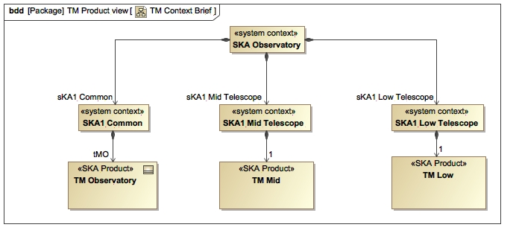

**Figure 2.1. TM LOW External Composition**

**2.4.2.2. TM LOW deployment**

Figure 2.2, “TM LOW deployment context” illustrates the physical deployment of TM LOW.  TM LOW SOC UIs, TM LOW Engineering Operations Centre UIs and TM LOW Servers, and the facilities they are deployed in, are shown with deployment groupings of TM MID and TMO to give context.

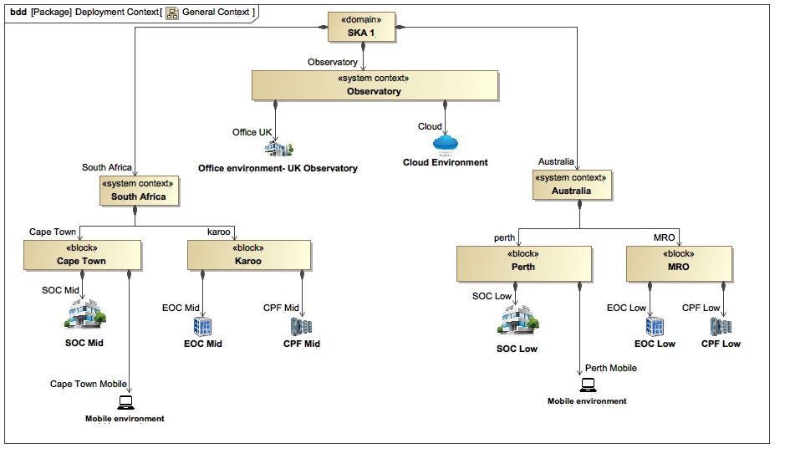

**Figure 2.2. TM LOW deployment context**

**2.4.2.3. TM LOW Functional Context**

**2.4.2.3.1. TM Relationships within SKA environment**

Figure 2.3, “TM LOW relationships within SKA environment” shows the various types of interfaces the TM LOW has with other sub-systems inside the SKA environment. Each general interface traces to a number of specific interfaces that the TM LOW can have with that particular sub-system. These relations are shown in Figure 2.4, “SKA1_Low TM LOW Functional Context Diagram” . Note that each interface essentially maps to a Interface Control Document/Dossier (ICD) that describes a collection of interfaces for two systems to be developed (one of which is of course the TM LOW).

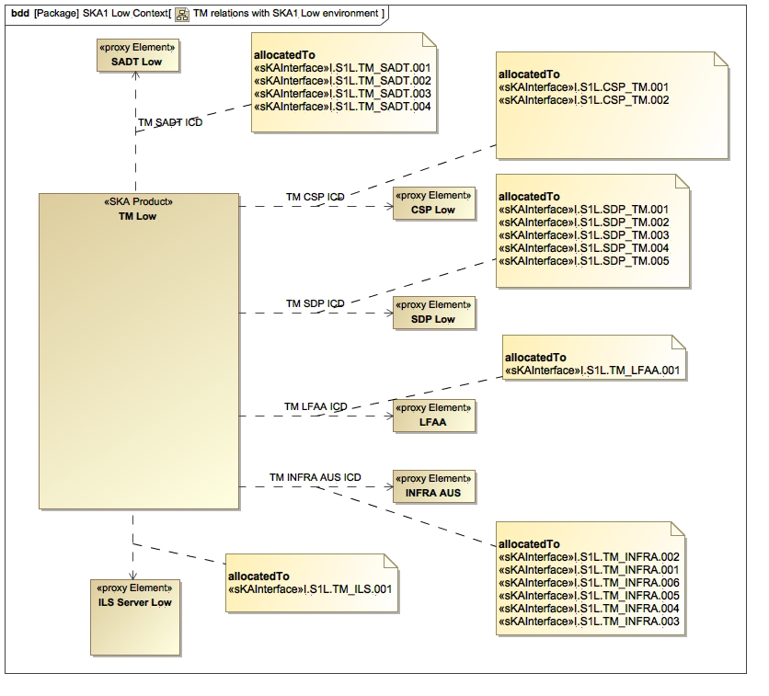

**Figure 2.3. TM LOW relationships within SKA environment**

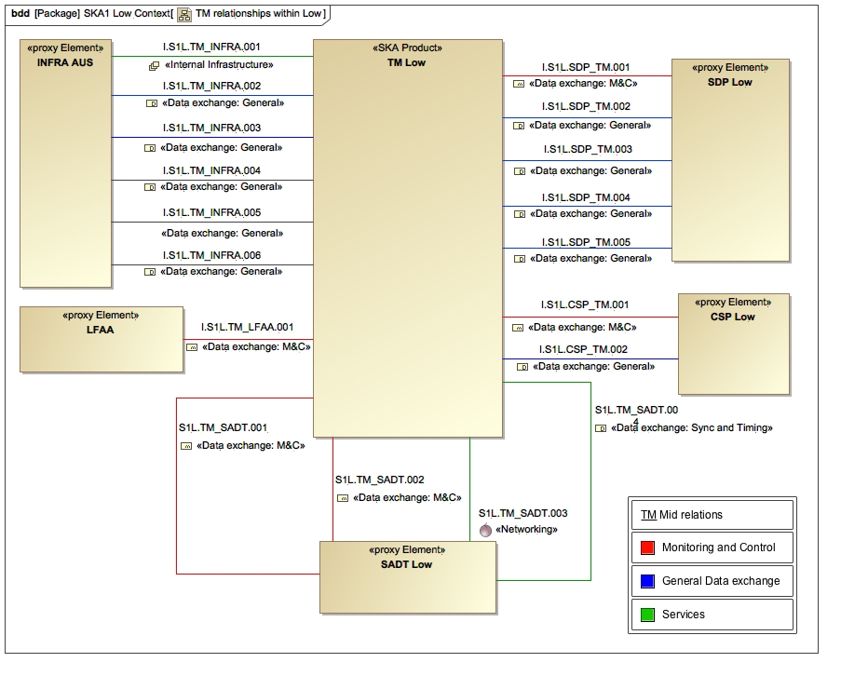

**Figure 2.4. SKA1_Low TM LOW Functional Context Diagram**

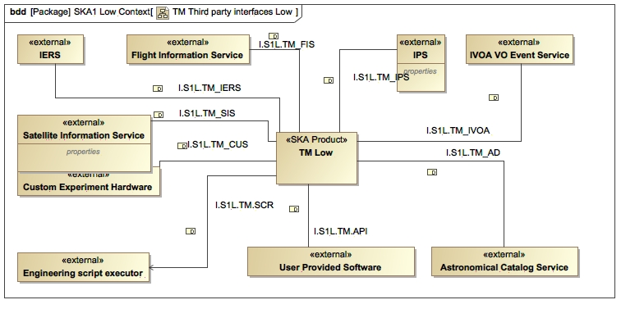

**Figure 2.5. TM LOW Third party interfaces**

Figure 2.5, “TM LOW Third party interfaces” show the functional interfaces that the TM LOW has with other systems outside the SKA Observatory.

**2.4.2.4. User need presentation**

The TM LOW, as a sub-system of the SKA1 LOW Telescope, is required to enable a user to perform a predefined set of radio astronomy observations. As such its requirements are derivations of SKA Phase 1 System requirements as well as interface requirements for proper interaction with other sub-systems of the SKA1 LOW Telescope.

The TM LOW will also be the main interaction point for the operator and user of the SKA1 LOW Telescope. Therefore a large part of its functionality has also to do with providing a proper user interface to utilise the SKA1 LOW Telescope effectively.

**2.4.3. Life cycle description**

The TM LOW will have the following life cycle stages:

a)      Development: The TM LOW system is defined and implemented

b)      Deployment: The TM LOW system is installed, commissioned and accepted for operation use

c)      Utilisation: The TM LOW system is being operated and provides functionality as required

d)      Maintenance: The TM LOW is repaired, upgraded and supported to continue its utilisation

e)      Disposal: The TM LOW is decommissioned (if required) or ‘mothballed’

**2.4.4. Functional Breakdown**

Figure 2.6, “TM Functional Breakdown - Main features” gives the high level functional breakdown of TM MID and TM LOW, while Figure 2.7, “Telescope Online Operations Management Structure” elaborates on the Telescope Online Operations Management function.Figure 2.8, “TMO Functional Breakdown - Main features” gives the high level functional breakdown of TMO.

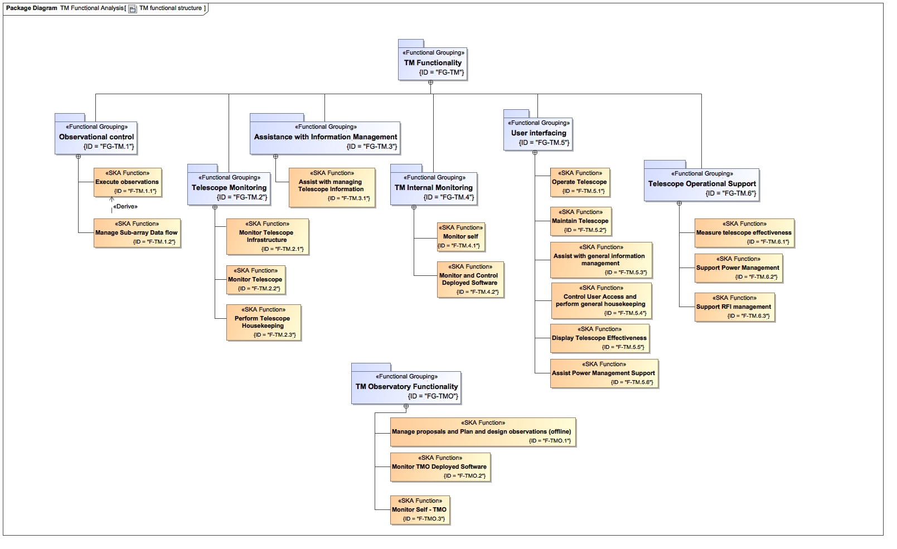

**Figure 2.6. TM Functional Breakdown - Main features**

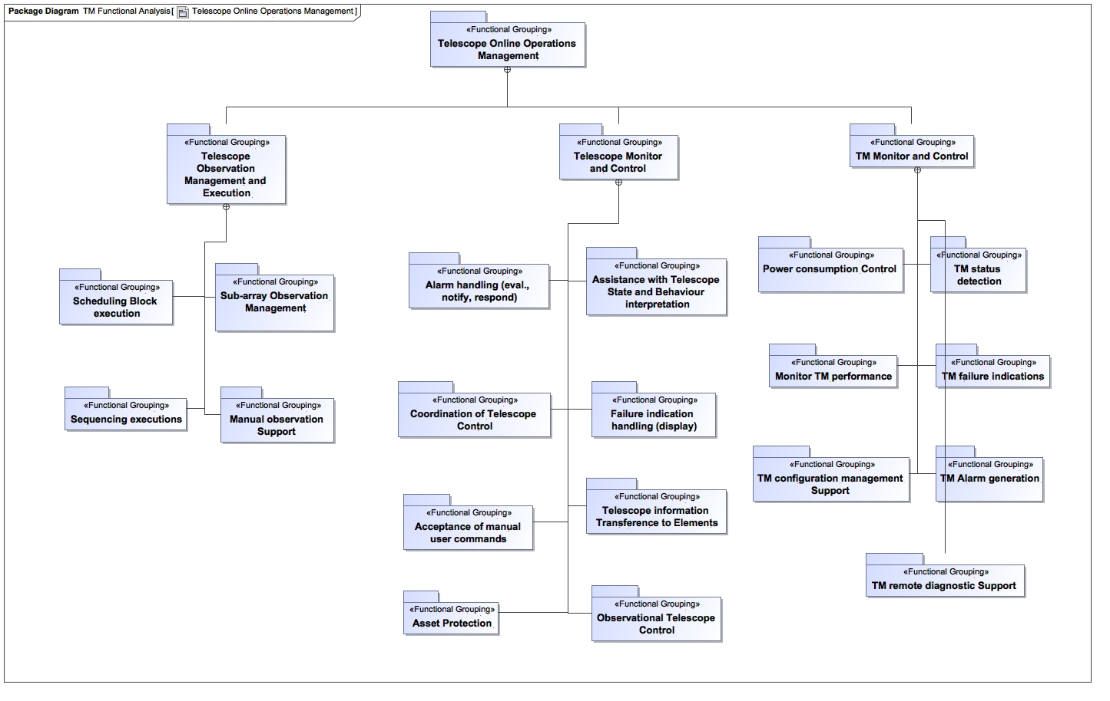

**Figure 2.7. Telescope Online Operations Management Structure**

Figure 2.6, “TM Functional Breakdown - Main features” depicts how the main functional categories for the TM can be organized into more detailed groups. The functional requirements will be organised according to this structure. The most comprehensive contribution is Execute Telescope Operations. Their decomposition is depicted in Figure 2.7, “Telescope Online Operations Management Structure” .

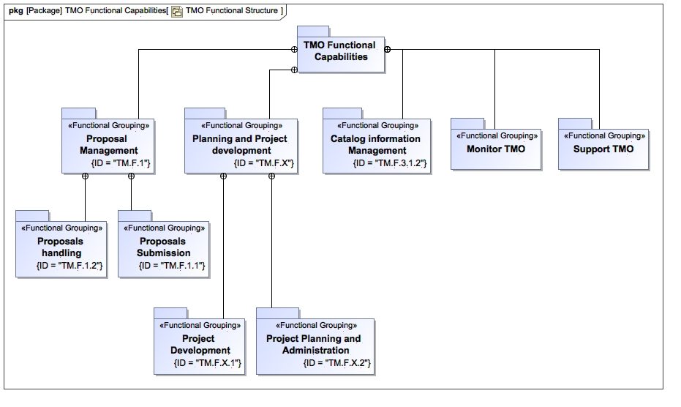

**Figure 2.8. TMO Functional Breakdown - Main features**

The following figures depict the main use cases of the TM and TMO.

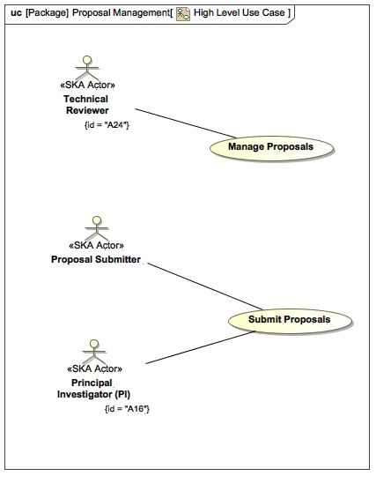

**Figure 2.9. Handle Proposals**

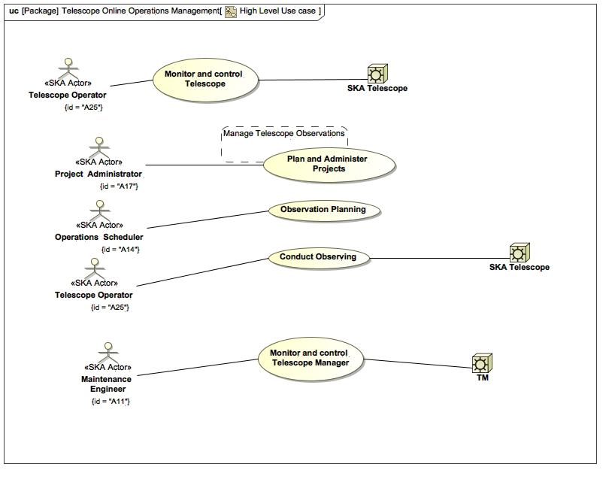

**Figure 2.10. Conduct Telescope Operations**

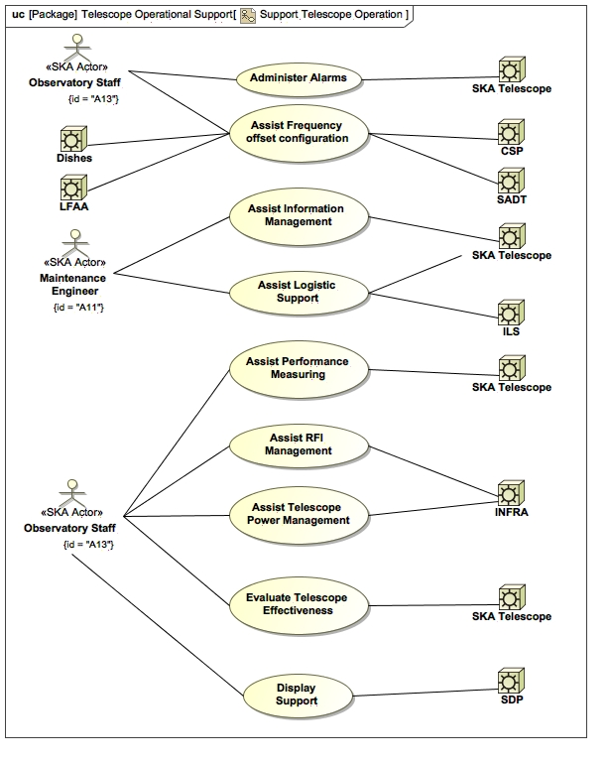

**Figure 2.11. Auxiliary Functions**

**2.4.5. External interfaces identification**

TM LOW external interfaces will be listed in the tables inside this section. Interface requirements are defined in Section 4.3, “Interface Requirements” .

**2.4.5.1. External Interfaces within SKA1 Observatory**

Table 2.2, “Diagram External Interfaces TM Low” identifies all the external interfaces of TM LOW with other systems in the SKA Observatory and Telescopes. Table 2.3, “Diagram Interfaces between SKA1-Low, SKA1-Mid and SKA1-Common” lists interfaces between SKA1 LOW, SKA1 MID and SKA1 Common.

Note that the terms used in the ‘Interface Class’ column is accordance with [RD3], par. 4.2.

| **#** | **Name** | **Telescope** | **Lead** | **Follow** | **Interface class** | **Reference** |
| --- | --- | --- | --- | --- | --- | --- |
| 1 | I.S1L.CSP_TM.001 | SKA1 Low | CSP | TM | Data exchange specifications | [RD4] |
| 2 | I.S1L.CSP_TM.002 | SKA1 Low | CSP | TM | Data exchange specifications | [RD4] |
| 3 | I.S1L.SDP_TM.001 | SKA1 Low | SDP | TM | Data exchange specifications | [RD5] |
| 4 | I.S1L.SDP_TM.002 | SKA1 Low | SDP | TM | Data exchange specifications | [RD5] |
| 5 | I.S1L.SDP_TM.003 | SKA1 Low | SDP | TM | Data exchange specifications | [RD5] |
| 6 | I.S1L.SDP_TM.004 | SKA1 Low | SDP | TM | Data exchange specifications | [RD5] |
| 7 | I.S1L.SDP_TM.005 | SKA1 Low | SDP | TM | Data exchange specifications | [RD5] |
| 8 | I.S1L.TM_ILS.001 | SKA1 Low | TM | ILS | Data exchange specifications | [RD58] |
| 9 | I.S1L.TM_INFRA.001 | SKA1 Low | TM | INFRA | TBD | [RD11] |
| 10 | I.S1L.TM_INFRA.002 | SKA1 Low | TM | INFRA | TBD | [RD11] |
| 11 | I.S1L.TM_INFRA.003 | SKA1 Low | TM | INFRA | TBD | [RD11] |
| 12 | I.S1L.TM_INFRA.004 | SKA1 Low | TM | INFRA | TBD | [RD11] |
| 13 | I.S1L.TM_INFRA.005 | SKA1 Low | TM | INFRA | TBD | [RD11] |
| 14 | I.S1L.TM_INFRA.006 | SKA1 Low | TM | INFRA | TBD | [RD11] |
| 15 | I.S1L.TM_LFAA.001 | SKA1 Low | TM | LFAA | Data exchange specifications | [RD7] |
| 16 | I.S1L.TM_SADT.001 | SKA1 Low | TM | SADT | Data exchange specifications | [RD12] |
| 17 | I.S1L.TM_SADT.002 | SKA1 Low | TM | SADT | Data exchange specifications | [RD12] |
| 18 | I.S1L.TM_SADT.003 | SKA1 Low | TM | SADT | networking | [RD12] |
| 19 | I.S1L.TM_SADT.004 | SKA1 Low | TM | SADT | Data exchange specifications | [RD12] |

**Table 2.2. Diagram External Interfaces TM Low**

| **#** | **Name** | **Source** | **Target** |
| --- | --- | --- | --- |
| 1 | I.S1ML.TM_TM | TM Mid | TM Low |
| 2 | I.S1L.TMO_TM.001 | TM Low | TM Observatory |
| 3 | I.S1M.TMO_TM.001 | TM Mid | TM Observatory |

**Table 2.3. Diagram Interfaces between SKA1-Low, SKA1-Mid and SKA1-Common**

**2.4.5.2. External Interfaces with systems outside the SKA1 Observatory**

Table 2.4, “Diagram Third party interfaces TM Low” identifies all the external interfaces of TM LOW with other Elements in the SKA Observatory and Telescopes. Note that the terms used under ‘Interface Type’ in the Description column are accordance with [RD3], par. 4.2.

| **#** | **Name** | **Interface type** | **Documentation** | **ICD Reference** |
| --- | --- | --- | --- | --- |
| 1 | I.S1L.TM_AD | Data exchange: General | This is an Interface with the SIMBAD Astronomical Catalog Service.  Set of Identifications, Measurements and Bibliography for Astronomical Data (SIMBAD).  For further information, refer to simbad.u-strasbg.fr/simbad/ Virtual Observatory compliant web service. | [RD23] |
| 2 | I.S1L.TM_CUS | Data exchange: General | This is an interface with TBD user supplied custom experiment equipment which is external to the Telescope. |  |
| 3 | I.S1L.TM.SCR | Data exchange: General | This is an interface to an Engineering Script Executor.  The user executes commands either manually or programmatically, using a text based user interface. |  |
| 4 | I.S1L.TM_FIS | Data exchange: General | This is an interface with the FlightAware LCC Flight Information Service (FIS).    SKA observations will be affected by commercial flights flying over the telescope. Aircraft communications are carried out in the VHF band with frequencies between 108 and 137 MHz. SKA-Low would be affected directly by these communications. The TM external interfaces to flight data will provide the information necessary to mitigate the effects of commercial flights.    For determining which flights will affect the telescope, the current de facto standard API comes from a commercial provider named  FlightAware LLC. The API provides flight status, flight tracking, and aviation data which can be accessed via REST or SOAP. The API can be accessed via a wide choice of programming languages including .NET, ASP, PHP, Perl, Java, JavaScript, Tcl, Ruby and Python. The API seems to be well documented.  The underlying XML specification used for data exchange is called FlightXML. The company FlightAware LLC provides real time responses to queries. This is a charged service. Charge per query reduces as the number of queries increase. A number mobile phone applications e.g. FlightAware Flight Tracker for Android provide a graphical interface that show the track of a particular flight or the real time positions over a particular airport etc.    In the SKA context, one will need to build a similar operator user interface that shows flights over the telescope. SDP/CSP may also need to be aware of when a commercial flight enters the telescope beam or one of the sidelobes for mitigative action. For more information, refer to http://uk.flightaware.com/commercial/flightxml/  More information:    1.  FF System: http://www.f-15e.info/technology/avionics/iff/iff.htm  2.  FlightAware API: http://uk.flightaware.com/commercial/flightxml/  3.  Live flights over Mumbai airport as an example of a GUI interface: https://uk.flightaware.com/live/airport/VABB  4.  FlightRadar24 provides a (www.flightradar24.com) map view of real-time positions as well as planned routes of live air traffic. | [RD45] |
| 5 | I.S1L.TM_IERS | Data exchange: General | This is an interface with the International Earth Rotation and Reference Systems Service (IERS) FTP server.    Earth orientation parameters can be downloaded via FTP.    For more information, refer to http://www.iers.org/IERS/EN/DataProducts/EarthOrientationData/eop.html. | [RD46] |
| 6 | I.S1L.TM_IPS | Data exchange: General | This is an interface with the TBD Ionospheric Prediction Service.    Produces Total Electron Content and information to correct Faraday rotation.    For more information, refer to http://www.ips.gov.au/ | [RD47] |
| 7 | I.S1L.TM_IVOA | Data exchange: General | This is an interface with the International Virtual Observatory (IVOA) Virtual Observatory (VO) Event Service from which the TM receives VO Events.    For more information, refer to:  a) Website of the International Virtual Observatory Alliance: http://www.ivoa.net/  b) VoEvent: http://wiki.ivoa.net/twiki/bin/view/IVOA/IvoaVOEvent    The international Virtual Observatory (VO) aims to make a wide variety of astronomical data accessible to users via a standardised set of protocols made available as web services. By the time the SKA is available, the breadth and scope of these services may grow many fold and the use cases for VO will increase substantially. At the present time, we envisage that VO services will be used at least in the following ways.1/ In the Proposal Submission tool and the Proposal handling tool, all stakeholders (e.g. Proposal submitters, reviewers and TAC members) will be able to use VO services to access and visualise data provided by image access services, catalog services, spectrum access services, footprint services etc. Access to these data will enable all stakeholders to develop a better understanding of the scientific merits of the proposed observations.    2/ Since the SKA will have modes to support rapid follow-up for transients detected by itself and by other telescopes worldwide, it will need an interface to the VO via the VOEvent protocol. VOEvent defines the content and meaning of a standard information packet for representing, transmitting, publishing and archiving information about a transient celestial event, with the implication that timely follow-up is of interest. Implementing VoEvent protocols, SkyAlert provides a web-based interface for exploring and collating VOEvents and defining personalised event alert schemes. Dakota and Comet provide tools for connecting to high-speed TCP streams of VOEvents. Depending on the transient follow-up policy at the SKA, we will need to connect to one or more such streams. Note that the SKA will also publish VOEvent streams that other telescopes can subscribe to.    VOEvent is deliberately transport-agnostic. However, the VOEvent Transport Protocol (VTP) may be used to distribute streams of VOEvents across the internet with a relatively low latency. “brokers” using Dakota or Comet are available to provide access to such streams.    Since VOEvents are XML documents, they can be manipulated with a wide range of standard tools. These include VOEventLib which is a Python library for working with VOEvent documents. voevent-parse is a lightweight Python library for parsing, manipulating, and generating VOEvents. The Dakota VOEvent    Tools are a cross-platform, open source set of tools which fully implement the VOEvent Transport 1.1 protocol for subscriber, publisher, and broker-to-broker operations. The Dakota tools are written in portable C#. Comet is a Python implementation of the VOEvent Transport Protocol. It is capable of receiving events either by subscribing to one or more remote brokers or by direct connection from authors, and can then both process those events locally and forward them to its own subscribers. In addition, Comet provides a tool for publishing VOEvents to a remote broker.    The tools described above are still evolving at the present time. The underlying VOEvent protocol (currently at version 2.0) may also evolve in the future. | [RD22] |
| 8 | I.S1L.TM_SIS | Data exchange: General | This is an interface with the Celestrak satellite information service FTP server.    For more information, refer to celestrak.com    Geostationary satellites remain stationary with respect to an observer on Earth. A reasonably complete set of known stationary satellites is available. The 447 currently operational GEO satellites include 177 from the U.S., 35 from China and 22 from Russia. These are mostly used for telecommunicatio and weather forecasting.    In the SKA context, these may be identified and characterised with the frequency of transmission, their signal strength etc. and appropriate mitigation can then be worked out.    Non-geostationary satellites change their position with time. Actual satellite positions are obtained using a worldwide arrangement of radar tracking stations. Although several global powers have such tracking stations, but from a practical point of view, all the “tracking” data that is publicly accessible comes from the US Air Force Space Command (AFSC).    AFSC remove militarily sensitive information from a database and voluntarily hand the rest over at regular intervals to celestrak.com, in the form of two-line element sets (TLEs).    Then available satellite tracking program (e.g. n2yo) take the TLE for any given satellite, and calculate its position using an orbit model. At regular intervals (once a day or so), the client application needs to update its database of TLE’s from CelesTrak. As a service to the CelesTrak user community, users with valid Space Track accounts (accounts may be obtained at www.space-track.org) may receive the the TLE data in a variety of standard formats.    In the SKA context, it should be relatively straightforward to ingest the data for use by SDP/CSP and also provide a operator interface that updates in real time showing satellites passing over the observatory. n2you.com provides an example of an interface using the Google Maps API.    SKA may also wish to develop over time a database of military satellites which are missing from the CelesTrak TLEs. It will be more straightforward to do this for geostationary satellites than for non stationery ones. | [RD48] |
| 9 | I.S1L.TM.API | Data exchange: General | This is an interface with the Scheduling Block Construction Tool.    Software application/script that uses an API, provided by the Telescope, to programatically create Scheduling Blocks. A productivity tool that automates some of the manual data entry that would have been required to create Scheduling Blocks using e.g. a graphical user interface. |  |

**Table 2.4. Diagram Third party interfaces TM Low**

**2.5. Conventions**

**2.5.1. Imperative Usage**

In this document ‘shall’ is used to indicate requirements strictly to be followed in order to conform to the standard and in which no deviation is permitted. ‘Must’ will not be used as an alternative for ‘shall’ (refer to [RD29] Annex H). ‘Should’ is used to indicate that, among several possibilities, one is recommended as particularly suitable - without mentioning or excluding others (refer to [RD29] Annex H). ‘Will’ is used for declaration of purpose.

**2.5.2. Codes used for Attributes of Requirements**

The following key shall be used to define attributes of a requirement:

1. Status - An enumerated set of possible reviewed states the requirement is in with regards to the previous document version:Accepted: The requirement is the same as it was when the previous version of the document was published.
2. Draft: The requirement has changed since the previous version of the document was published.
3. Proposed: The requirement have been added since the last version of the document was published
4. Allocated System - The specific TM that this requirement applies to (TM Mid, TM Low or both TM Mid and TM Low, or to TM Observatory)
5. Source - The trace to an information item that was the source for deriving the requirement. Note this may not always be a SKA Phase 1 System requirement.
6. Software Package - The work package/s to take part in delivering the desired outcome for this requirement:Observatory Science Operations (OSO) software,
7. Telescope Manager Control (TMC) software,
8. Telescope Manager Services (Services) software,
9. Telescope Manager Local Infrastructure (LINFRA) software and hardware.

**Chapter 3. References**

**3.1. Applicable documents**

The following documents are applicable to the extent stated herein. In the event of conflict between the contents of the applicable documents and this document, the applicable documents shall take precedence.None

| **#** | **Name** | **Description : String** |
| --- | --- | --- |
| 1 | [AD1] | SKAO, SKA-TEL-SKO-000008, SKA Phase 1 System Requirements Specification, Rev 11. |

**Table 3.1. Diagram Applicable Documents**

**3.2. Reference documents**

The following documents are referenced in this document. In the event of conflict between the contents of the referenced documents and this document, this document shall take precedence.

| **#** | **Name** | **Description** |
| --- | --- | --- |
| 1 | [RD2] | SKAO, SKA-TEL-SKO-0000002, SKA1 System Baseline Design, Rev 3. |
| 2 | [RD3] | SKAO, SKA-TEL-SKO-0000025, SKA Interface Management Plan, Rev 2. |
| 3 | [RD4] | SKAO, 100-000000-021, SKA1-Low Interface Control Document CSP to TM, Rev 2. |
| 4 | [RD5] | SKAO, 100-000000-029, SKA1-Low Interface Control Document SDP to TM, Rev 3. |
| 5 | [RD6] | SKAO, SKA-TEL-SKO0000150, SKA1-Mid Interface Control Document TM to DSH, Rev 2B. |
| 6 | [RD7] | SKAO, 100-000000-028, SKA1-Low Interface Control Document TM to LFAA, Rev 1. |
| 7 | [RD8] | SKAO, SKA-TEL-AIV-2310004, Interface Control Document MeerKAT to SKA1-Mid TM, Rev 2. |
| 8 | [RD10] | SKAO, 300-000000-022, SKA1 Interface Control Document SKA1-Mid TM to INFRA-SA, Rev G. |
| 9 | [RD11] | SKAO, 100-000000-022, SKA1 Interface Control Document SKA1-Low TM to INAU, Rev 1A. |
| 10 | [RD12] | BSKAO, SKA-TEL-SKO-0000153, SKA1 Interface Control Document TM to SADT, Rev 1B. |
| 11 | [RD14] | TMC, T0000-0000-MP-002, SKA1 TM System Engineering Management Plan, Rev 3. |
| 12 | [RD15] | TMC, T0000-0000-MP-004, SKA1 TM Construction Plan, Rev C. |
| 13 | [RD16] | ETSI EN 300 019-1-1, Environmental Engineering (EE); Environmental conditions and environmental tests for telecommunications equipment; Part 1-1: Classification of environmental conditions; Storage, V2.1.9 (2013-12). |
| 14 | [RD17] | BS EN IEC 60721-3-2, Classification of environmental conditions. Classification of groups of environmental parameters and their severities Classification of environmental conditions. Classification of groups of environmental parameters and their severities. Transportation, 1993. |
| 15 | [RD18] | BS EN IEC 60721-3-3, Classification of environmental conditions. Classification of groups of environmental parameters and their severities Stationary use at weather protected locations, 1995. |
| 16 | [RD19] | US Department of Commerce, FIPS PUB 199, Standards for Security Categorization of Federal Information and Information Systems, Feb 2004. |
| 17 | [RD20] | National Institute of Standards and Technology, 800-63-1, Information Security, Dec 2011. |
| 18 | [RD21] | ISO 6385:2004, Ergonomic Principles in the Design of Work Systems. |
| 19 | [RD22] | International Virtual Observatory Alliance, “Sky Event Reporting Metadata (VOEvent) Version 2.0 - IVOA Recommendation 27 June 2011”. |
| 20 | [RD23] | Centre de Donn es astronomiques de Strasbourg, http://simbad.u-strasbg.fr/simbad/, SIMBAD Astronomical Database, 9 Sept 2014. |
| 21 | [RD24] | British Ministry of Defence, Defence Standard 00-60, Integrated Logistic Support Part 0: Application of Integrated Logistic Support, Issue 6. |
| 22 | [RD25] | TMC, T0000-0000-AR-003, Proposal Handling and Observation Options, Rev 1. |
| 23 | [RD26] | TMC, T0000-0000DR-001, SKA1 TM Design Report, Rev 1B. |
| 24 | [RD27] | SKAO, SKA-TEL-SKO-0000102, SKA RAM Allocation, Rev 02. |
| 25 | [RD28] | SKAO, SKA-TEL-SKO-0000035, SKA1 Power Budget, Rev 4. |
| 26 | [RD29] | ISO/IEC Directives, Part 2 (Edition 6) Rules for the structure and drafting of International Standards, 2011. |
| 27 | [RD30] | SKAO, SKA-TEL-SKO-0000016, Technical Use Cases, Rev 1. |
| 28 | [RD31] | SKAO, SKA-TEL-SKO-0000256, Concept of Operations for the SKA Observatory, Rev 2. |
| 29 | [RD32] | TMC, T0000-0000-DR-003, SKA1 Observation Management Design Report, Rev D. |
| 30 | [RD33] | AIV Consortium, SKA-TEL-AIV-4410001, Roll-out Plan for SKA1_LOW, Rev 5. |
| 31 | [RD34] | AIV Consortium, SKA-TEL-AIV-2410001, Roll-out Plan for SKA1_MID, Rev 5. |
| 32 | [RD37] | TMC, 300-000000-021, SKA1-Mid Interface Control Document CSP to TM, Rev 2. |
| 33 | [RD38] | IEC 62682, “Management of alarms systems for the process industries”, Edition 1.0 2014-10. |
| 34 | [RD39] | SKAO, 300-000000-001, SKA_MID Functional Architecture, Rev 3. |
| 35 | [RD42] | T0000-0000-MP-003, SKA1 TM Maintenance Plan, Rev 1. |
| 36 | [RD43] | SKAO, SKA‐TEL‐SKO‐0000307, SKA1 Operational Concept Document, Rev 2 |
| 37 | [RD44] | SKAO, 300-000000-029, SKA1-Mid Interface Control Document SDP to TM, Rev 3. |
| 38 | [RD45] | FlightAware, “Flight Tracking and Flight Status API”, http://uk.flightaware.com/commercial/flightxml/. |
| 39 | [RD46] | International Earth Rotation and Reference Systems Service, “Earth Orientation Data” http://www.iers.org/IERS/EN/DataProducts/EarthOrientationData/eop.html. |
| 40 | [RD47] | Australian Breau of Meteorology - Space Weather Services, “Space Weather Services”, http://www.ips.gov.au/. |
| 41 | [RD48] | Centre for Space Standards and Innovation, “Celestrak”, celestrak.com. |
| 42 | [RD49] | Celestrak, “NORAD Two-Line Element Set Format”, http://www.celestrak.com/NORAD/documentation/tle-fmt.asp. |
| 43 | [RD50] | International Earth Rotation and Reference Systems Service, “Bulletin A - Product metadata”, http://datacenter.iers.org/web/guest/eop/-/somos/5Rgv/product/6 |
| 44 | [RD51] | US DoD, MIL-STD-721C, “Definitions of Terms for Reliability and Maintainability”. |
| 45 | [RD54] | SKA-TEL-SKO-0000438, “Dish Pointing, Motion Behaviour and Control”, Rev B |
| 46 | [RD55] | SKAO, 602-000000-002, Engineering Management System to Observation & Telescope Management ICD, Rev A. |
| 47 | [RD56] | T0000-0000-AR-023, SKA1 TM Monitoring Latency Report, Rev A. |
| 48 | [RD57] | T0000-0000-AR-022, SKA1 Alarm Philosophy Report, Rev B. |
| 49 | [RD58] | SKAO, 602-000000-002, Engineering Management System to Observation & Telescope Management ICD, Rev A. |
| 50 | [RD59] | SKAO, 100-000000-001, SKA LOW Telescope Functional Architecture, Rev 2. |
| 51 | [RD60] | SKAO, 000-000000-010, SKA1 Control System Guidelines (CS_Guidelines Main Volume), Rev 01. |
| 52 | [RD61] | SKAO, 000-000000-011, SKA TANGO Developers Guidelines (CS_Guidelines Volume 1), Rev 01. |
| 53 | [RD62] | ETSI EN 300 019-1-2, Equipment Engineering Environmental conditions and environmental tests for telecommunications equipment Part 1-2: Classification of environmental conditions Transportation |
| 54 | [RD63] | SKAO, 000-000000-012, SKA1 TANGO Naming Convention (CS_Guidelines Volume 2), Rev 01. |
| 55 | [RD64] | SKAO, SKA-TEL-SKO-0000120, SKA Configuration Management Plan, Rev 01. |
| 56 | [RD65] | International Earth Rotation and Reference Systems Service, “The International Celesctial Reference System (ICRS)”, https://www.iers.org/IERS/EN/Science/ICRS/ICRS.html, 2017-10-04. |
| 57 | [RD66] | SKA-TEL.TM.MGT-TMC-MEM-006, SKA Dish Pointing Proposal, Rev 2. |
| 58 | [RD67] | Nagios Enterprises, “Nagios XI - Best Practices”, https://assets.nagios.com/downloads/nagiosxi/docs/Nagios-XI-Best-Practices.pdf, viewed 2017-10-30. |
| 59 | [RD68] | MIT Haystack Observatory, “VLBI Experiment Definition (VEX)”, http://www.vlbi.org/vex/, viewed 2017-11-02. |

**Table 3.2. Diagram Reference Documents**

**Chapter 4. Requirements**

**4.1. Functional Requirements**

**4.1.1. Required States and Modes**

[RD30] par. 6.2 shows a high level scenario for Alarm monitoring and failure management.

[RD30] par. 7.2 shows a high level scenario for fault repair. To support the activities “Remove identified faulty items” and “Replace with tested unit”, the TM needs modes for powering up and shutting down.

Figure 4.1, “TM State Diagram” shows the required TM states.  Figure 4.2, “Change Power Demand State functionality” provides detail about the “Change Power Demand State” function.  Figure 4.3, “standby” shows detail of the *standby* state functionality.

Figure 4.4, “TM states to TANGO device states mapping” shows the mapping of TM states, as columns, to TANGO device states (refer to [RD60 par. 5.8), as rows.

**4.1.1.1. State Functionality**

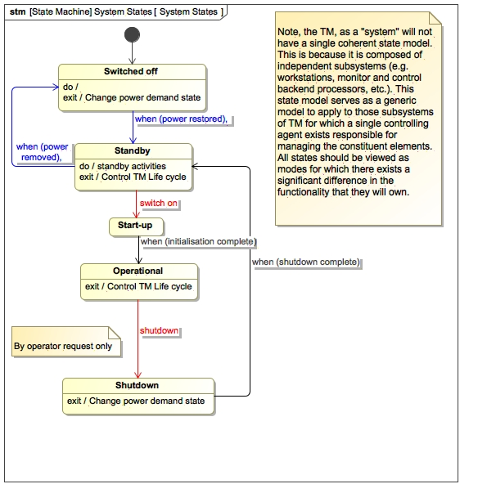

**Figure 4.1. TM State Diagram**

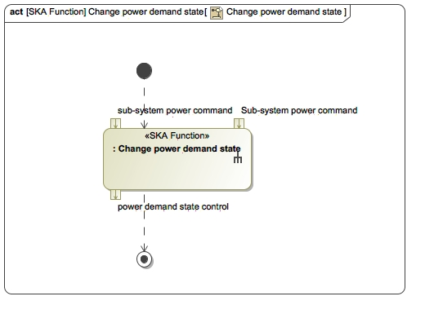

**Figure 4.2. Change Power Demand State functionality**

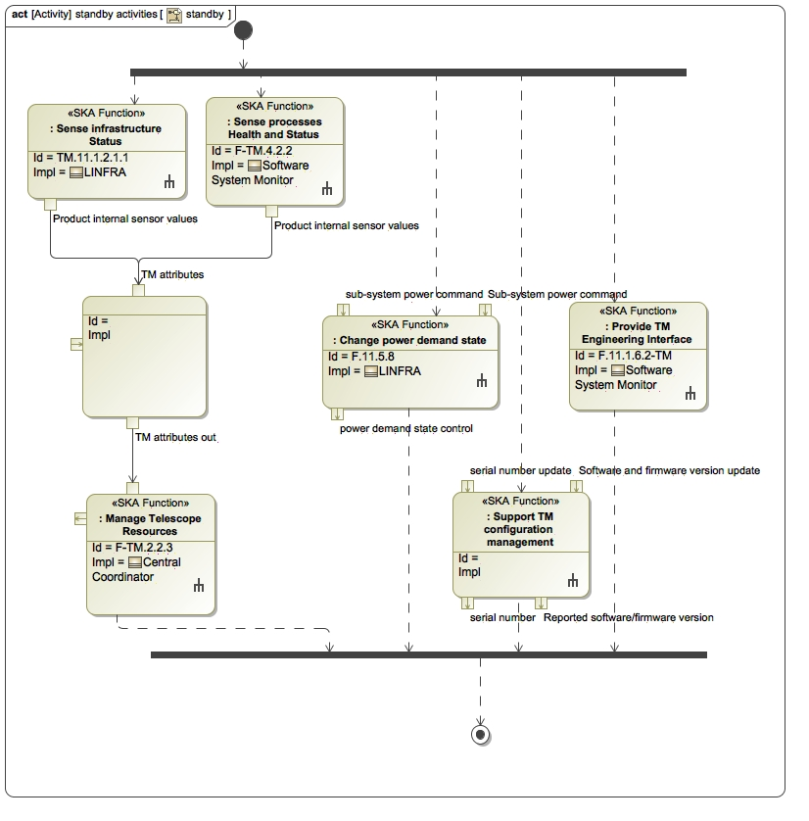

**Figure 4.3. standby**

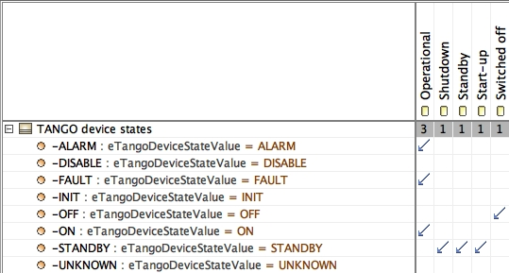

**Figure 4.4. TM states to TANGO device states mapping**

| **#** | **Description** | **Source** | **Allocated System** |
| --- | --- | --- | --- |
| 1 | **TM_REQ_427**  **Standby state power consumption**  *Status: Proposed*  *Software Package: LINFRA*  The TM, when in the Standby state, shall consume less than 5% of its nominal power consumption.    Note: This state is applicable to TM equipment installed in the CPF, and may not apply to parts of TM that are deployed in the SOC and EOC. | SYS_REQ-3084 | TM Mid  TM Low |
| 2 | **TM_REQ_385**  **Standby state functionality**  *Status: Proposed*  *Software Package: Services*  The TM, when in the *Standby* state, shall perform the following functions:       a) report TM status,       b)  generate TM Alarms,       c)  report TM faults,       d)  perform TM life cycle management,       e)  support TM engineering interface,       f)  support TM configuration management,       g)  state control and reporting,       h)  control TM power consumption.    Note: This state is applicable to TM equipment installed in the CPF, and may not apply to parts of TM that are deployed in the SOC and EOC. | SYS_REQ-3086  SYS_REQ-3088 | TM Mid  TM Low |
| 3 | **TM_REQ_198**  **Start-up time**  *Status: Accepted*  *Software Package: TM*  The TM shall complete the *Start-up* process (i.e. enter and exit the *Start-up* state) in an average time of 10 minutes. TBC36    Rationale: A start-up time equal to the shut-down time is reasonable. | Best practice | TM Mid  TM Low |
| 4 | **TM_REQ_197**  **Shutdown time**  *Status: Accepted*  *Software Package: TM*  The TM shall complete the shutdown process (i.e. enter and exit the *Shutdown* state) in an average time of 10 minutes. TBC35.    Rationale:  This time is determined by how long INFRA can maintain power to equipment after a power failure, and by the ratio of temperature rise in case of INFRA cooling system failure. Note that power down of equipment on cooling system failure results in less heat generated.  INFRA-SA: Can provide power in order of during power failure. For critical failure of cooling system, 10 minutes can be used, will be confirmed later.  INFRA-AUS: Can provide power for a few hours during power faliure (depending on fuel storage). For critical failure of cooling system, 10 minutes can be assumed. | Best practice | TM Mid  TM Low |
| 5 | **TM_REQ_195**  **Shutdown state**  *Status: Accepted*  *Software Package: Services*  The TM shall perform any required closure of functionality and configuration to ensure no failures can be introduced and that the system can initialise properly during *Start-up*. The TM shall not be allowed to perform any operations and interactions with its external environment when it is in the *Shutdown* state.    Note 1: The TM is not required to perform any functions in the *Shutdown* state.    Note 2: This state is applicable to TM equipment installed in the CPF, and may not apply to parts of TM that are deployed in the SOC and EOC. | SYS_REQ-3088  SYS_REQ-3084 | TM Mid  TM Low |
| 6 | **TM_REQ_193**  **Operational state functionality**  *Status: draft*  *Software Package: TM*  The TM shall perform all required and specified functionality during *Operational* state.  Note: This state is applicable to TM equipment installed in the CPF, and may not apply to parts of TM that are deployed in the SOC and EOC. | [RD30] par. 7.2 | TM Mid  TM Low |
| 7 | **TM_REQ_192**  **Start-up state functionality**  *Status: Accepted*  *Software Package: Services*  The TM shall initialise all required functionality and system configuration during the *Start-up* state.    Note: This state is applicable to TM equipment installed in the CPF, and may not apply to parts of TM that are deployed in the SOC and EOC. | Best practice | TM Mid  TM Low |

**Table 4.1. Diagram reqTable_State Functionality**

**4.1.1.2. State transition triggers**

| **#** | **Description** | **Source** | **Allocated System** |
| --- | --- | --- | --- |
| 1 | **TM_REQ_199**  **Power restored trigger**  *Status: draft*  *Software Package: LINFRA*  The TM shall transition from *Off* state to *Standby* state when external power is restored to TM. | SYS_REQ-3086  [RD30] par. 7.2 | TM Mid  TM Low |
| 2 | **TM_REQ_201**  **initialisation complete trigger**  *Status: draft*  *Software Package: Services*  TM shall transition from the *Start-up* state to the *Operational*  state when all its sub-systems are ready for operational use.    Note: The transition will be succeeded by a signal from the TM Services to all TM sub-systems that they can enter into *Operational*  state after *Start-up*. | [RD30] par. 7.2 | TM Mid  TM Low |
| 3 | **TM_REQ_202**  **shutdown signal event**  *Status: draft*  *Software Package: Services*  The TM, when it receives the shutdown signal from the Operator while in the *Operational*  state, shall transition to the *Standby* state. | SYS_REQ-3084  [RD30] par. 7.2 | TM Mid  TM Low |
| 4 | **TM_REQ_386**  **shutdown complete trigger**  *Status: Proposed*  *Software Package: Services*  TM shall automatically transition from the *Shutdown* state to the *Standby* state once the shutdown process has completed. | [RD30] par. 7.2 | TM Mid  TM Low |
| 5 | **TM_REQ_387**  **switch on signal event**  *Status: Proposed*  *Software Package: Services*  The TM, when it receives the switch on signal from the Operator while in the *Standby* state, shall transition to the *Start-up* state. | [RD30] par. 7.2 | TM Mid  TM Low |

**Table 4.2. Diagram reqTable_State transition triggers**

**4.1.2. Execute Telescope Operations**

**4.1.2.1. Manage Telescope Observations**

**4.1.2.1.1. Modes of Observation**

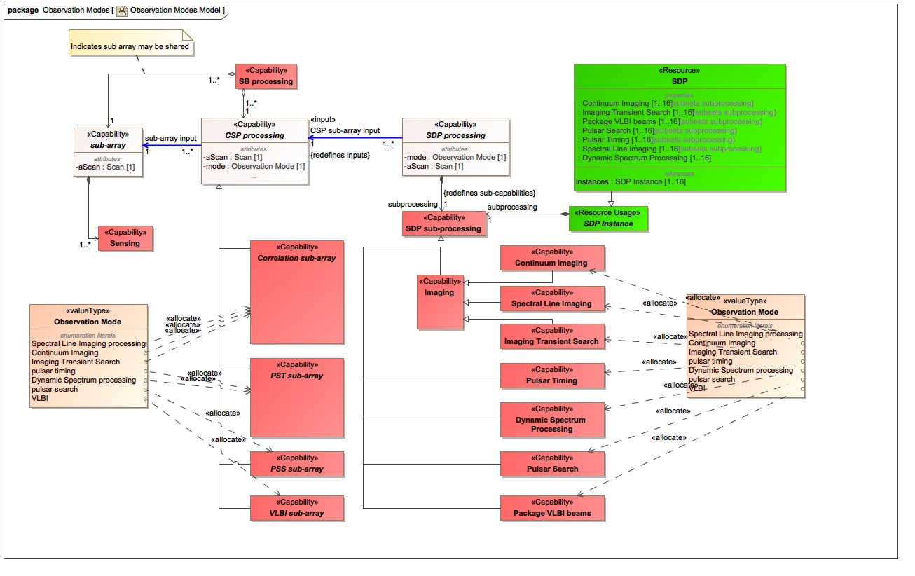

**Figure 4.5. Model showing the structure of observation modes**

| **#** | **Description** | **Source** | **Allocated System** |
| --- | --- | --- | --- |
| 1 | **TM_REQ_81**  **Pulsar Search observing mode**  *Status: draft*  *Software Package: TMC*  The TM Mid and TM Low shall configure the SKA1_Mid and SKA1_Low telescopes to perform observations in Pulsar Search Mode for which the definition of setup and control parameters shall be:   1. number of beams (up to 500 for SKA1_LOW; up to 1500 for SKA1_MID), 2. search frequency band, 3. centre frequency per beam, 4. bandwidth per beam, 5. frequency band, 6. observation time, 7. sampling interval, 8. single pulse search control parameters (for SKA1_MID only), 9. whether or not full Stokes polarisation products (I, Q, U, V) are required. 10. TBD56. | ~~SYS_REQ-2129~~  SYS_REQ-2203  SYS_REQ-2888  SYS_REQ-2890  SYS_REQ-2894  SYS_REQ-2918  SYS_REQ-2946  SYS_REQ-3037  SYS_REQ-3467 | TM Mid  TM Low |
| 2 | **TM_REQ_82**  **Pulsar Timing observing mode**  *Status: draft*  *Software Package: TMC*  The TM Mid and TM Low shall configure the SKA1_Mid and SKA1_Low telescopes to perform observations in Pulsar Timing Mode for which definition of setup and control parameters shall be:   1. Pulsar time, 2. number of beams, 3. centre frequency per beam, 4. bandwidth per beam, 5. frequency band, 6. observation time, 7. sampling interval, 8. TBD56. | ~~SYS_REQ-2130~~  SYS_REQ-2207  SYS_REQ-2757  SYS_REQ-2766  ~~SYS_REQ-2950~~  SYS_REQ-2924  SYS_REQ-2926 | TM Mid  TM Low |
| 3 | **TM_REQ_84**  **Configuration and Control change latency**  *Status: Accepted*  *Software Package: TMC*  The TM shall execute any configuration or control command as part of setting up, changing observing modes or changing configuration settings on a Sub-Array to within 1 second, from the moment the command is initiated till it is presented on the output to the Telescope network.  Rationale: The 1 second latency comes from various performance requirements placed on Mid and Low Telescope to change Sub-array configuration, composition and observing modes, all set as 30 seconds. However since TM wont have control over latencies due to network or processing done by other elements, an upper bound for any command send by TM was set at 1 second. | SYS_REQ-2133  SYS_REQ-2986  SYS_REQ-2987  SYS_REQ-3020 | TM Mid  TM Low |
| 4 | **TM_REQ_290**  **SKA1-Low Scan Types**  *Status: draft*  *Software Package: OSO*  The SKA1-Low TM shall support the following Scan types.   1. Sidereal Track, 2. Non-Sidereal Track, 3. Drift Scanning, 4. tracking celestial object, 5. raster from start position to end position at a specified rate, 6. series of pointings around a celestial position. 7. Note: See related assumptions below for information. 9. Assumption TM.A.6:  Stability of configuration of Capabilities during observations: 10. 1.      A Scheduling Block consists of one or more Scans. 11. 2.      Once configured, the parameters for a Scan (which is part of a Scheduling Block) for the LFAA Tiles or LFAA Field Nodes (grouped as a LFAA Logical Station), CSP and SDP do not change. 13. Assumption TM.A.8:  Stability of Observing Mode:  Observing Mode is one of the key observation parameters that should not change during a Scan. 15. Assumption TM.A.65: Scan: once configured, the parameters for the Scan observation unit (i.e. a Scan, which is part of a Scheduling Block) for the Dish, LFAA Station, CSP and SDP do not change. | [RD43] | TM Low |
| 5 | **TM_REQ_312**  **Independent Spectral resolutions on same Sub-array**  *Status: Accepted*  *Software Package: TMC*  When multiple processes are configured on a single Sub-array, TM shall allow configurations of CSP and SDP to have different spectral resolutions as performance parameters, provided the process types are mutually exclusive by belonging to either of the following types:  1. Correlation (Continuum Imaging, Spectral Line Imaging)  2. Beamforming (Pulsar Search, Pulsar Timing, VLBI)    Note, for example if Pulsar Search and Pulsar Timing are used together, the spectral resolution can not be different since they are of the same type. | SKA1-SYS_REQ-2855 | TM Mid  TM Low |
| 6 | **TM_REQ_321**  **Continuum Imaging observing mode**  *Status: draft*  *Software Package: TMC*  TM shall configure the SKA1_MID Telescope and SKA1_LOW Telescope to perform observations in Continuum Imaging mode (generating I, Q, V and U parameters), which can be confugured by:  1. Centre frequency,  2. Bandwidth,  3. Number of frequency channels,  4. Up to 4 Continuum Imaging zoom windows,  5. Polarisation parameters,  6. Visibility integration period, as integer multiples of 0.25 seconds to a maximum of 36 seconds (SKA1_LOW),  7. Visibility integration period, as integer multiples of 0.14 seconds to a maximum of 1.4 seconds (SKA1_MID),  8. TBD56. | SKA1-SYS_REQ-2150  SKA1-SYS_REQ-2197  SKA1-SYS_REQ-2968  SKA1-SYS_REQ-2971  SKA1-SYS_REQ-3038  SKA1-SYS_REQ-3037 | TM Mid  TM Low |
| 7 | **TM_REQ_322**  **Spectral Line Imaging observing mode**  *Status: draft*  *Software Package: TMC*  TM shall configure the SKA1_MID and SKA1 LOW Telescope to perform observations in Spectral Line Imaging observing mode for which the definition of setup and control parameters shall be:   1. number of spectral channels (from 52,500 to 65,536 for Low, and from 51,180 to 65,536 for MID), 2. frequency band, 3. Up to 4 Spectral Line Imaging zoom windows, 4. Visibility integration period, as integer multiples of 0.25 seconds to a maximum of 36 seconds (SKA1_LOW), 5. Visibility integration period, as integer multiples of 0.14 seconds to a maximum of 1.4 seconds (SKA1_MID), 6. whether full Stokes polarisation products (I, Q, U, V) are required. 7. TBD56 | SKA1-SYS_REQ-2128  SKA1-SYS_REQ-2148  SKA1-SYS_REQ-2150  SKA1-SYS_REQ-2195  SKA1-SYS_REQ-2197  SKA1-SYS_REQ-2971  SKA1-SYS_REQ-2975  SYS_REQ-3037 | TM Mid  TM Low |
| 8 | **TM_REQ_391**  **Dynamic Spectrum observing mode**  *Status: Proposed*  *Software Package: TMC*  The SKA1_Mid and SKA1_Low TM shall configure the SKA1_Mid and SKA1_Low Telescopes to perform observations in Dynamic Spectrum observing mode for which the definition of setup and control parameters are:   1. number of Pulsar Timing beams,  low 2. polarisation(s), 3. centre frequency per beam, 4. bandwidth per beam, 5. frequency band, 6. observation time, 7. sampling interval, 8. spectral resolution, 9. temporal resolution, 10. whether full Stokes polarisation products (I, Q, U, V) are required, 11. TBD123. | SYS_REQ-3037  SYS_REQ-3196  SYS_REQ-3195  SYS_REQ-3201  SYS_REQ-3531  SYS_REQ-3534 | TM Mid  TM Low |
| 9 | **TM_REQ_392**  **Imaging Transient Search observing mode**  *Status: Proposed*  *Software Package: TMC*  The SKA1_MID and SKA1_LOW TM shall configure the SKA1_MID and SKA1_LOW telescopes to perform observations in Imaging Transient Search observing mode for which the definition of setup and control parameters shall be:   1. frequency band, 2. centre frequency, 3. number of channels, 4. channel bandwidth, 5. imaging transient detection thresholds, 6. imaging RFI mask, 7. Visibility integration period, as integer multiples of 0.25 seconds to a maximum of 36 seconds (SKA1_LOW), 8. Visibility integration period, as integer multiples of 0.14 seconds to a maximum of 1.4 seconds (SKA1_MID), 9. whether full Stokes polarisation products (I, Q, U, V) are required, 10. TBD124. | SYS_REQ-2150  SYS_REQ-2197  SYS_REQ-3037  SYS_REQ-3128 | TM Mid  TM Low |
| 10 | **TM_REQ_398**  **Zoom windows**  *Status: Proposed*  *Software Package: TMC*  TM, when configuring a Sub-array for Continuum Imaging or Spectral Line Imaging zoom windows, shall set the following parameters per zoom window:   1. centre frequency, 2. bandwidth, 3. number of channels (maximum: 16384). | SKA1-SYS_REQ-2968  SKA1-SYS_REQ-2969  SKA1-SYS_REQ-2971  SKA1-SYS_REQ-2975  SKA1-SYS_REQ-2976  SKA1-SYS_REQ-2977  SKA1-SYS_REQ-3462  SKA1-SYS_REQ-3463 | TM Mid  TM Low |
| 11 | **TM_REQ_401**  **Concurrent processing on LOW Sub-array**  *Status: Proposed*  *Software Package: TMC*  SKA1-Low TM shall be able to initiate and coordinate the following types of processes for concurrent execution on a single Sub-array instance:  1.  Imaging Transient Search,  2.  Continuum Imaging,  3.  Spectral Line Imaging,  4.  Pulsar Search,  5.  Pulsar Timing,  6.  Dynamic Spectrum.    Note: The TM will achieve this by:  a) configuring the CSP into more than one logical resource, each using the output of the same set of Stations (Sub-array),  b) configuring the SDP into more than one logical resource, each using either the same CSP output, or different CSP outputs. | SKA1-SYS_REQ-3197  SKA1-SYS_REQ-3202  SKA1-SYS_REQ-3550  SKA1-SYS_REQ-2924  SKA1-SYS_REQ-2128 | TM Low |

**Table 4.3. Diagram reqTable_Modes of Observation**

**4.1.2.1.2. Conduct Observing**

**4.1.2.1.2.1. Conduct Short Term Scheduling**

| **#** | **Description** | **Source** | **Allocated System** |
| --- | --- | --- | --- |
| 1 | **TM_REQ_94**  **Schedule Scheduling Block**  *Status: draft*  *Software Package: OSO*  The TM, when requested by an operator from Operations personnel, shall assign Scheduling Blocks to the Schedule. | SYS_REQ-3168  ~~SYS_REQ-2292~~ | TM Mid  TM Low |
| 2 | **TM_REQ_96**  **Simultaneous Scheduling**  *Status: draft*  *Software Package: OSO*  The TM shall perform concurrent scheduling on a maximum of 16 predetermined set of Sub-arrays for independent execution. | SYS_REQ-3018  SYS_REQ-3019  SYS_REQ-3021  SYS_REQ-3025  SYS_REQ-3547  SYS_REQ-3548 | TM Mid  TM Low |
| 3 | **TM_REQ_97**  **Display Schedule**  *Status: Accepted*  *Software Package: OSO*  The TM shall display the schedule of Scheduling Blocks selected for execution on their respective Sub-arrays.    The source of the Scheduling Blocks that constitute the schedule of a Sub-array is the Schedule. | [RD25] par. 4.2.4 | TM Mid  TM Low |
| 4 | **TM_REQ_175**  **Maintain Schedule**  *Status: draft*  *Software Package: OSO*  The TM shall maintain a Schedule of Scheduling Blocks that will allow the Scheduling Blocks to be executed according to a predetermined order and or time list. | SYS_REQ-3125  SYS_REQ-3168  ~~SYS_REQ-2292~~ | TM Mid  TM Low |
| 5 | **TM_REQ_257**  **Manage concurrent SB execution**  *Status: Accepted*  *Software Package: OSO*  Where Scheduling Blocks are to be executed concurrently, the TM shall track progress of Scheduling Blocks executing on independent and pre-determined Sub Arrays over time. | [RD32] par. 2.1 | TM Mid  TM Low |
| 6 | **TM_REQ_337**  **Create a schedule of SBs for execution**  *Status: draft*  *Software Package: OSO*  The TM shall enable the creation and loading of a Schedule containing a list or queue of SBs planned for execution on the Telescope. | SYS_REQ-3168  ~~SYS_REQ-2292~~ | TM Mid  TM Low |

**Table 4.4. Diagram reqTable_Conduct Short Term Scheduling**

**4.1.2.1.2.2. Observe Schedule**

**Execute Scheduling Blocks**

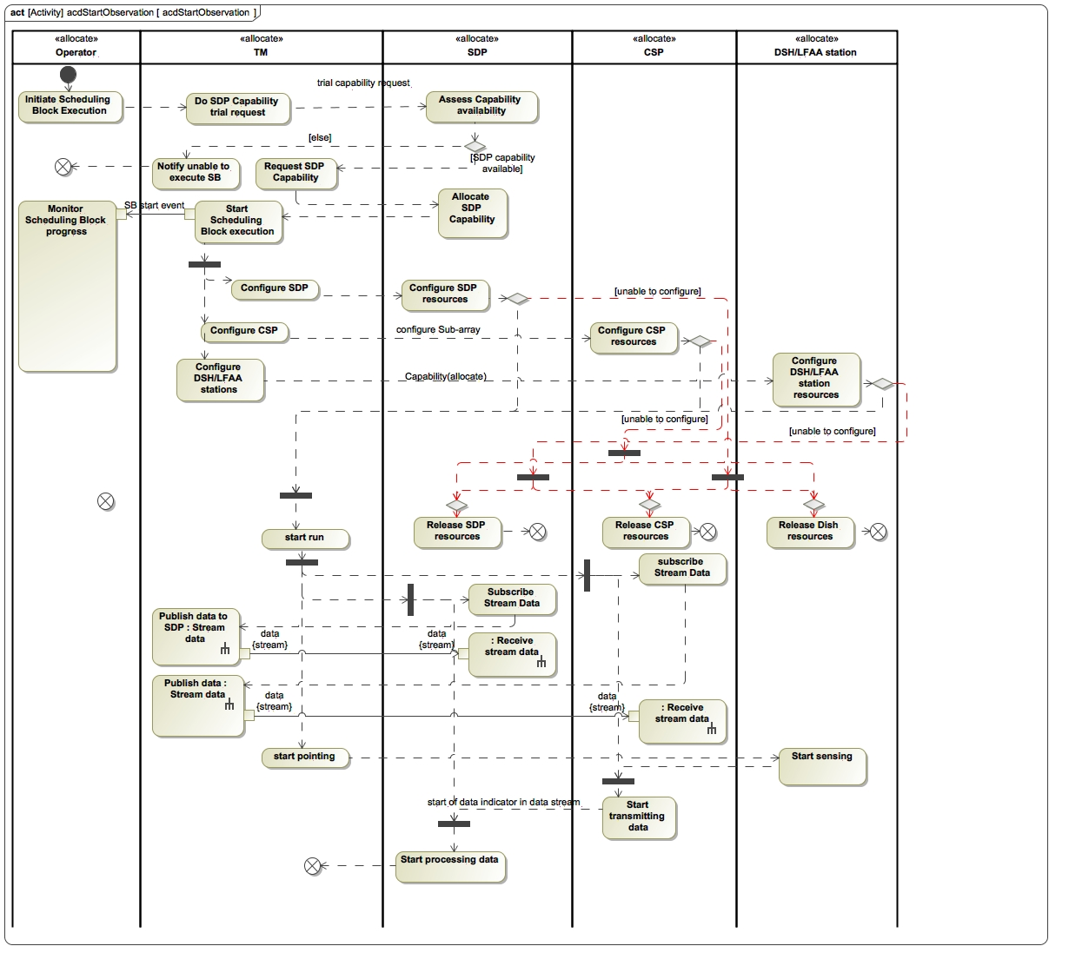

**Figure 4.6. Start Observation Scenario**

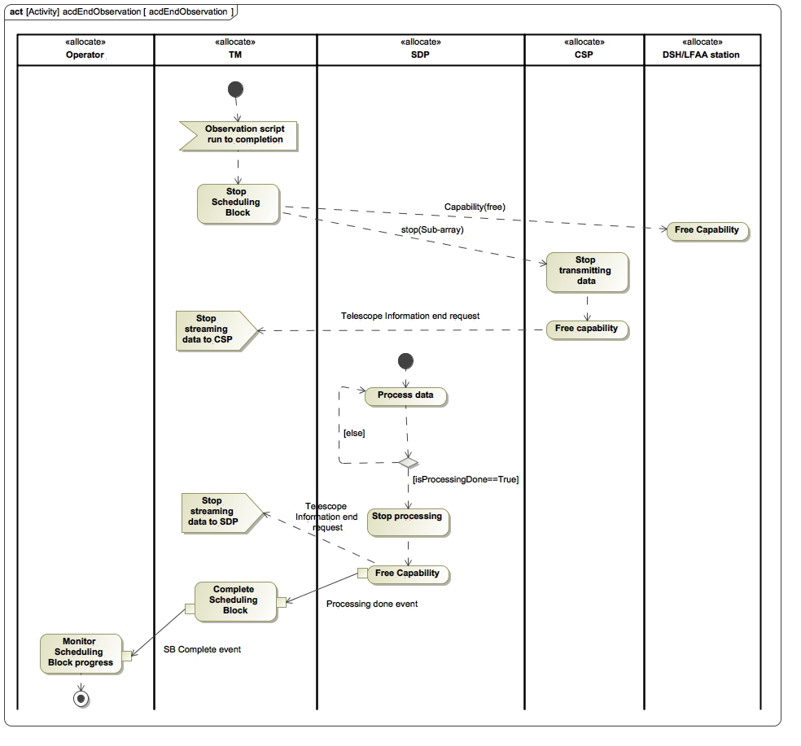

**Figure 4.7. End Observation Scenario**

| **#** | **Description** | **Source** | **Allocated System** |
| --- | --- | --- | --- |
| 1 | **TM_REQ_99**  **Scheduling Block Execution Modes**  *Status: draft*  *Software Package: OSO*  The TM shall provide for a Manual Execution Mode and an Automatic Execution Mode.    Rationale: Manual Execution Mode provides the Operator with the flexibility to control the order of execution using judgement.  Automatic execution relieves the Operator of the repetitive task of initiating execution of pre-ordered Scheduling Blocks in the Observing Sequence and reduces human supervision.    Note 1: It is expected that Manual Execution Mode to be common with Sub-arrays used for engineering purposes (maintenance, test, integration, verification, etc.). | TBD64 | TM Mid  TM Low |
| 2 | **TM_REQ_100**  **Manual Execution Mode - Manually Execute Scheduling Block**  *Status: Accepted*  *Software Package: OSO*  The TM, when in Manual Execution Mode and requested by the Operator, shall execute a Scheduling Block from the Schedule, as selected by the Operator. | SYS_REQ-2735 | TM Mid  TM Low |
| 3 | **TM_REQ_101**  **Automatic Execution Mode - Automatically Execute Scheduling Blocks**  *Status: draft*  *Software Package: OSO*  The TM, when in Automatic Execution Mode, shall automatically execute Scheduling Blocks (for which resources are available) in the order of sequence set by the Schedule.    Note: The Scheduling Block is the smallest unit of scheduling for observations. | SYS_REQ-3125  SYS_REQ-3168  [RD43] par. 6.1 | TM Mid  TM Low |
| 4 | **TM_REQ_103**  **Simultaneous execution**  *Status: draft*  *Software Package: TMC*  The TM shall be able to execute Scheduling Blocks concurrently.  Note 1: The TM will do this by executing a Scheduling Block on one Sub-array while executing another Scheduling Block on a different Sub-array. In other words by having Sub-arrays as independent resources. | SYS_REQ-2128  SYS_REQ-2992  SYS_REQ-2993  SYS_REQ-3016  SYS_REQ-3468  SYS_REQ-3524  SYS_REQ-3547  SYS_REQ-3548  ~~SYS_REQ-2129~~  ~~SYS_REQ-2130~~ | TM Mid  TM Low |
| 5 | **TM_REQ_174**  **Number of Simultaneous observations**  *Status: draft*  *Software Package: TMC*  The TM shall make provision for simultaneous execution of observations on up to 16 Sub-arrays.  Note however the maximum limit to simultaneous VLBI observations will be only 4 Sub-arrays. | SYS_REQ-3021  SYS_REQ-3025  SYS_REQ-3026  SYS_REQ-3468  SYS_REQ-3524 | TM Mid  TM Low |
| 6 | **TM_REQ_179**  **Execute SB script**  *Status: Accepted*  *Software Package: TM*  The TM shall interpret and execute the observation script contained inside the Scheduling Block into the appropriate control commands to the Sub-array elements as defined in its S1L.TM_API and S1M.TM_API interface. | SYS_REQ-2646 | TM Mid  TM Low |
| 7 | **TM_REQ_291**  **SB execution multiplicity**  *Status: Accepted*  *Software Package: OSO*  The TM shall assign a single Scheduling Block to not more than one Sub-array at a time.  Rationale: No known science driver that requires a resource (e.g. a dish) to participate in an observation that is executed by more than one Sub-array. Because resources are assigned to Sub-arrays for use, and because Scheduling Blocks are allocated to Sub-arrays for execution, each Scheduling Block is allocated to only one Sub-array. | SYS_REQ-3027  SYS_REQ-3028 | TM Mid  TM Low |

**Table 4.5. Diagram reqTable_Execute Scheduling Blocks**

Monitor Scheduling Block Execution

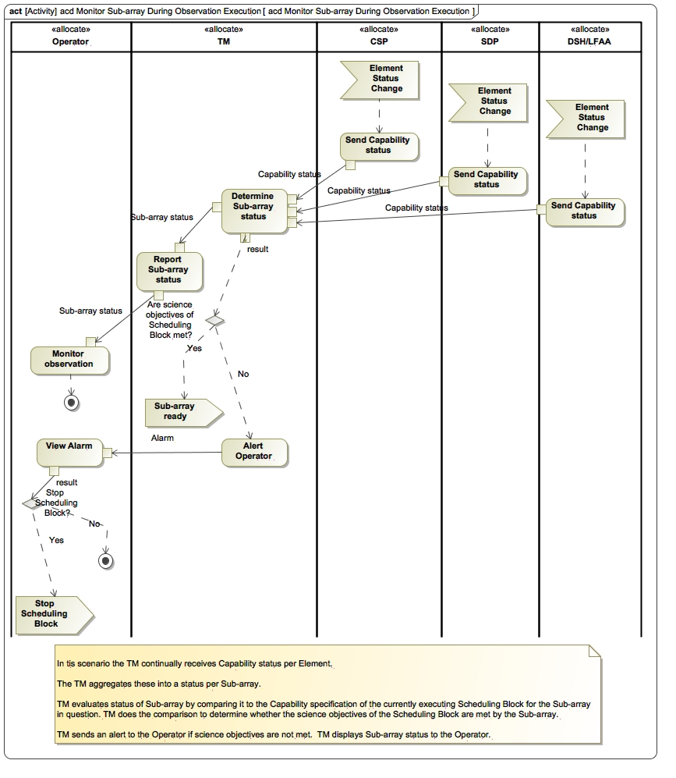

**Figure 4.8. Monitor Sub-array During Observation Execution**

| **#** | **Description** | **Source** | **Allocated System** |
| --- | --- | --- | --- |
| 1 | **TM_REQ_205**  **Display Sub-array status**  *Status: Accepted*  *Software Package: TMC*  The TM shall display the status of each Sub-array to the Operator.  Note: The TM will derive the Sub-array status from the status of the Capabilities (as reported by other Elements to TM) that are allocated to a Sub-array. | SYS_REQ-2127  SYS_REQ-3016  SYS_REQ-3017 | TM Mid  TM Low |
| 2 | **TM_REQ_206**  **Monitor Sub-array status during Scheduling Block Execution**  *Status: Accepted*  *Software Package: TMC*  The TM, before and during execution of a Scheduling Block, shall compare the status of the Sub-array with the requirements imposed by the Scheduling Block and if the Capability requirements of the Scheduling Block are not met by the Sub-array:   1. alert the operator, 2. log the event. | SYS_REQ-2127  SYS_REQ-3016  SYS_REQ-3017  SYS_REQ-2735 | TM Mid  TM Low |
| 3 | **TM_REQ_207**  **Report Scheduling Block Status**  *Status: Accepted*  *Software Package: OSO*  The TM shall report the following statuses of Scheduling Blocks to the Operator:  1. not started,  2. failed to start,  3. executing,  4. completed,  5. failed (during execution),  6. interrupted.    Rationale: Because the user exercises control over Scheduling Block execution during manual execution mode (e.g. start and cancel operations), the execution status of Scheduling Blocks needs to be made available for monitoring by the user.  The monitoring capability is also useful during Automatic Execution Mode. | SYS_REQ-2735 | TM Mid  TM Low |
| 4 | **TM_REQ_374**  **Store Scheduling Block Status**  *Status: Proposed*  *Software Package: OSO*  The TM shall store the following statuses of Scheduling Blocks, together with the date and time at which the status became applicable for a period of 50 years:  1. not started,  2. fails to start,  3. executing,  3. completed,  4. failed (during execution),  5. interrupted.    Note 1: 50 years is the expected life of the SKA (refer to [RD31] par. 3.2). | SYS_REQ-3161  SYS_REQ-3169 | TM Mid  TM Low |
| 5 | **TM_REQ_375**  **Capture Operator Scheduling Block Logs**  *Status: Proposed*  *Software Package: OSO*  The TM shall store narrative text entries, together with the date and time of entry, relating to a specific Scheduling Block, from an authorised and authenticated Operator for a period of 50 years.    Note 1: 50 years is the expected life of the SKA (refer to [RD31] par. 3.2). | SYS_REQ-3161  SYS_REQ-3169  SYS_REQ-3177 | TM Mid  TM Low |
| 6 | **TM_REQ_388**  **Send Scheduling Block status to TMO**  *Status: Proposed*  *Software Package: OSO*  TM shall send the following Scheduling Block status to TMO via its I.S1M.TMO_TM.001, I.S1L.TMO_TM.001 interface:  1. not started,  2. failed to start,  3. executing,  4. completed,  5. failed (during execution),  6. interrupted. | SYS_REQ-3169  SYS_REQ-3126 | TM Mid  TM Low |

**Table 4.6. Diagram reqTable_Monitor Scheduling Block Execution**

**4.1.2.1.2.3. Cancel Execution of Scheduling Blocks**

| **#** | **Description** | **Source** | **Allocated System** |
| --- | --- | --- | --- |
| 1 | **TM_REQ_109**  **Manual Cancellation of Scheduling Block - abort and end**  *Status: Accepted*  *Software Package: OSO*  The TM shall give the following options to the Operator to cancel a currently executing Scheduling Block:   1. abort now: end execution of the Scheduling Block immediately, discarding the data, 2. stop: end execution of the Scheduling Block at the end of the current Scan. 3. Note: Without this Operator intervention, the TM will allow the Scheduling Block to run to completion. | SYS_REQ-2735 | TM Mid  TM Low |
| 2 | **TM_REQ_110**  **Cancel Scheduling Block on TOO Trigger**  *Status: draft*  *Software Package: OSO*  The TM, when receiving a TOO trigger, shall be able to cancel execution of the currently executing Scheduling Block in order to execute a Scheduling Block triggered by a TOO, if all of the following conditions are met:  1. The Scheduling Block triggered by the TOO has “override” priority (an appropriate level of priority higher than the currently executing Scheduling Block, i.e. the event is deemed of such an high importance that it has to execute immediately).  2. The currently executing Scheduling Block and the Scheduling Block triggered by the TOO trigger contest for the same resources. | ~~SYS_REQ-2283~~  SYS_REQ-3134  SYS_REQ-3168 | TM Mid  TM Low |
| 3 | **TM_REQ_170**  **Discard SDP execution of SB on abort**  *Status: Accepted*  *Software Package: TMC*  The TM, when aborting a Scheduling Block, shall send a discard command to the SDP, to discard the results from the canceled Scheduling Block, via the I.S1M.SDP_TM.001 interface (in accordance with [RD44]) and I.S1L.SDP_TM.001 interface (in accordance with [RD5]). | ~~SYS_REQ-2286~~ | TM Mid  TM Low |

**Table 4.7. Diagram reqTable_Cancel Execution of Scheduling Blocks**

**4.1.2.1.2.4. Respond to VO Events**

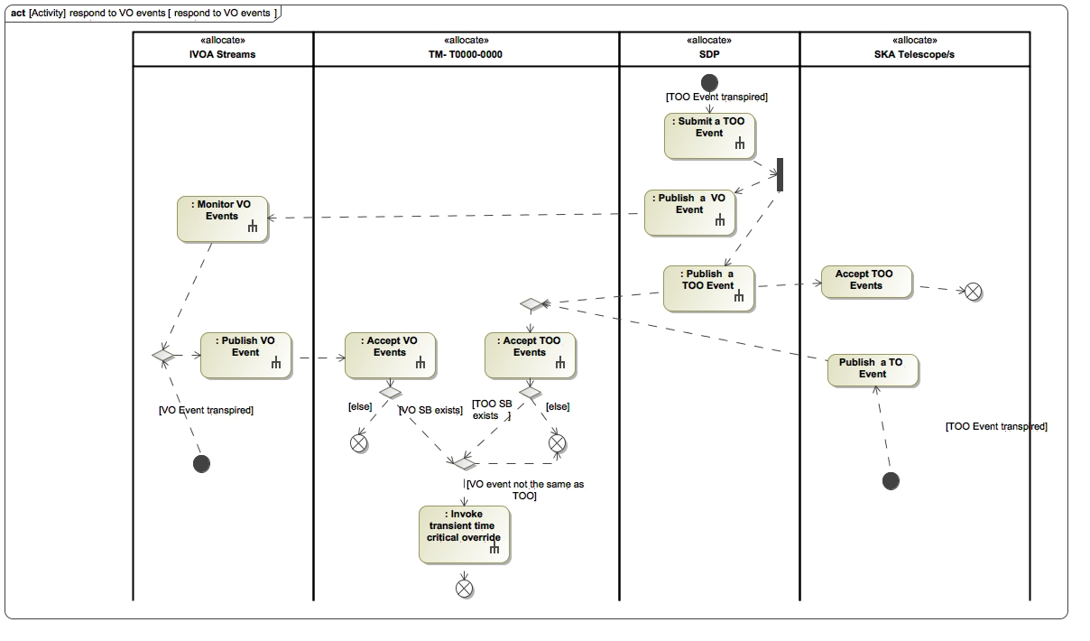

**Figure 4.9. respond to VO events scenario**

| **#** | **Description** | **Source** | **Allocated System** |
| --- | --- | --- | --- |
| 1 | **TM_REQ_152**  **Receive VO Events - IVOA**  *Status: Accepted*  *Software Package: OSO*  The TM shall receive VO Events via its S1L.TM_IVOA, S1M.TM_IVOA interface. | SYS_REQ-2298 | TM Mid  TM Low |
| 2 | **TM_REQ_187**  **VO Event Response Performance**  *Status: draft*  *Software Package: TM*  The TM shall initiate a transient time-critical override in less than 1 second of receiving a VO Event.  Note by initiate response is meant the first time TM outputs a command or message that has specifically to do with the Internal Transient Event.  Note that the 1 second includes delays imposed by TM, but excludes any delays of other sub-systems outside of TM. | SYS_REQ-2285  ~~SYS_REQ-2299~~  SYS_REQ-2301  ~~SYS_REQ-2300~~ | TM Mid  TM Low |
| 3 | **TM_REQ_329**  **Receive VO Events - SKA1-Low Generated**  *Status: Accepted*  *Software Package: OSO*  SKA1-Mid TM shall receive SKA1-Low generated transient announcements as VO Events from SKA1-Low TM via the I.S1ML.TM_TM interface. | SYS_REQ-2296 | TM Low |
| 4 | **TM_REQ_93**  **Internal Transient Event Response Configuration**  *Status: draft*  *Software Package: OSO*  Each Scheduling Block shall include a configuration setting that determines how an Internal Transient Event shall be responded to. The setting parameter shall be either one of the following:  a) perform a transient time-critical override;  b) issue a VOE event via its I.S1M.TM_IVOA, I.S1L.TM_IVOA interface;  c) issue a TOO announcement to SKA telescopes via its I.S1ML.TM_TM interface;  d) no action | SYS_REQ-2296  SYS_REQ-3168  ~~SYS_REQ-2295~~  ~~SYS_REQ-2283~~ | TM Mid  TM Low |
| 5 | **TM_REQ_182**  **Receive Internal Transient Event**  *Status: Accepted*  *Software Package: OSO*  The TM shall receive internal transient events (internal transient Detection alerts) from the SDP via its I.S1L.SDP_TM.003 (as per [RD5]) and I.S1M.SDP_TM.003 interface (as per [RD44]). | SYS_REQ-2296 | TM Mid  TM Low |
| 6 | **TM_REQ_183**  **Internal Transient Response Function**  *Status: draft*  *Software Package: TM*  The TM, when it receives an Internal Transient Event, shall respond to the event as specified in the Internal Transient Response Configuration of the Scheduling Block that was created for observing the transient event. | SYS_REQ-2296  SYS_REQ-3168 | TM Mid  TM Low |
| 7 | **TM_REQ_184**  **Internal Transient Response Performance**  *Status: draft*  *Software Package: TM*  The TM shall initiate a response to an Internal Transient Event in less than 1 second of receiving the Internal Transient Event. Note by initiate response is meant the first time TM outputs something that has specifically to do with the Internal Transient Event. | SYS_REQ-2285  ~~SYS_REQ-2299~~ | TM Mid  TM Low |
| 8 | **TM_REQ_186**  **Transient Time-Critical Override**  *Status: draft*  *Software Package: OSO*  The TM, when performing an transient time-critical override, shall:   1. cancel currently executing Scheduling Blocks if those Scheduling Blocks compete for resources with the Scheduling Block that was created for observing the Transient Event, 2. execute the Scheduling Block that was created for observing the Transient Event. 3. if the following conditions are met: 4. a Scheduling Block exists for observing the Transient Event, 5. no resource constraints prevents the Scheduling Block from executing, 6. however if there are currently executing Blocks that compete for resources with the Scheduling Block that was created for observing the Transient Event, the currently executing Scheduling Block is of a lower priority than the Scheduling Block that monitors the Transient Event, 7. the Scheduling Block that was created for observing the Transient Event is not already executing, and has not run to completion. | SYS_REQ-2301  SYS_REQ-3168  ~~SYS_REQ-2300~~  ~~SYS_REQ-2283~~ | TM Mid  TM Low |

**Table 4.8. Diagram reqTable_Respond to VO Events**

**4.1.2.1.2.5. Manage Sub-array Observing**

| **#** | **Description** | **Source** | **Allocated System** |
| --- | --- | --- | --- |
| 1 | **TM_REQ_178**  **Definition and configuration of sub arrays**  *Status: draft*  *Software Package: TMC*  The TM shall allow the operator to define and configure a Sub-array based on a selection of available Schedulable Resource’s to be treated as a single functional unit capable of executing observations TBC27.  Each Sub-array shall be configured (independently from other Sub-array instances) in terms of the following parameters:  1.      Its pointing (i.e. the central direction of its main beam),  2.      Its frequency resolution,  3.      Its bandwidth,  4.      Its Visibility or beam integration period.    Note1: This requirement makes it possible for existence of Sub-arrays to be independent of the existence of Scheduling Blocks. Any Sub-array instance will be independent from any other instance in terms of their control and configuration factors. | SYS_REQ-2127  ~~SYS_REQ-2850~~  SYS_REQ-2990  SYS_REQ-2994  SYS_REQ-3007  SYS_REQ-3008  SYS_REQ-3009  SYS_REQ-3010  SYS_REQ-3012  SYS_REQ-3013  SYS_REQ-3014  SYS_REQ-3015  SYS_REQ-3030  SYS_REQ-3029  SYS_REQ-3368 | TM Mid  TM Low |
| 2 | **TM_REQ_216**  **Sub-array management with CSP - updates**  *Status: Accepted*  *Software Package: TMC*  The TM, when allocating/de-allocating receptors to/from an existing Sub-array, shall send updated Sub-array definition to the CSP as per [RD4], Tables 17, 21, 25. | Analysis | TM Mid  TM Low |
| 3 | **TM_REQ_217**  **Sub-array management with CSP - life cycle management**  *Status: Accepted*  *Software Package: TMC*  The TM, when creating or deleting a Sub-array, shall send updated Sub-array definition to the CSP as per [RD4] and [RD37]. | Analysis | TM Mid  TM Low |
| 4 | **TM_REQ_278**  **Automatic Sub-array configuration**  *Status: draft*  *Software Package: TM*  The TM, when in Automatic Execution Mode, shall automatically define and configure a Sub-array, based on the selection of Dishes or LFAA Stations or LFAA Sub-stations as specified in the Scheduling Block parameters, within the constraints of availability of Dishes and LFAA Field Nodes or LFAA antennas. | SYS_REQ-2127  SYS_REQ-3039  [RD43] par. 6.5.1 | TM Mid  TM Low |
| 5 | **TM_REQ_292**  **LFAA Station Sub-array membership**  *Status: draft*  *Software Package: TMC*  The SKA1-Low TM, when configuring a Sub-array, shall enforce the following rules:   1. all Sub-arrays contain a maximum of 512 Stations or Sub-stations (See Note 1), 2. a Sub-array contains 1 to 64 Stations or Sub-stations (See Note 1), 3. a Station or Sub-station is a member of only 1 Sub-array, 4. a Tile is allocated as resource exclusively to a specific Sub-station, 5. a Field Node is allocated as resource exclusively to a specific Station, 6. a Station uses 16 Tiles of a single Field Node, 7. a Sub-station uses Tiles of a single Field Node, 8. a Field Node provides Tiles as resources for 1 to 6 Sub-stations, 9. a Station/Sub-station produces 1 to 8 Station Beams, 10. a Station Beam is produced by only 1 Station/Sub-station. 11. Note 1: Subject to availability of Field Nodes and antennas, or Station Beams at the time of allocation. | SYS_REQ-2988  SYS_REQ-2989  SYS_REQ-2990  SYS_REQ-2991  SYS_REQ-3287  SYS_REQ-3039  SYS_REQ-3368  SYS_REQ-3528 | TM Low |
| 6 | **TM_REQ_293**  **Stability of Sub-array configuration**  *Status: draft*  *Software Package: TMC*  The TM shall not allow the allocation of Dishes or LFAA Stations to a Sub-array to change while a Scheduling Block is executing on the Sub-array. | SYS_REQ-2998  SYS_REQ-2999 | TM Mid  TM Low |
| 7 | **TM_REQ_317**  **Invariance of Sub-array element configurations**  *Status: draft*  *Software Package: TMC*  TM shall ensure a Sub-array’s configuration remains valid, during its operational use by a Scheduling Block, by maintaining the following constraints:  1. For each constituent Dish or LFAA Station element, the frequency configuration remains equal.  2. For each constituent Dish or LFAA Station element, the pointing (i.e. the desired location in the sky to which it must point) remains equal.  3. For each constituent Dish or LFAA Station element, the RFI flagging control parameters remain equal. | SKA1-SYS_REQ-2994  SKA1-SYS_REQ-2995  ~~SKA1-SYS_REQ-3004~~  ~~SKA1-SYS_REQ-3005~~ | TM Mid  TM Low |
| 8 | **TM_REQ_318**  **Sub-array failure handling**  *Status: draft*  *Software Package: TMC*  If any equipment of SKA1-Low LFAA Field Nodes (that resource a Station) or SKA1-Mid dishes fail (i.e. become degraded or non-operational) during the execution of a Scheduling Block on a Sub-array to which the these members belong, TM shall do the following:  1.      Flag the relevant member as faulty for information to be used by SDP during downstream processing.  2.      Flag the relevant member as faulty for information to the CSP.  2.      Ensure the relevant member is still treated as a constituent of the Sub-array even though its functionality has been lost until the Scheduling Block execution has finished.    Note 1: The granularity of flagging for LFAA will be down to Field Node level.    Note 2: Latency of flagging to SDP is addressed in TM_REQ_358.    Note 3: Latency of flagging to CSP is addressed in TM_REQ_302. | SKA1-SYS_REQ-3000  SKA1-SYS_REQ-3001 | TM Mid  TM Low |
| 9 | **TM_REQ_319**  **Invariance of Sub-Array level configuration**  *Status: draft*  *Software Package: TMC*  TM shall ensure the following settings per Sub-array remain fixed during the execution of a Scheduling Block:  1.      Its frequency resolution,  2.      Its bandwidth,  3.      Its Visibility integration period (if in imaging mode). | SKA1-SYS_REQ-3012  SKA1-SYS_REQ-3013  SKA1-SYS_REQ-3010  SKA1-SYS_REQ-3009  SKA1-SYS_REQ-3014  SKA1-SYS_REQ-3015 | TM Mid  TM Low |

**Table 4.9. Diagram reqTable_Manage Sub-array Observing**

**4.1.2.2. Monitor and Control Telescope**

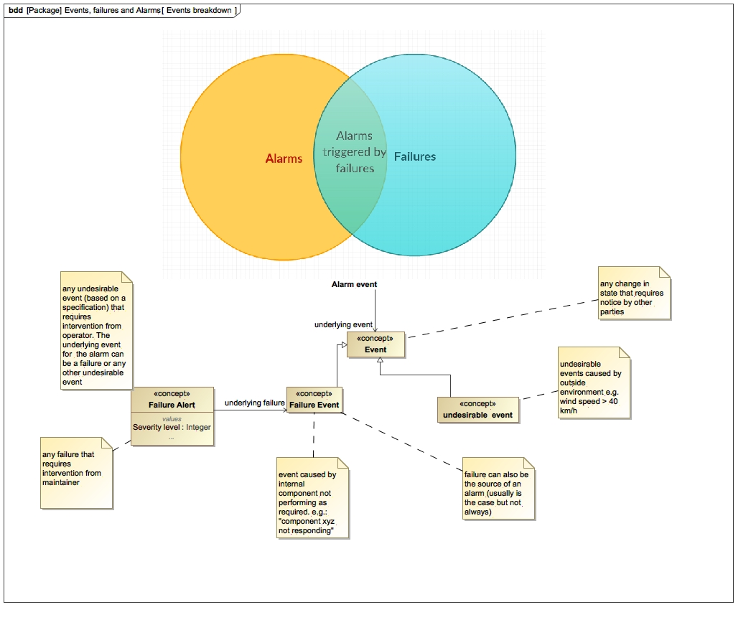

**Figure 4.10. Conceptual Illustration of the difference between Alarms and Events**

**4.1.2.2.1. Handle Alarms**

| **#** | **Description** | **Source** | **Allocated System** |
| --- | --- | --- | --- |
| 1 | **TM_REQ_15**  **Handle Alarms from external information - latency**  *Status: draft*  *Software Package: TMC*  The time latency between receiving information from an Element, and reporting the Alarm shall be 700 milliseconds. | SYS_REQ-2312  [RD56] | TM Mid  TM Low |
| 2 | **TM_REQ_418**  **Handle Alarms**  *Status: Proposed*  *Software Package: TMC*  The TM shall report Alarms based on assessment of information from Elements (including the TM), against Alarm attributes.    Note 1:  The information from Elements that are assessed are Element-specific in scope, and may include:   1. instrument diagnostic alarms (Element Alarms - refer to [RD60]), 2. monitoring data generated by Elements, 3. monitoring data generated by TM. 4. Note 2: The assessment of information will be based on Alarm attributes, which will be determined in accordance with [RD57]. | SYS_REQ-2309 | TM Mid  TM Low |

**Table 4.10. Diagram reqTable_Handle Alarms**

**4.1.2.2.2. Handle Failure Indications**

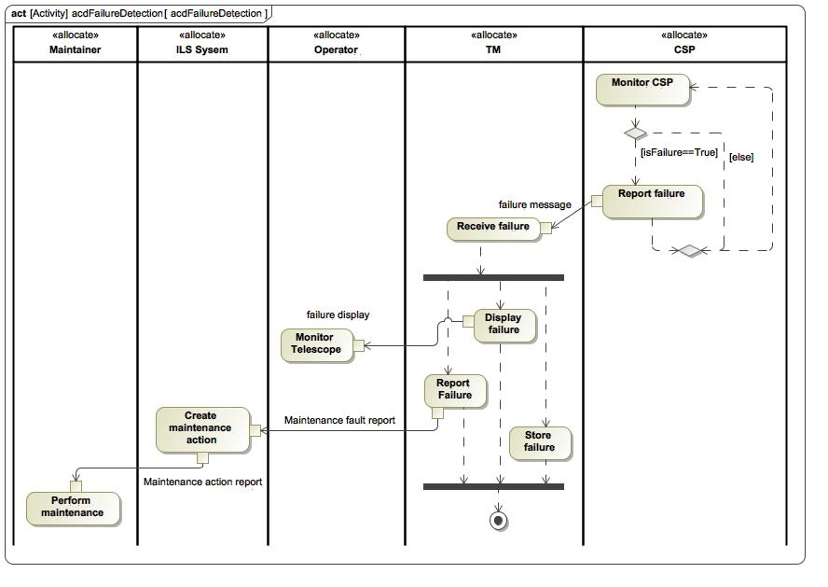

**Figure 4.11. Failure Detection Scenario**

| **#** | **Description** | **Source** | **Allocated System** |
| --- | --- | --- | --- |
| 1 | **TM_REQ_10**  **Report failure events to Operator**  *Status: draft*  *Software Package: TMC*  The TM shall report failure events received from other Elements (as well as those internally detected by its own monitoring system) to the Operator.  Note that failures may in addition also be reported by the source of information as Alarms if the qualified criteria are met (i.e. when they require not only maintainer action but also operator intervention). | SYS_REQ-2279  SYS_REQ-3002  SYS_REQ-3249  [RD39] par. 5.12 | TM Mid  TM Low |
| 2 | **TM_REQ_17**  **Report failure event - latency**  *Status: draft*  *Software Package: TMC*  The time latency between receiving an external failure event and reporting the event shall be 3 seconds. | [RD56] | TM Mid  TM Low |
| 3 | **TM_REQ_65**  **Record failure events**  *Status: draft*  *Software Package: TMC*  The TM shall record the following data from failures:  a. failure indication data received from Elements,  b. physical location of the item from which the failure is reported,  b. Configuration Item Number (CIN) of the item from which the failure is reported,  c. if applicable, the serial number of the item from which the failure is reported. | SYS_REQ-2279  SYS_REQ-3183 | TM Mid  TM Low |
| 4 | **TM_REQ_181**  **Configure internal failure detection**  *Status: draft*  *Software Package: Services*  The TM shall allow the conditions for detecting internal failures to be configured by an authenticated and authorised user.    Rationale: Allowing for change is considered part of best practice for abnormal event management, which includes reporting of failures. | Best practice  SYS_REQ-3249 | TM Mid  TM Low |
| 5 | **TM_REQ_338**  **Send Maintenance Fault Report**  *Status: draft*  *Software Package: TMC*  The TM shall report failure events received from other Elements (as well as those internally detected by its own monitoring system) to the ILS System via the I.S1L.TM_ILS.001 and I.S1M.TM_ILS001 interfaces. | SYS_REQ-2279  SYS_REQ-3249  [RD39] par. 5.12 | TM Mid  TM Low |

**Table 4.11. Diagram reqTable_Handle Failure Indications**

**4.1.2.2.3. Accept Manual User Commands**

| **#** | **Description** | **Source** | **Allocated System** |
| --- | --- | --- | --- |
| 1 | **TM_REQ_141**  **Command Telescope Manually**  *Status: Accepted*  *Software Package: TMC*  The TM shall provide the Sub-array Control Authority and Telescope Control Authority (with appropriate authorisation and authentication) with the ability to manually command the Telescope via a user interface.  The control commands available to the User shall be limited to those provided by the Telescope Elements over their respective interfaces.    Note: With this requirement the TM provides the User with the capability to manually control the constituent parts of the Telescope and Sub-arrays. | SYS_REQ-2735 | TM Mid  TM Low |
| 2 | **TM_REQ_296**  **Command Telescope via scripts**  *Status: Accepted*  *Software Package: TMC*  The TM shall provide a Sub-array Control Authority and Telescope Control Authority (with appropriate authorisation and authentication) with the ability to manually command the Telescope programmatically using an API that exposes the commands, that the Elements’ LMCs are exposing to the TM, via its S1L.TM_SCR and S1M.TM_SCR interface.  Note that the control commands available to the User will be limited to those provided to the TM by the external elements over their respective interfaces.  With this requirement the TM provides the User with the capability to manually command the constituent parts of the Telescope and Sub-arrays.  Rationale: During commissioning and Telescope integration and verification, it is conceivable that Science Commissioners and Integration Engineers will work more efficiently using scripts to execute routine tasks. Possibly Maintainers will also benefit from this capability. | SYS_REQ-2735 | TM Mid  TM Low |

**Table 4.12. Diagram reqTable_Accept Manual User Commands**

**4.1.2.2.4. Coordinate Telescope Control**

| **#** | **Description** | **Source** | **Allocated System** |
| --- | --- | --- | --- |
| 1 | **TM_REQ_266**  **Telescope Control Authority - Single Point of Control**  *Status: Accepted*  *Software Package: TMC*  The TM shall allow only one Operator, the Lead Operator, to control the Telescope at any given time. | SYS_REQ-2735  SYS_REQ-2482 | TM Mid  TM Low |
| 2 | **TM_REQ_267**  **Transfer of Telescope Control Authority - Transfer**  *Status: draft*  *Software Package: TMC*  The TM shall allow the Lead Operator to transfer Telescope control to another Operator.  The Operator to whom control of the Telescope has been transferred from the Lead Operator will become the Lead Operator after transfer. | SYS_REQ-2735  SYS_REQ-2482 | TM Mid  TM Low |
| 3 | **TM_REQ_268**  **Sub-array Control Authority**  *Status: draft*  *Software Package: TMC*  The TM, while executing a Scheduling Block, shall allow an authorised Sub-array control authority (an actor, the identity of whom is specified in the Scheduling Block configuration) to control the Schedulable Resource’s of the Sub-array on which the Scheduling Block is executing. | SYS_REQ-2735  SYS_REQ-3016  SYS_REQ-3017 | TM Mid  TM Low |

**Table 4.13. Diagram reqTable_Coordinate Telescope Control**

**4.1.2.2.5. Perform Observational Telescope Control**

**4.1.2.2.5.1. Configure Telescope**

| **#** | **Description** | **Source** | **Allocated System** |
| --- | --- | --- | --- |
| 1 | **TM_REQ_346**  **Configure SKA1-Low LFAA for observations**  *Status: draft*  *Software Package: TMC*  The SKA1-Low TM shall configure the SKA1-Low LFAA for Sub-array observations via its I.S1L.TM_LFAA.001 interface as per [RD7]. | SYS_REQ-3039  SYS_REQ-3041  SYS_REQ-2147  [RD60] | TM Low |
| 2 | **TM_REQ_347**  **Configure SKA1-Low CSP for observations**  *Status: draft*  *Software Package: TMC*  The SKA1-Low TM shall configure the SKA1-Low CSP via its I.S1L.CSP_TM.001 interface for the following Sub-array observing modes:   1. imaging observation as per [RD4] par. 7.8.9.1, 2. pulsar search as per [RD4] par. 7.8.9.2, 3. pulsar timing as per [RD4] par. 7.8.9.3, 4. VLBI beamforming as per [RD4] par. 7.8.9.4. | SYS_REQ-2147  SYS_REQ-2150  SYS_REQ-2924  SYS_REQ-3548  [RD60] | TM Low |
| 3 | **TM_REQ_350**  **Configure SKA1-Low SDP for observations**  *Status: draft*  *Software Package: TMC*  The SKA1-Low TM shall configure the SKA1-Low SDP via its I.S1L.SDP_TM.001 interface for the following Sub-array processing as per [RD5] par. 2.1.2.1.2:   1. pulsar search, 2. single pulse / fast transient detection, 3. imaging transient search, 4. pulsar timing, 5. continuum imaging, 6. spectral line imaging. | SYS_REQ-2147  SYS_REQ-2924  SYS_REQ-3524  SYS_REQ-3548  SYS_REQ-3081  [RD60] | TM Low |
| 4 | **TM_REQ_352**  **Control SKA1-Low SDP processing**  *Status: Accepted*  *Software Package: TMC*  The SKA1-Low TM shall control the SKA1-Low SDP (via its I.S1L.SDP_TM.001 interface) during Sub-array processing as per [RD5] par. 2.1.2.1. | [RD60] | TM Low |

**Table 4.14. Diagram reqTable_Configure Telescope**

**4.1.2.2.5.2. Pointing Control**

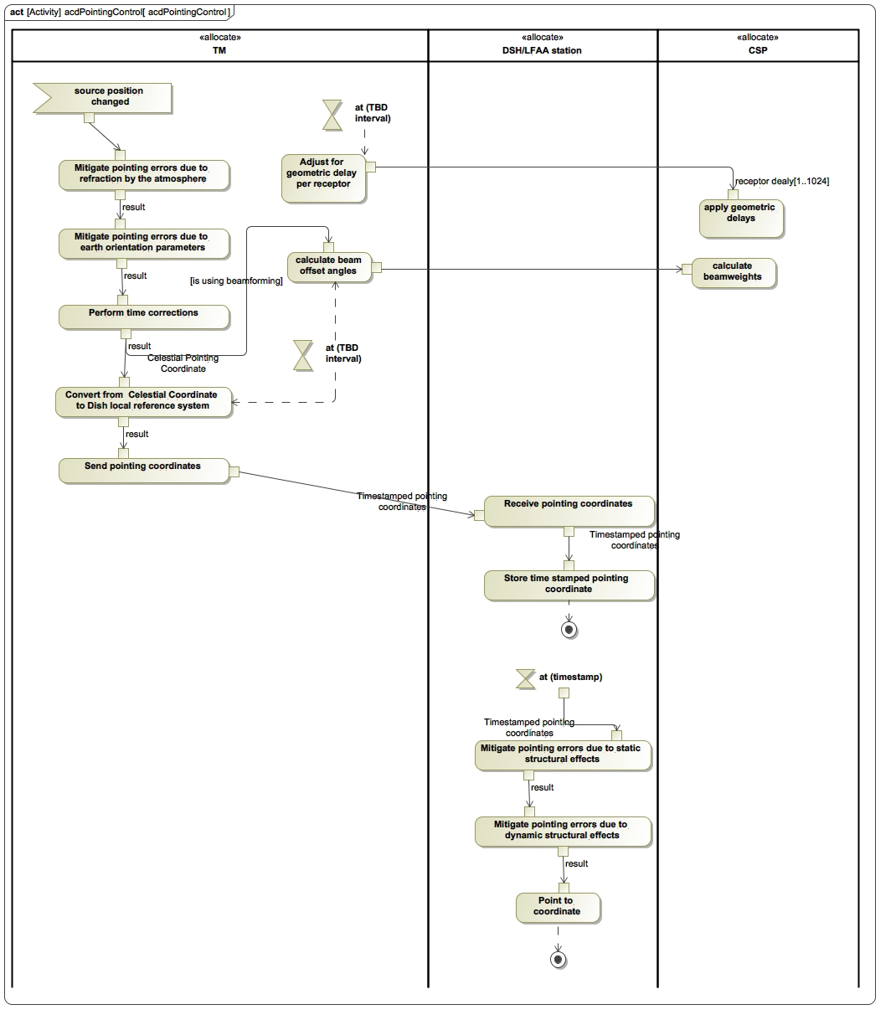

**Figure 4.12. Pointing Control Scenario**

| **#** | **Description** | **Source** | **Allocated System** |
| --- | --- | --- | --- |
| 1 | **TM_REQ_112**  **Pointing corrections - earth orientation parameters**  *Status: draft*  *Software Package: TMC*  The TM shall apply pointing corrections to pointing coordinates to mitigate pointing errors due to earth orientation parameters. | ~~SYS_REQ-2158~~  ~~SYS_REQ-2159~~  ~~SYS_REQ-2160~~  SYS_REQ-2304  SYS_REQ-2328  [RD39] par. 5.6.1  [RD66] | TM Mid  TM Low |
| 2 | **TM_REQ_113**  **Pointing corrections - refraction**  *Status: draft*  *Software Package: TMC*  The TM shall apply pointing corrections to pointing coordinates to mitigate pointing errors due to refraction in the atmosphere. | ~~SYS_REQ-2158~~  ~~SYS_REQ-2159~~  ~~SYS_REQ-2160~~  SYS_REQ-2304  SYS_REQ-2328  [RD39] par. 5.6.1  [RD66] | TM Mid  TM Low |
| 3 | **TM_REQ_117**  **Send pointing commands - LFAA**  *Status: draft*  *Software Package: TMC*  The SKA1_LOW TM shall send time stamped desired Station Beam pointing coordinates to the LFAA in accordance with [RD7] and within a single Scheduling Block observing. | ~~SYS_REQ-2779~~  SYS_REQ-2305  SYS_REQ-2853  SYS_REQ-3040  SYS_REQ-3041  SYS_REQ-3407  SYS_REQ-3476 | TM Low |
| 4 | **TM_REQ_169**  **Coordinate system conversion (Low)**  *Status: draft*  *Software Package: TMC*  The SKA1_Low TM shall, for each LFAA Station, convert astronomical source positions from ICRS coordinates to pointing coordinates in the beam reference frame (refer to [RD7]). | SYS_REQ-2303  SYS_REQ-2305  SYS_REQ-3039 | TM Low |
| 5 | **TM_REQ_283**  **Coordinate conversion resolution accuracy**  *Status: Accepted*  *Software Package: TMC*  TM shall convert pointing angles from celestial coordinates to a referenced system required for the Dish or LFAA with a resolution of TBD117. The accuracy of the information shall not be reduced due to inherent computational limitations (e.g. the size of variables in terms of number of digits) by TM; the correctness of information will therefore only be determined by the characteristics of the input variables. | [RD39] par. 5.6.1 | TM Mid  TM Low |
| 6 | **TM_REQ_426**  **Pointing corrections - Gravitational effects**  *Status: Proposed*  *Software Package: TMC*  The TM shall apply pointing corrections to pointing coordinates to mitigate pointing errors due to gravitational effects.    Note: A gravitational model will be used to determine geoid height and the difference between geodetic zenith direction and local astronomical zenith direction. | SYS_REQ-2304  SYS_REQ-2305 | TM Mid  TM Low |

**Table 4.15. Diagram reqTable_Pointing Control**

**4.1.2.2.5.3. Frequency Control**

| **#** | **Description** | **Source** | **Allocated System** |
| --- | --- | --- | --- |
| 1 | **TM_REQ_300**  **Observing frequency change speed**  *Status: draft*  *Software Package: TMC*  TM shall implement a change in frequency band, from when the instruction is read, till when the resulting commands are output from TM, to within 1 second. | SKA1-SYS_REQ-2224 | TM Mid  TM Low |

**Table 4.16. Diagram reqTable_Frequency Control**

**4.1.2.2.5.4. Pulsar Timing Control**

| **#** | **Description** | **Source** | **Allocated System** |
| --- | --- | --- | --- |
| 1 | **TM_REQ_357**  **Next pulsar timing control**  *Status: Accepted*  *Software Package: TMC*  When the TM receives a stop timing recommendation from the CSP (via the I.S1M.CSP_TM.001, I.S1L.CSP_TM.001 interface), it will send control commands to CSP (via the I.S1M.CSP_TM.001, I.S1L.CSP_TM.001 interface) and SDP (via the I.S1M.SDP_TM.001, I.S1L.SDP_TM.001 interface) to proceed with pulsar timing for the next pulsar.    Note: The CSP will generate a stop timing recommendation while pulsar timing is being performed on a specific pulsar.    Note: This requirement provides sequential control to perform pulsar timing on a list of pulsars. | [RD39] par. 5.3.3  [RD59] par. 4.5.3.3 | TM Mid  TM Low |

**Table 4.17. Diagram reqTable_Pulsar Timing Control**

**4.1.2.2.5.5. Quality Assurance Support**

| **#** | **Description** | **Source** | **Allocated System** |
| --- | --- | --- | --- |
| 1 | **TM_REQ_364**  **Set QA Thresholds**  *Status: draft*  *Software Package: TMC*  The TM shall configure the SDP with Quality Assurance thresholds via its I.S1M.SDP_TM.001 interface, as per [RD44], and I.S1L.SDP_TM.001 interface, as per [RD5]. | ~~SYS_REQ-2347~~  SYS_REQ-2742  SYS_REQ-2749 | TM Mid  TM Low |
| 2 | **TM_REQ_365**  **QA Alerts**  *Status: draft*  *Software Package: TMC*  The TM shall alert the operator when it receives Quality Assurance Alarms from SDP via its I.S1M.SDP_TM.001 interface, as per [RD44], and I.S1L.SDP_TM.001 interface, as per [RD5]. | ~~SYS_REQ-2347~~  ~~SYS_REQ-2742~~  ~~SYS_REQ-2749~~ | TM Mid  TM Low |
| 3 | **TM_REQ_284**  **Display QA Metrics**  *Status: draft*  *Software Package: TMC*  The TM shall display to the Operator Quality Assurance metrics received from the SDP via the I.S1M.SDP_TM.004, I.S1L.SDP_TM.004 interface.    Note: The TM will pass on to the SDP control information to allow the operator to control the display. | Analysis  ~~SYS_REQ_2347~~  ~~SYS_REQ_2742~~  ~~SYS_REQ_2749~~  SYS_REQ-3059  SYS_REQ-3060  SYS_REQ-3061  SYS_REQ-3062  SYS_REQ-3063 | TM Mid  TM Low |
| 4 | **TM_REQ_389**  **QA Annotations**  *Status: Proposed*  *Software Package: TMC*  TM shall capture quality assurance related annotations in the form of text from the Operator, and send it to the SDP via its I.S1M.SDP_TM.001 interface, as per [RD44], and I.S1L.SDP_TM.001 interface, as per [RD5]. | SYS_REQ-2357 | TM Low  TM Mid |
| 5 | **TM_REQ_424**  **Store QA Metrics and Alerts**  *Status: Proposed*  *Software Package: TMC*  The TM shall store Quality Assurance metrics and alerts received from the SDP via the I.S1M.SDP_TM.004, I.S1L.SDP_TM.004 interface. | SYS_REQ-3054  SYS_REQ-3055  SYS_REQ-3056  SYS_REQ-3057  SYS_REQ-3058 | TM Mid  TM Low |

**Table 4.18. Diagram reqTable_Quality Assurance Support**

**4.1.2.2.6. Assist Understanding and Interpretation of Telescope Behaviour**

| **#** | **Description** | **Source** | **Allocated System** |
| --- | --- | --- | --- |
| 1 | **TM_REQ_40**  **Determine and Report current state of activity**  *Status: draft*  *Software Package: TMC*  The TM shall allow the operator to determine by inspection:  1. the configuration and mode of any Sub-array, with a synoptic view of all of them TBC19,  2. which Project(s) and Scheduling Block(s) are being executed by Sub-arrays TBC19. | SYS_REQ-2306  SYS_REQ-3182 | TM Mid  TM Low |
| 2 | **TM_REQ_41**  **Determine and Report timing characteristic of current activity**  *Status: Accepted*  *Software Package: TMC*  The TM shall report the duration in time that the telescope or a Sub-array has been in its current state. | SYS_REQ-2306 | TM Mid  TM Low |
| 3 | **TM_REQ_42**  **User interface for reporting Telescope behaviour- mobile device platform**  *Status: Accepted*  *Software Package: TMC*  It shall be possible to provide the telescope behaviour information on at least the following mobile device platforms: TBD89 | SYS_REQ-2307 | TM Mid  TM Low |
| 4 | **TM_REQ_323**  **User interface for reporting Telescope behaviour - interface network**  *Status: Accepted*  *Software Package: TMC*  It shall be possible to report Telescope behaviour using an HTTP client over an HTTP Secure network (TBC18). | SYS_REQ-2307 | TM Mid  TM Low |
| 5 | **TM_REQ_324**  **User interface for reporting Telescope behaviour - web browser platform**  *Status: Accepted*  *Software Package: TMC*  The web client for accessing the reporting of Telescope behaviour shall be at least HTML 5 compliant. | SYS_REQ-2307 | TM Mid  TM Low |
| 6 | **TM_REQ_336**  **Display Telescope health state**  *Status: draft*  *Software Package: TMC*  The TM shall display the health status of the Telescope to the User by presenting Monitoring Data in the following views:  1. a functional view,  2. a physical view.    Note 1: The physical view will be structured according to the Telescope PBS, and is used for controlling and monitoring the subsystems and components of the Telescope.  The physical view contains the unique instances of items that are of the same part number, and includes the physical location (slot), part number and serial number (if applicable) of each item.    Note 2: The functional view, consisting of a functional structure of the Telescope, is used to control and monitor the Capabilities (which relate directly to the functionality) of the Telescope Elements.    Note 3: The TM will derive the Telescope health status from the status of the Observation Resource Units (as reported by other Elements to TM) that are allocated to a Sub-array.    Note 4: The physical and functional views will accentuate aggregations of concern, e.g. aggregations of equipment in the CPF, core, spiral arm or region and LFAA Field Nodes to indicate group dependencies on signal or power distribution services.    State of LFAA Stations (and therefore the Sub-arrays they belong to) are dependent on the state of LFAA Field Nodes they are made up of. | SKA1-SYS_REQ-2280  SKA1-SYS_REQ-3182  [RD39] par. 5.12.1.5 | TM Mid  TM Low |
| 7 | **TM_REQ_344**  **Display infrastructure status**  *Status: Accepted*  *Software Package: TMC*  The TM, when requested by the User, shall display the following information about INFRA:   1. operational and health status, 2. operational modes. 3. Note: The focus of the information is on services that INFRA supplies to the Telescope (power, cooling). | SYS_REQ-2280 | TM Mid  TM Low |

**Table 4.19. Diagram reqTable_Assist Understanding and Interpretation of Telescope Behaviour**

**4.1.2.2.7. Protect Assets**

**4.1.2.2.7.1. Telescope Shutdown**

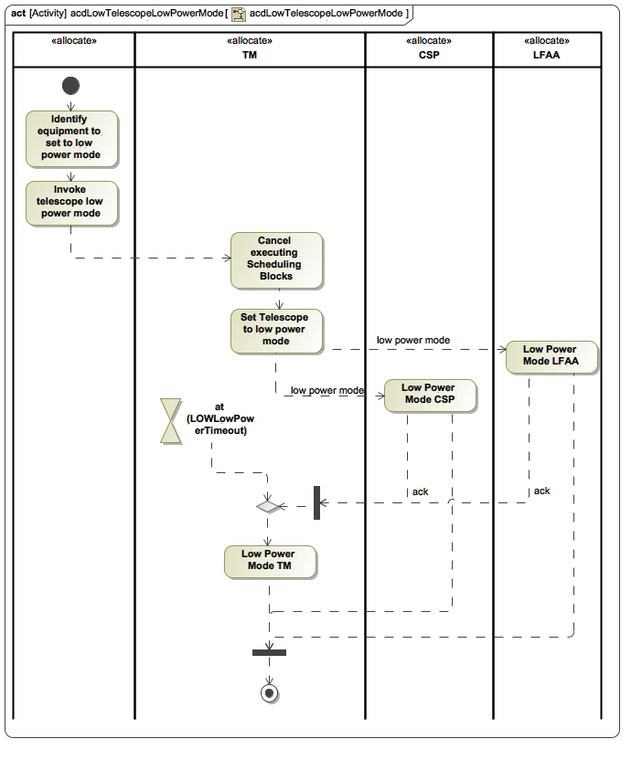

**Figure 4.13. Shutdown SKA1-Low Telescope Scenario**

| **#** | **Description** | **Source** | **Allocated System** |
| --- | --- | --- | --- |
| 1 | **TM_REQ_220**  **Telescope Low Power Mode - Manual**  *Status: draft*  *Software Package: TM*  The TM, when requested by the Operator with a single request, shall perform the following actions:  1. Cancel executing Scheduling Blocks.  2. Command all Dishes to stow (for SKA1 TM Mid only).  3. Command Elements to low power mode.  4. Go to the *Standby* state.    Rationale:  The TM will orchestrate bringing the Telescope in the low power mode: a sequenced, orderly termination of relevant processes and changing power demand state of equipment that are affected by the power/cooling loss event.  The idea is to ensure that data taken during the current observation is not compromised, equipment that are sensitive to hard power down are given due instruction to manage own power down, and to leave equipment in a state that poses least hazard for people or themselves (e.g. stowing of Dishes).  Excluded from Telescope low power coordination from TM are INFRA-SA and INFRA-AUS computing sub-systems, SADT networking equipment and SDP. | SYS_REQ-3088  SYS_REQ-3238  [RD30] par. 7.3 | TM Mid  TM Low |
| 2 | **TM_REQ_221**  **Automatic Telescope Low Power Mode Conditions**  *Status: draft*  *Software Package: TMC*  The TM shall perform the Coordinate Telescope Low Power Mode function when it receives one of the following indications via its via its I.S1M.TM_INFRA-SA.002, I.S1L.TM_INFRA-AUS.002 interface:  1. cooling system failure indication (refer [RD10] par. 5.2.3 and [RD11] par. 5.1.2.3 and 5.2.2.3),  2. power status identifies an impending power failure (refer [RD10] par. 5.2.3 and [RD11] par. 5.1.2.3 and 5.2.2.3). | SYS_REQ-3088  SYS_REQ-3238  [RD30] | TM Mid  TM Low |
| 3 | **TM_REQ_222**  **Automatic Telescope Low Power Mode Function**  *Status: draft*  *Software Package: TMC*  The TM, when performing the Automatic Telescope Low Power Mode function, shall perform the following actions:  1. Cancel executing Scheduling Blocks.  2. Command all Dishes to stow (for TM Mid only).  3. Command CSP, SKA1-Mid Dishes (for TM MID only), MeerKAT Dishes (for TM MID only), LFAA (for TM LOW only) to low power mode.  4. Set TM equipment in CPF to low power mode.    Rationale:  The TM will orchestrate bringing the Telescope to the low power mode: a sequenced, orderly termination of relevant processes and changing the power demand state of equipment that are affected by the power/cooling loss event.  The idea is to ensure that data taken during the current observation is not compromised, equipment that are sensitive to hard power down are given due instruction to manage own power down, and to leave equipment in a state that poses least hazard for people or themselves (e.g. stowing of Dishes).  Excluded from Telescope low power mode coordination from TM are INFRA-SA and INFRA-AUS computing sub-systems, and SADT networking equipment, and SDP equipment because it is not deployed at the array site. | SYS_REQ-3088  SYS_REQ-3238  [RD30] | TM Mid  TM Low |
| 4 | **TM_REQ_223**  **Report Telescope Low Power Mode Events**  *Status: draft*  *Software Package: TMC*  The TM, when performing manual and automatic Telescope Low Power Mode coordination, shall report to the Operator the following Events:  1. Telescope Low Power Mode trigger event,  2. Telescope Low Power Mode coordination alarm event if a step in the process fails.    Rationale: Telescope Low Power Mode events are reported to explain the state of the Telescope. | SKA1-SYS_REQ-3182  [RD30] | TM Mid  TM Low |
| 5 | **TM_REQ_232**  **Persist Telescope Low Power Mode Events**  *Status: draft*  *Software Package: TMC*  The TM, when performing manual and automatic Telescope Low Power Mode coordination, shall persist the following Events:  1. Telescope Low Power Mode trigger event,  2. Telescope Low Power Mode alarm event if a step in the process fails.    Note by persistence is meant the storage of information for retrieval at a later stage when the system may be in a state where the information stored is not necessarily relevant to the current operation. I.e. it is stored for use other than what the current operation requires and may be used at a post hoc stage.  Rationale: Shutdown events are recorded to help explain the exact cause of shutdown after the fact and to find the cause of failure to transition to Telescope Low Power Mode automatically. | SYS_REQ-2306  SYS_REQ-3182 | TM Mid  TM Low |

**Table 4.20. Diagram reqTable_Telescope Shutdown**

**4.1.2.3. Monitor and Control Telescope Manager LOW**

**4.1.2.3.1. Detect internal failures**

| **#** | **Description** | **Source** | **Allocated System** |
| --- | --- | --- | --- |
| 1 | **TM_REQ_1**  **Detect internal failures - accuracy**  *Status: draft*  *Software Package: Services*  The TM, when performing the Detect Internal Failures function, shall achieve at least the following probabilities:   1. 99% for detection of Critical Failures (as defined by [RD51], 2. 95% for isolating and logging of all failures. | ~~SYS_REQ-2543~~  ~~SYS_REQ-2544~~  ~~SYS_REQ-2545~~  SYS_REQ-3249 | TM Mid  TM Low |
| 2 | **TM_REQ_2**  **Detect internal failures - latency**  *Status: draft*  *Software Package: Services*  The TM shall perform the Detect Internal Failures function within a time range between 10 seconds and 60 minutes from the occurrence of a failure condition.  The different time interval depends on the particular failure condition.    Note: The time range is considered best practice (refer to [RD67]). | Best practice | TM Mid  TM Low |
| 3 | **TM_REQ_434**  **Detect internal failures - scope**  *Status: Proposed*  *Software Package: Services*  The TM shall perform the Detect Internal Failures function by detecting and reporting the failure to perform a required function on any of its subsystems and lower level components down to the level of LRU. | SYS_REQ-3249 | TM Mid  TM Low |

**Table 4.21. Diagram reqTable_Detect internal failures**

**4.1.2.3.2. Handle TM Alarms**

| **#** | **Description** | **Source** | **Allocated System** |
| --- | --- | --- | --- |
| 1 | **TM_REQ_5**  **Handle Alarms from internal information - latency**  *Status: draft*  *Software Package: TMC*  The time between assessing TM-generated information against an Alarm rule, and reporting an Alarm shall be less than 1 second.    Note: For a failure this means detection after the failure effect has occurred not necessarily the cause - for example a latent defect may only be detected once it is used. | SYS_REQ-2312  [RD56] | TM Mid  TM Low |

**Table 4.22. Diagram reqTable_Handle Alarms**

**4.1.2.3.3. Monitor internal Performance Measures**

| **#** | **Description** | **Source** | **Allocated System** |
| --- | --- | --- | --- |
| 1 | **TM_REQ_7**  **Monitor own performance**  *Status: draft*  *Software Package: Services*  The TM shall detect and report TBD10 key measures of its own performance. | ~~SYS_REQ-2544~~  ~~SYS_REQ-2546~~  ~~SYS_REQ-2545~~ | TM Mid  TM Low |

**Table 4.23. Diagram reqTable_Monitor internal Performance Measures**

**4.1.2.3.4. Produce internal Logs**

| **#** | **Description** | **Source** | **Allocated System** |
| --- | --- | --- | --- |
| 1 | **TM_REQ_208**  **Access logging data**  *Status: draft*  *Software Package: Services*  The TM shall allow the Maintainer and Operator to access and copy TM Element logging files (where applicable). | [RD60] par. 5.7  SYS_REQ-3183 | TM Mid  TM Low |
| 2 | **TM_REQ_209**  **Report log messages**  *Status: draft*  *Software Package: Services*  The TM shall report log messages to the Maintainer and Operator on request via the TM Logging Service. | [RD60] par. 5.7  SYS_REQ-3183 | TM Mid  TM Low |
| 3 | **TM_REQ_210**  **Control logging**  *Status: draft*  *Software Package: Services*  The TM shall allow the Maintainer and Operator to control logging, including:  a) destination for logging messages,  b) logging level. | [RD60] par. 5.7  SKA1-SYS_REQ-3183 | TM Mid  TM Low |
| 4 | **TM_REQ_368**  **Maintain Log Data**  *Status: Proposed*  *Software Package: Services*  All data stored for the logging purposes shall be maintained for 2 years TBC43, after which TM will be allowed to decimate the data.    Rationale:  Two year period is selected to be consistent with TM Observatory requirement to store logs for two years. | [RD60] par. 5.7  Best Practice  SYS_REQ-3183 | TM Mid  TM Low |
| 5 | **TM_REQ_369**  **TM Logging Service - Log forwarding**  *Status: Proposed*  *Software Package: Services*  The TM shall provide a logging forwarding service to all TM applications and SKA elements.    Note: Applications will send log data to a TM log data centre. | [RD60] par. 5.7  SYS_REQ-3183 | TM Mid  TM Low |
| 6 | **TM_REQ_370**  **TM Logging Service - Log querying**  *Status: Proposed*  *Software Package: Services*  The TM shall, when a Historic Data Requester directly query’s it’s log data centre, send the following to the user (depending on the query):  a) an entire log file or  b) a collection of log files or  c) a specific query result. | [RD60] par. 5.7  SYS_REQ-3183  SYS_REQ-3183 | TM Mid  TM Low |

**Table 4.24. Diagram reqTable_Produce internal Logs**

**4.1.2.3.5. Monitor internal status**

| **#** | **Description** | **Source** | **Allocated System** |
| --- | --- | --- | --- |
| 1 | **TM_REQ_211**  **Aggregate and report internal status**  *Status: draft*  *Software Package: Services*  The TM shall aggregate its internal status and report the aggregated status as well as that of it’s LRUs to the User in a structured health view.    Note 1: The structure will be based on the TM PBS, down to LRU level (LRUs will be identified in the TM Maintenance Plan).    Note 2: EInternal status information will include healthState (refer [RD60] par. 5.8). | SYS_REQ-2306 | TM Mid  TM Low |
| 2 | **TM_REQ_342**  **Report TM States**  *Status: draft*  *Software Package: Services*  The TM shall report its current state to the Operator as:  1.  TM state (as defined by TM_REQ_192, TM_REQ_193, TM_REQ_195 and TM_REQ_385,  2.  TM TANGO device state as defined in [RD60] par. 5.8.    Note: The TM will derive its current state from its lower level product states and modes. | SYS_REQ-2280 | TM Mid  TM Low |

**Table 4.25. Diagram reqTable_Monitor internal status**

**4.1.2.3.6. Report Version information**

| **#** | **Description** | **Source** | **Allocated System** |
| --- | --- | --- | --- |
| 1 | **TM_REQ_212**  **Report TM software versions**  *Status: draft*  *Software Package: TM*  The TM shall, when requested by the Maintainer, report its internal software versions down to the level of software application. | [RD30] par. 8.3.3  SYS_REQ-3247 | TM Mid  TM Low |

**Table 4.26. Diagram reqTable_Report Version information**

**4.1.2.3.7. Report Serial Numbers**

| **#** | **Description** | **Source** | **Allocated System** |
| --- | --- | --- | --- |
| 1 | **TM_REQ_335**  **Report Serial Numbers**  *Status: Accepted*  *Software Package: TM*  The TM shall, when requested by the Maintainer, report its internal serial numbers down to the level of hardware LRU.    Rationale:  Detecting of serial numbers of equipment enables reporting of equipment serial numbers (see TM_REQ_245 and TM_REQ_295).    Note1: Hardware LRUs will be identified in the TM Maintenance Plan.    Note2: Serial numbers are applicable to hardware only, and not to software. | [RD30]  [RD39] par. 5.12.2 | TM Mid  TM Low |

**Table 4.27. Diagram reqTable_Report Version information**

**4.1.2.4. Supply Telescope information to Elements**

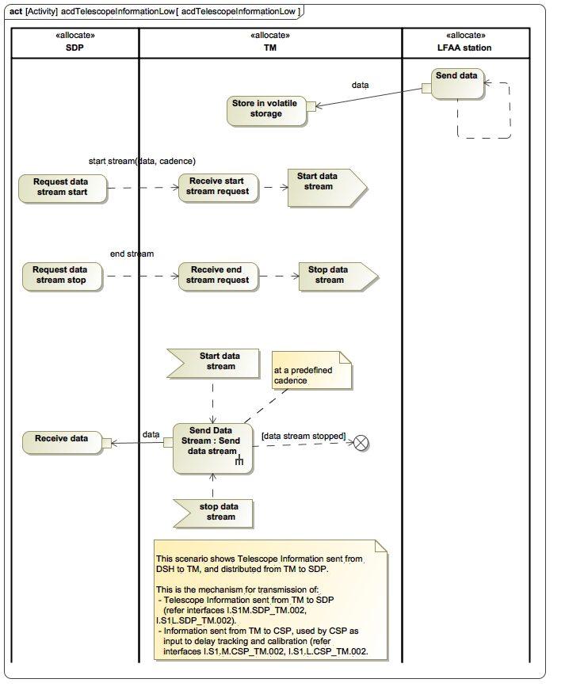

**Figure 4.14. Distribute Telescope Information Scenario**

| **#** | **Description** | **Source** | **Allocated System** |
| --- | --- | --- | --- |
| 1 | **TM_REQ_48**  **Publish Telescope Information**  *Status: draft*  *Software Package: TMC*  The TM shall send Telescope Information, relating to each instantiated Sub-array, to requesting Elements via the following interfaces:  1. I.S1M.SDP_TM.002 (refer to [RD44], par. 5.2),  2. I.S1L.SDP_TM.002 (refer to [RD5], par. 5.2),  3. I.S1M.TM_INFRA-SA.002 (refer to [RD10], par. 4.2),  4. I.S1M.TM_INFRA-SA.004 (refer to [RD10], par. 4.4),  5. I.S1M.CSP_TM.001 (refer to [RD37]),  6. I.S1L.CSP_TM.001 (refer to [RD4]). | SYS_REQ-2634  SYS_REQ-2645  SYS_REQ-3018  SYS_REQ-3019 | TM Mid  TM Low |
| 2 | **TM_REQ_358**  **Publish Telescope Information to SDP - latency**  *Status: Accepted*  *Software Package: TMC*  The TM shall send Telescope Information to the SDP with the following latencies:  1. within TBD118 seconds after TM has received the information, for critical information as defined in [RD5] and [RD44] par. 2.2,  2. within TBD119 seconds after TM has received the information, for non-critical information as defined in [RD5] and [RD44] par. 2.2. | SYS_REQ-2645  SYS_REQ-3018  SYS_REQ-3019 | TM Mid  TM Low |
| 3 | **TM_REQ_359**  **Publish Telescope Information to SDP - frequency**  *Status: Accepted*  *Software Package: TMC*  The TM shall send Telescope Information to the SDP at the following frequencies:  1. up to TBD120 Hz, for critical information as defined in [RD5] and [RD44] par. 2.2,  2. up to TBD121 Hz, for non-critical information as defined in [RD5] and [RD44] par. 2.2. | SYS_REQ-2645  SYS_REQ-3018  SYS_REQ-3019 | TM Mid  TM Low |
| 4 | **TM_REQ_402**  **Publish Telescope Information to CSP - latency**  *Status: Proposed*  *Software Package: TMC*  The TM shall send real-time scan information to the CSP (as defined in [RD4] and [RD37] par. 7.8.9) within TBD118 seconds after TM has received the information. | SYS_REQ-2645  SYS_REQ-3018  SYS_REQ-3019 | TM Mid  TM Low |
| 5 | **TM_REQ_403**  **Publish Telescope Information to CSP - frequency**  *Status: Proposed*  *Software Package: TMC*  The TM shall send real-time scan information to the CSP (as defined in [RD4] and [RD37] par. 7.8.9) at a rate of up to TBD120 Hz, | SYS_REQ-2645  SYS_REQ-3018  SYS_REQ-3019 | TM Mid  TM Low |

**Table 4.28. Diagram reqTable_Supply Telescope information to Elements**

**4.1.3. Support Telescope Operation**

**4.1.3.1. Assist Logistic Support**

**4.1.3.1.1. Assist on-line fault-finding**

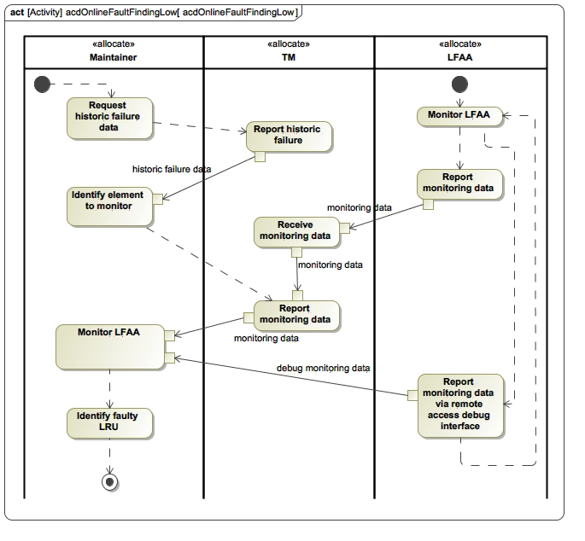

**Figure 4.15. Online Fault-finding Scenario**

| **#** | **Description** | **Source** | **Allocated System** |
| --- | --- | --- | --- |
| 1 | **TM_REQ_43**  **Recording of automatic control commands**  *Status: draft*  *Software Package: TMC*  Where a situation has occurred where the TM system automatically intervened with the standard operations on a Sub-array, the TM shall record the event to include at least the reason behind the action as justification.  Justification: While state and behaviour of the system depends on internal changes within equipment and the environment, it also depends on intentional and unintentional supervisory control exercised over the system by humans and the TM. Understanding of state and behaviour (SKA1-SYS_REQ-2306) therefore depends on knowledge of historic interventions that may be considered as cause for state changes. | SKA1-SYS_REQ-2306  SKA1-SYS_REQ-3182 | TM Mid  TM Low |
| 2 | **TM_REQ_214**  **Display historic events**  *Status: Accepted*  *Software Package: TMC*  The TM, when requested by a Maintainer, shall display historic failure events. | SYS_REQ-2313 | TM Mid  TM Low |
| 3 | **TM_REQ_215**  **Access remote debugging interfaces**  *Status: Accepted*  *Software Package: TMC*  The TM shall allow the Maintainer to access the remote debug interfaces of other Elements.    Rationale: Remote diagnostic capability is required because the Telescope is a distributed system. The TM provides a means for users to navigate to the remote diagnostic interfaces of the Elements. | [RD30] par. 6.3.3  [RD43] par. 7.5 | TM Mid  TM Low |

**Table 4.29. Diagram reqTable_Assist on-line fault-finding**

**4.1.3.2. Assist Performance Measuring**

| **#** | **Description** | **Source** | **Allocated System** |
| --- | --- | --- | --- |
| 1 | **TM_REQ_29**  **Receive Telescope performance measures**  *Status: draft*  *Software Package: TMC*  The TM shall receive TBD33 measures of performance (including at least Tsys per Dish/LFAA Field Node) from the SDP via its I.S1M.SDP_TM.002 interface (as per [RD44]) and I.S1L.SDP_TM.002 interface (as per [RD5]). | ~~SYS_REQ-2546~~ | TM Mid  TM Low |
| 2 | **TM_REQ_30**  **Report Telescope performance measures**  *Status: draft*  *Software Package: TMC*  The TM shall report to the Operator, key Telescope Performance Measures. | ~~SYS_REQ-2546~~ | TM Mid  TM Low |

**Table 4.30. Diagram reqTable_Assist Performance Measuring**

**4.1.3.3. Assist Information Management**

**4.1.3.3.1. Support Upgrades**

| **#** | **Description** | **Source** | **Allocated System** |
| --- | --- | --- | --- |
| 1 | **TM_REQ_230**  **Support software and firmware upgrades**  *Status: draft*  *Software Package: TMC*  The TM shall allow the Maintainer to perform TM software upgrades remotely. | Best Practice  [RD30] par. 6.3.3 & par. 8.  SYS_REQ-3247 | TM Mid  TM Low |
| 2 | **TM_REQ_245**  **Report external item’s software and firmware versions**  *Status: draft*  *Software Package: TMC*  The TM shall, when requested by the Maintainer, report the software and firmware versions and item serial numbers of Elements.    Rationale: Maintainers will periodically perform a physical configuration audit by comparing the version numbers and serial numbers as reported by TM to the version and serial numbers captured in the configuration database. This is done to ensure that only authorised changes have been deployed, and to ensure that the planned (approved) changes have been implemented.    Note: Serial numbers are applicable to hardware only, not to software. | Best Practice  [RD30] par. 6.3.3 & par. 8.  SYS_REQ-3247 | TM Mid  TM Low |
| 3 | **TM_REQ_295**  **Report all software and firmware versions and serial numbers**  *Status: draft*  *Software Package: TMC*  The TM, when requested by the EMS, shall send an electronic report to the EMS, via its I.S1M.TM_ILS.001, I.S1L.TM_ILS.001 interface as per [RD55], with the Telescope software and firmware versions, serial number, physical location (slot) and part number of each item in the product breakdown as reported by LMCs to the TM, in XML TBC41 and CSV TBC41 formats.    Rationale: Maintainers need to compare a report exported from the configuration management tool to a report generated by TM. It is expected that the configuration management tool will have the ability to generate a report of the intended software and firmware versions and serial numbers of the Telescope, structured to the product breakdown structure of the Telescope. The TM report will be in the product breakdown structure as reported to TM by Element LMCs for similarity to the report generated by the configuration management tool. For a configuration audit of the Telescope It is more efficient to request a single report containing the versions of all software and firmware items and serial numbers of items with a single query. It is easier for a human to navigate a structured list than a flat list. XML allows parsing of the content of the report. The Maintainer will compare the actual software and firmware versions as reported by the TM with the intended software and firmware versions as exported by the configuration management tool in order to assess progress of upgrades and to ensure that no unintended upgrades have been performed.    Note 1: Serial numbers are applicable to hardware only, not to software.    Note 2: Software and firmware versions are reported to TM by Elements will include each item with | Best Practice  [RD30] par. 6.3.3 & par. 8.  SYS_REQ-2573  SYS_REQ-2576  SYS_REQ-3247 | TM Mid  TM Low |
| 4 | **TM_REQ_367**  **Support software and firmware upgrades (internal)**  *Status: draft*  *Software Package: Services*  The TM shall allow the Maintainer to perform software and firmware upgrades. | Best Practice  [RD30] par. 6.3.3& par. 8.  SYS_REQ-3247 | TM Mid  TM Low |

**Table 4.31. Diagram reqTable_Support Upgrades**

**4.1.3.3.2. Manage Instrumental Configuration**

| **#** | **Description** | **Source** | **Allocated System** |
| --- | --- | --- | --- |
| 1 | **TM_REQ_49**  **Automatically update version on Instrumental Configuration Data on change**  *Status: Accepted*  *Software Package: TMC*  If any changes are made to the Instrumental Configuration Data, the TM shall update the version of the Instrumental Configuration, which will be associated with the SDP’s data products. | SYS_REQ-2143  SYS_REQ-2645 | TM Mid  TM Low |
| 2 | **TM_REQ_58**  **Allow manual update of Instrumental Configuration Data**  *Status: draft*  *Software Package: TMC*  The TM shall enable the Operator to manually add long-term system calibrations as a version of the Instrumental Configuration Data to the Instrumental Configuration Data repository,including:  1. Geodetic models for SKA1_Mid and SKA1_Low Telescopes,  2. Geometric models for SKA1_Mid and SKA1_Low Telescopes,  3. SDP ingest processing configurations,  4. Pointing model per dish receptor system (including a structural model, thermal model, reference pointing model, refraction model),  5. Model per LFAA receptor system (including aspects of azimuth, zenith angle, frequency, and polarisation),  6. Source catalogues.  7. RFI configuration: RFI flagging thresholds and RFI flagging integration intervals. | SYS_REQ-2645  SYS_REQ-2302  SYS_REQ-2305  ~~SYS_REQ-2671~~  SYS_REQ-2143  ~~SYS_REQ-2817~~  ~~SYS_REQ-2653~~ | TM Mid  TM Low |
| 3 | **TM_REQ_272**  **User select Instrumental Configuration Data version**  *Status: draft*  *Software Package: TMC*  The TM shall enable the Operator and Sub-array Control Authority to select a version of Instrumental Configuration Data from the Instrumental Configuration Data Repository to use with a Sub-array.    Note: It is conceived that Instrumental Configuration Data will change over time. The operator selects a specific version to ensure that when the observed data is analysed, it be known how the Telescope was configured at the time of observation. | SYS_REQ-2143  SYS_REQ-2645 | TM Mid  TM Low |
| 4 | **TM_REQ_273**  **Associate Instrumental Configuration Data version with each Scheduling Block**  *Status: Accepted*  *Software Package: TMC*  The TM shall associate each Scheduling Block with the version of the Instrumental Configuration Data that was valid at the time of executing the SB. | SYS_REQ-2143  SYS_REQ-2645 | TM Mid  TM Low |

**Table 4.32. Diagram reqTable_Manage Instrumental Configuration**

**4.1.3.3.3. Handle Calibration Information**

| **#** | **Description** | **Source** | **Allocated System** |
| --- | --- | --- | --- |
| 1 | **TM_REQ_69**  **Receive Calibration Information**  *Status: draft*  *Software Package: TMC*  The TM shall receive calibration information from:   1. SDP via the I.S1L.SDP_TM.002 interface (as per [RD5]) and I.S1M.SDP_TM.002 interface (as per [RD44]), 2. CSP via the I.S1L.CSP_TM.002 interface (as per [RD4]) and I.S1M.CSP_TM.002 (as per [RD37]). | SYS_REQ-2280  SYS_REQ-2634 | TM Mid  TM Low |
| 2 | **TM_REQ_70**  **Store Calibration Information**  *Status: draft*  *Software Package: TMC*  The TM shall store Calibration Information. | SYS_REQ-2280  SYS_REQ-3043  SYS_REQ-3045 | TM Mid  TM Low |
| 3 | **TM_REQ_71**  **Retrieve Current Calibration Information**  *Status: Accepted*  *Software Package: TMC*  The TM, when requested by TBD46 user, shall display the current Calibration Information. | SYS_REQ-2280 | TM Mid  TM Low |
| 4 | **TM_REQ_72**  **Retrieve Historic Calibration Information**  *Status: Accepted*  *Software Package: TMC*  The TM, when requested by TBD46 user, displays the historical Calibration Information for a specific time in history. | SYS_REQ-2280  SYS_REQ-2313 | TM Mid  TM Low |
| 5 | **TM_REQ_301**  **Handle Aperture Array DDE**  *Status: draft*  *Software Package: TMC*  TM shall persist and retrieve a direction dependent model for the aperture array primary beam to be used in calibration and imaging by the Science Data Processor. The source of this model and the clients for which this model needs to be retrieved are still TBD113. | SKA1-SYS_REQ-2724  SKA1-SYS_REQ-2143  SKA1-SYS_REQ-2817 | TM Low |
| 6 | **TM_REQ_302**  **Handle Faraday Rotation DDE**  *Status: Accepted*  *Software Package: TMC*  TM shall persist the direction dependent rotation measure of the ionosphere, and send it to CSP.    The TM will use TEC as input to determine the rotation measure.  The CSP will use the rotation measure to perform Faraday de-rotation. | SKA1-SYS_REQ-2725 | TM Mid  TM Low |
| 7 | **TM_REQ_320**  **Glass Box Calibration**  *Status: draft*  *Software Package: TMC*  TM, when requested by the User, shall identify the calibration correction algorithms and parameters that were applied at the time specified in the User request, up to a time resolution of the data cadence. | SKA1-SYS_REQ-3033  SKA1-SYS_REQ-3034 | TM Mid  TM Low |

**Table 4.33. Diagram reqTable_Handle Calibration Information**

**4.1.3.3.4. Manage pulsar Information**

| **#** | **Description** | **Source** | **Allocated System** |
| --- | --- | --- | --- |
| 1 | **TM_REQ_334**  **Manage Pulsar ephemerides**  *Status: Accepted*  *Software Package: TMC*  TM shall be able to persist and update pulsar ephemerides and timing configurations with updates received from the SDP via its a)      I.S1L.SDP_TM.002 (as per [RD5]),      I.S1M.SDP_TM.002 (as per [RD44]) interface. | [RD39] par. 5.3.2 | TM Mid  TM Low |

**Table 4.34. Diagram reqTable_Manage Pulsar information**

**4.1.3.3.5. Manage historical Telescope information**

| **#** | **Description** | **Source** | **Allocated System** |
| --- | --- | --- | --- |
| 1 | **TM_REQ_6**  **Persist data for later retrieval - timestamp**  *Status: draft*  *Software Package: TMC*  The TM, when persisting events for later retrieval, shall persist a timestamp with the event, accurate to 1 millisecond and with 1 millisecond resolution.    Rationale:  1 millisecond accuracy is achievable with NTP, and 1 millisecond resolution timestamp is supported by TANGO. | SYS_REQ-2306 | TM Mid  TM Low |
| 2 | **TM_REQ_44**  **Persist data for later retrieval**  *Status: draft*  *Software Package: TMC*  The TM shall persist all the current information available necessary for understanding and interpreting the past behaviour of the Telescope together with the recorded time at which an attribute of information have changed.  The types of persisted information shall include at least:    a)      monitoring data received from Telescope Elements (including TM itself),  b)      observation scheduling and execution related logs produced by TM and personnel (observing log),  b)      User actions that:           1.   change the Admin Mode an Element, Sub-element or LRU,            2.   change the state of and Alarm,            3. reasons for shelving of Alarms,            4.   alarm annunciations,            5.  exercise control over the Telescope,            6.  change the Schedule,            7.   change the state of a Scheduling Block. | SYS_REQ-2308  SYS_REQ-2313  SYS_REQ-3176  SYS_REQ-3182 | TM Mid  TM Low |
| 3 | **TM_REQ_45**  **Filter and retrieve Telescope Information**  *Status: draft*  *Software Package: TMC*  The TM shall enable an authorised historic data requester to query and retrieve a filtered set of historic Telescope Information as Comma Separated Values (based on a maximum number of TBD36 records) stored previously within 1 minute (TBC23) | SYS_REQ-2308  SYS_REQ-2313  SYS_REQ-2739  SYS_REQ-3183 | TM Mid  TM Low |
| 4 | **TM_REQ_50**  **Telescope information repository**  *Status: draft*  *Software Package: TMC*  The TM shall store all necessary Telescope Information received to enable a historic data requester to access and view historical information. | SYS_REQ-2313  SYS_REQ-3183 | TM Mid  TM Low |

**Table 4.35. Diagram reqTable_Manage historical Telescope information**

**4.1.3.3.6. Manage External Information**

| **#** | **Description** | **Source** | **Allocated System** |
| --- | --- | --- | --- |
| 1 | **TM_REQ_51**  **TEC repository**  *Status: draft*  *Software Package: TMC*  The TM shall store the TEC for dual frequency GPS for a past period of 50 years to an accuracy of 3 TECU.    Note 1:  50 years is the expected life of the SKA (refer to [RD31] par. 3.2.  Note 2:  1 TECU = 1016 electrons / m2 | SYS_REQ-2314  ~~SYS_REQ-2282~~  [RD31] par. 3.2 | TM Mid  TM Low |
| 2 | **TM_REQ_52**  **Ionospheric conditions repository**  *Status: draft*  *Software Package: TMC*  The TM shall collect and make available to other Elements information regarding unusual ionospheric conditions for a past period of TBD39, resolution of TBD39 and accuracy of TBD39. | SYS_REQ-2315  ~~SYS_REQ-2282~~ | TM Mid  TM Low |
| 3 | **TM_REQ_53**  **Site Weather Data repository**  *Status: draft*  *Software Package: TMC*  The TM shall store, and make available to the Historic Data Requester, historical site weather information (wind, temperature and humidity).  Note: Site weather data is stored for the entire operational life of the Telescope.  Rationale: It can be expected that a historic data requester wants access to one year’s environmental data to see trends, comparing the performance of equipment that are influenced by the weather conditions (e.g. temperature) with the weather data. | SYS_REQ-2313  SYS_REQ-2316  ~~SYS_REQ-2282~~ | TM Mid  TM Low |
| 4 | **TM_REQ_54**  **Satellite data repository**  *Status: draft*  *Software Package: TMC*  The TM shall store, and make available to the historic data requester, the following Satellite Information for a past period of 50 years:  a) satellite trajectories,  b) satellite orbit information,  c) satellite RF emission characteristics.    Note 1: 50 years is the expected life of the SKA (referr to [RD31] par. 3.2. | SYS_REQ-2313  SYS_REQ-2317  ~~SYS_REQ-2282~~  SYS_REQ-3237 | TM Mid  TM Low |
| 5 | **TM_REQ_55**  **Commercial flight data repository**  *Status: draft*  *Software Package: TMC*  The TM shall make available information regarding commercial flights in the relevant area for a past period of TBD42 to the historic data requester. | SYS_REQ-2313  SYS_REQ-2318  ~~SYS_REQ-2282~~ | TM Mid  TM Low |
| 6 | **TM_REQ_56**  **RFI data repository**  *Status: draft*  *Software Package: TMC*  The TM shall collect and make available to other Elements information regarding RFI sources in the relevant area for a past period of TBD43. | SYS_REQ-2313  SYS_REQ-2319  ~~SYS_REQ-2282~~  SYS_REQ-2734  SYS_REQ-2472  ~~SYS_REQ-2653~~ | TM Mid  TM Low |
| 7 | **TM_REQ_332**  **Allow Manual Update of Satellite Information**  *Status: Accepted*  *Software Package: TMC*  The TM shall allow an authorised catalog maintainer to add the RF emission characteristics of a satellite to the Satellite data repository. | SYS_REQ-2317 | TM Mid  TM Low |
| 8 | **TM_REQ_343**  **Display site weather data**  *Status: Accepted*  *Software Package: TMC*  The TM, when requested by the User, shall display the following current site weather data:   1. wind speed and direction, 2. temperature, 3. humidity. | Best Practice | TM Mid  TM Low |
| 9 | **TM_REQ_377**  **Display weather forecasts**  *Status: Proposed*  *Software Package: TMC*  TM, when requested by the User, shall display weather forecasts. | SYS_REQ-2316 | TM Mid  TM Low |
| 10 | **TM_REQ_378**  **Display weather alerts**  *Status: Proposed*  *Software Package: TMC*  TM shall display weather alerts. | SYS_REQ-2316 | TM Mid  TM Low |

**Table 4.36. Diagram reqTable_Manage External Information**

**4.1.3.4. Evaluate Telescope effectiveness**

| **#** | **Description** | **Source** | **Allocated System** |
| --- | --- | --- | --- |
| 1 | **TM_REQ_32**  **Assist Evaluation of Telescope effectiveness - Utilisation Factor**  *Status: Accepted*  *Software Package: TMC*  The TM shall be able to determine and present to an operator the current and historic (with time range selectable, but up to 5 months TBC14 in the past) utilisation factor of the Telescope in terms of the ratio between the Schedulable Resource’s currently performing observational experiments (i.e. its core mission) and the Schedulable Resource’s available to perform observational experiments. TBC14 The utilisation factor shall also be based on the specific observation being performed. | SYS_REQ-2306 | TM Mid  TM Low |
| 2 | **TM_REQ_33**  **Assist Evaluation of Telescope effectiveness - Availability Factor**  *Status: Accepted*  *Software Package: TMC*  The TM shall determine and present to an operator the current and historic (time range selectable, but up to 6 months TBC15 in the past) availability factor of the Telescope in terms of the ratio between the Schedulable Resource’s currently available to perform observational experiments (i.e. its core mission) and the total number of Schedulable Resource’s commissioned (i.e. accepted for operational use) and therefore including those that are faulty, in maintenance or not ready. | SYS_REQ-2306 | TM Mid  TM Low |
| 3 | **TM_REQ_34**  **Assist Evaluation of Telescope effectiveness - Current Power Consumption**  *Status: Accepted*  *Software Package: TMC*  The TM shall determine and present to an operator the current power consumption (within a resolution of 5 minutes TBC16) of the telescope.  Note: The TM will obtain power consumption from the INFRA-AUS operational status (refer [RD11] par. 5.2.2.3) and INFRA-SA operational status (refer [RD10] par. 5.2.3). | SYS_REQ-2306 | TM Mid  TM Low |
| 4 | **TM_REQ_36**  **User interface to assist evaluation of Telescope effectiveness - interface network**  *Status: Accepted*  *Software Package: TMC*  It shall be possible to provide the operational effectiveness information (TM_REQ_31) using an HTTP client over an HTTP Secure network (TBC18). | SYS_REQ-2307 | TM Mid  TM Low |
| 5 | **TM_REQ_37**  **User interface to assist evaluation of Telescope effectiveness - web browser platform**  *Status: Accepted*  *Software Package: TMC*  The web client for accessing the Measures of Telescope Effectiveness shall be at least based on HTTP 1.1 with at least HTML 5 content. | SYS_REQ-2307 | TM Mid  TM Low |
| 6 | **TM_REQ_38**  **User interface to assist evaluation of Telescope effectiveness - mobile device platform**  *Status: Accepted*  *Software Package: TMC*  The web client for accessing the Measures of Telescope Effectiveness shall run on at least the following mobile device platforms: TBD89 | SYS_REQ-2307 | TM Mid  TM Low |

**Table 4.37. Diagram reqTable_Evaluate Telescope effectiveness**

**4.1.3.5. Assist RFI Management**

| **#** | **Description** | **Source** | **Allocated System** |
| --- | --- | --- | --- |
| 1 | **TM_REQ_304**  **Identify RFI threat**  *Status: draft*  *Software Package: TMC*  TM shall identify possible sources of RFI interferences by monitoring satellite information (as obtained via S1L.TM_SIS, S1M.TM_SIS interfaces) and commercial flight information (as obtained via S1L.TM_FIS, S1M.TM_FIS interfaces). The basis of such a deduction shall be made by means of the presence or non-presence of a known satellite or commercial flight. | SYS_REQ-2730  ~~SYS_REQ-2653~~ | TM Mid  TM Low |
| 2 | **TM_REQ_305**  **Present RFI threat**  *Status: draft*  *Software Package: TMC*  TM shall notify and present to the Telescope Operator information regarding the possibility of RFI threats, which have been obtained by either (1) its own detection mechanism; or (2) an external RFI measurement system provided by INFRA. This information shall include at least the following context related data:  1.  Currently running sub Arrays affected,  2.  Currently running Scheduling Blocks Affected,  3.  Type of RFI Source Flight/Satellite,  4.  Frequency band of the RFI threat. | SYS_REQ-2730  ~~SYS_REQ-2653~~ | TM Mid  TM Low |
| 3 | **TM_REQ_306**  **Manually Generate RFI Flags**  *Status: draft*  *Software Package: TMC*  TM shall be able to allow an operator to manually generate RFI flag(s) to be used by the CSP and SDP during the execution of a SB based on information presented to him. The parameters of this data item are TBD116. | SYS_REQ-2730  ~~SYS_REQ-2653~~ | TM Mid  TM Low |
| 4 | **TM_REQ_355**  **Send RFI flagging configuration**  *Status: draft*  *Software Package: TMC*  The TM shall configure the CSP with RFI flagging thresholds and integration intervals via the I.S1M.CSP_TM.001, I.S1L.CSP_TM.001 interface.    Note: The CSP will use RFI flagging thresholds and integration intervals to do RFI detection and mitigation. | SYS_REQ-2472  ~~SYS_REQ-2653~~  [RD39] par. 5.6.8 | TM Mid  TM Low |
| 5 | **TM_REQ_430**  **Display RFI Monitoring System Data - LOW**  *Status: Proposed*  *Software Package: TMC*  TM LOW, when it receives RFI measurements from the INAU RFI Monitoring System via it’s I.S1M.TM_INAU.005 interface, shall display the RFI measurements to the User. | SYS_REQ-2730 | TM Low |
| 6 | **TM_REQ_431**  **Request data from RFI Monitoring System - LOW**  *Status: Proposed*  *Software Package: TMC*  TM LOW, when requested by a User, shall request RFI measurements in a frequency band from the INAU RFI Monitoring System via it’s I.S1M.TM_INAU.005 interface, with the frequency band defined by the User request. | SYS_REQ-2730 | TM Low |
| 7 | **TM_REQ_432**  **Store data from RFI Monitoring System - LOW**  *Status: Proposed*  *Software Package: TMC*  TM LOW, when it receives RFI measurements from the INAU RFI Monitoring System via it’s I.S1M.TM_INAU.005 interface, shall store the RFI measurements. | SYS_REQ-2730 | TM Low |

**Table 4.38. Diagram reqTable_Assist RFI Management**

**4.1.3.6. Assist Frequency offset configuration**

| **#** | **Description** | **Source** | **Allocated System** |
| --- | --- | --- | --- |
| 1 | **TM_REQ_354**  **Control frequency offsets**  *Status: draft*  *Software Package: TMC*  TM MID shall send sampler frequency clock offsets per Dish (SKA1-MID Dish and MeerKAT Dish), per frequency band to:   1. SADT SAT MID via its I.S1M.TM_SADT.002 interface, 2. CSP MID via its I.S1M.CSP_TM.001 interface, 3. each SKA1-MID Dish via its I.S1M.TM_DSH.001 interface. 4. each MeerKAT Dish via its I.S1M.AIV_TM.001 interface. | [RD39] par. 5.8.2 | TM Mid |
| 2 | **TM_REQ_356**  **Capture sampler clock offset configuration**  *Status: draft*  *Software Package: TMC*  The TM MID shall store the sampler frequency clock offset per Dish (SKA1-MID Dish and MeerKAT Dish) per frequency band, as provided by the user. | [RD39] par. 5.8.2 | TM Mid |

**Table 4.39. Diagram reqTable_Handle Calibration Information**

**4.1.3.7. Support Displaying**

| **#** | **Description** | **Source** | **Allocated System** |
| --- | --- | --- | --- |
| 1 | **TM_REQ_360**  **Host CSP Pulsar Timing Operator Display**  *Status: Accepted*  *Software Package: TMC*  The TM shall host the Pulsar Timing Operator user interface provided by CSP.    Note: The TM will receive pulsar timing diagnostic visualisation display content to the TM for display.  The TM will pass on to the CSP control information to allow the operator to control the visualisation display.    Note: Human Telescope operators will need to see various forms of diagnostic information during the pulsar timing observation, typically displayed as plots. | [RD39] par. 5.3.3 | TM Mid  TM Low |

**Table 4.40. Diagram reqTable_Support displaying**

**4.1.3.8. Assist Telescope Power Management**

| **#** | **Description** | **Source** | **Allocated System** |
| --- | --- | --- | --- |
| 1 | **TM_REQ_379**  **Report power availability and consumption**  *Status: Proposed*  *Software Package: TMC*  The TM shall, when requested by the User, display the following:   1. current and historic measure of power available to the Telescope, 2. current and historic power consumption of the Telescope, 3. current and historic power consumption per Telescope equipment. 4. Note 1: Historic values for a period of 50 years. 6. Note 2: 50 years is the expected life of the SKA (refer to [RD31] par. 3.2). 8. Note 3: Granularity of reporting of Telescope equipment consumption is determined by the levels of reporting and command as per ICDs between TM and Telescope Elements. | SYS_REQ-3088  SYS_REQ-3084 | TM Mid  TM Low |
| 2 | **TM_REQ_382**  **Maintain Telescope Power Load Configuration**  *Status: Proposed*  *Software Package: TMC*  TM shall store, and allow the Operator to update, the Telescope Power Load Configuration, the power consumption per power demand state per Telescope equipment. | Analysis | TM Mid  TM Low |
| 3 | **TM_REQ_383**  **Low Control power consumption**  *Status: Proposed*  *Software Package: TMC*  SKA1-Low TM shall, when requested by an authorised and authenticated Operator, send commands to the following Telescope sub-systems, as per Operator request, to control their power demand state:   1. CSP, 2. LFAA Field Node instances. | SYS_REQ-3088  SYS_REQ-3084 | TM Low |
| 4 | **TM_REQ_384**  **Low Request power supply increase**  *Status: Proposed*  *Software Package: TMC*  SKA1-Low TM, when commanded by an authorised and authenticated Operator, shall request INFRA-AUS via its I.S1L.TM_INFRA-SA.006 interface to energise a power circuit.    Note: Power circuits are energised in order to increase the power available to the SKA1-Low Telescope. | SYS_REQ-3088  SYS_REQ-3084 | TM Low |

**Table 4.41. Diagram reqTable_Assist Power Management**

**4.1.3.9. Assist Equipment Administration**

| **#** | **Description** | **Source** | **Allocated System** |
| --- | --- | --- | --- |
| 1 | **TM_REQ_410**  **Set Equipment Admin Mode**  *Status: Proposed*  *Software Package: TMC*  The TM shall, report to the Operator or Maintainer the Admin Mode (refer adminMode [RD60] par. 5.8) of a Telescope Element (including the TM itself), sub-element or LRU by displaying the value of the adminMode TANGO attribute of the relevant TANGO Device selected by the Operator.    Note: The relevant Element is responsible for persisting the adminMode of the Element, its sub-elements and LRUs. | [RD60] par. 5.8 | TM Mid  TM Low |
| 2 | **TM_REQ_423**  **Report Equipment Admin Mode**  *Status: Proposed*  *Software Package: TMC*  The TM shall, allow the Operator or Maintainer to set the Admin Mode (refer adminMode [RD60] par. 5.8) of a Telescope Element (including the TM itself), sub-element or LRU by setting the adminMode TANGO attribute of the relevant TANGO Device to the value selected by the Operator.    Note: The relevant Element is responsible for persisting the adminMode of the Element, its sub-elements and LRUs. | [RD60] par. 5.8 | TM Mid  TM Low |

**Table 4.42. Diagram reqTable_Assist Equipment Administration**

**4.1.4. Support TM**

**4.1.4.1. Persist Data**

| **#** | **Description** | **Source** | **Allocated System** |
| --- | --- | --- | --- |
| 1 | **TM_REQ_269**  **Persist TM data**  *Status: draft*  *Software Package: TMC*  The TM shall persist the following data that the TM operates on for 50 years:  a) Alarm attributes,  b) Alarm records (including reasons for shelving),  b) authorisation data,  c) active Schedule.    Note 1: 50 years is the expected life of the SKA (refer to [RD31] par. 3.2). | SYS_REQ-2308  SYS_REQ-3169  SYS_REQ-3161  SYS_REQ-3183 | TM Mid  TM Low |

**Table 4.43. Diagram reqTable_Persist Data**

**4.1.4.2. Authorise User Access**

| **#** | **Description** | **Source** | **Allocated System** |
| --- | --- | --- | --- |
| 1 | **TM_REQ_124**  **Authorise User Requests**  *Status: draft*  *Software Package: TM*  The TM shall allow only authorised pre-authenticated requests from registered Users to perform the following functions:  1. observation scheduling,  2. Telescope control (including observation execution),  3. administration of Alarms,  4. configuring the TM.    Note: The TM will perform the authorisation function on requests by users that have been authenticated by the AAA System. | SYS_REQ-2482  ~~SYS_REQ-2736~~  SYS_REQ-2739 | TM Mid  TM Low |

**Table 4.44. Diagram reqTable_Authorise User Access**

**4.2. Non-functional Requirements**

**4.2.1. Reliability**

| **#** | **Description** | **Source** | **Allocated System** |
| --- | --- | --- | --- |
| 1 | **TM_REQ_325**  **Mean Time Between failures**  *Status: draft*  *Software Package: TM*  TM shall have a Mean Time Between Failures (refer [RD51]) of not less than 3996 hours.    Note this is equivalent to having an availability of 99.9%, and Mean Time to Repair of 4 hours (see TM_REQ_163 and TM_REQ_298). | SKA1-SYS_REQ-3245 | TM Mid  TM Low |

**Table 4.45. Diagram reqTable_Reliability**

**4.2.2. Maintainability**

| **#** | **Description** | **Source** | **Allocated System** |
| --- | --- | --- | --- |
| 1 | **TM_REQ_297**  **Direct Maintenance Hours per month (DMH/m)**  *Status: draft*  *Software Package: TM*  DMH/m of the TM shall be less or equal to 5 hours per month [RD27]. | SKA1-SYS_REQ-3246  SKA1-SYS_REQ-3276 | TM Mid  TM Low |
| 2 | **TM_REQ_298**  **Mean Time To Repair**  *Status: draft*  *Software Package: TM*  The Mean Time To Repair of the TM shall be less or equal to 4 hours [RD27]. | SKA1-SYS_REQ-3245 | TM Mid  TM Low |

**Table 4.46. Diagram reqTable_Human Maintainability**

**4.2.3. Availability**

| **#** | **Description** | **Source** | **Allocated System** |
| --- | --- | --- | --- |
| 1 | **TM_REQ_163**  **Inherent Availability**  *Status: Accepted*  *Software Package: TM*  The Inherent Availability of the TM shall be more or equal to 99.9% [RD27]. | SKA1-SYS_REQ-3245 | TM Mid  TM Low |

**Table 4.47. Diagram reqTable_Availability**

**4.2.4. Environmental Conditions**

**4.2.4.1. Storage**

| **#** | **Description** | **Source** | **Allocated System** |
| --- | --- | --- | --- |
| 1 | **TM_REQ_146**  **Storage**  *Status: Accepted*  *Software Package: LINFRA*  All packaged LRUs and SRUs of the TM shall not sustain any physical, functional and/or performance damage when stored in the following environmental conditions, as specified in “Class 1.1: Weather protected, partly temperature-controlled storage locations” of [RD16]. | SYS_REQ-2801 | TM Mid  TM Low |

**Table 4.48. Diagram reqTable_Storage Requirements**

**4.2.4.2. Operation**

| **#** | **Description** | **Source** | **Allocated System** |
| --- | --- | --- | --- |
| 1 | **TM_REQ_144**  **Cooling Method - SKA1_Low**  *Status: Accepted*  *Software Package: LINFRA*  SKA1_low TM shall maintain full functional operation when installed in an environment that implements the cooling mechanism as specified in [RD11]. | Analysis | TM Low |
| 2 | **TM_REQ_164**  **Operating conditions in weather-protected locations**  *Status: Accepted*  *Software Package: LINFRA*  TM Equipment shall maintain full functional operation in environmental conditions in accordance with [RD18]:  a) 3K8H (climatic conditions),  b) 3Z1 (heat radiation),  c) 3Z11 (high air temperature),  d) 3Z12 (low air pressure),  e) 3B3 (biological conditions),  f) 3C1R (chemically active substances),  g) 3S3 (mechanically active substances),  h) 3M4 (mechanical conditions).    Note: All TM equipment will be in stationary use, at weather protected locations with climate control as per [RD10] for SKA1-Mid TM and [RD11] for SKA1-Low TM.  Note: TM Equipment includes product markings (i.e. labels). | SYS_REQ-2605  ~~SYS_REQ-2799~~ | TM Mid  TM Low |

**Table 4.49. Diagram reqTable_Operation**

**4.2.4.3. Transportation**

| **#** | **Description** | **Source** | **Allocated System** |
| --- | --- | --- | --- |
| 1 | **TM_REQ_371**  **Transportation conditions**  *Status: draft*  *Software Package: LINFRA*  All sub-assemblies and spare parts of the TM, when packaged, shall not sustain any physical, functional and/or performance damage when transported under “Class 2.2: careful transportation” [RD62] conditions, as defined in [RD17]:.   1. Climatic conditions 2K5H with tailoring based on [RD16] Section 6.1 2. Biological conditions 2B3 changed based on [RD16] Section 6.2 3. Chemical conditions 2C1 changed based on [RD16] Section 6.3 4. Dust and Sand conditions 2S3 changed based on [RD16] Section 6.4 5. Shock & Vibration conditions 2M3 changed based on [RD16] Section 6.5. | SYS_REQ-2501  SYS_REQ-3298 | TM Mid  TM Low |

**Table 4.50. Diagram reqTable_Transportation**

**4.2.5. Transportability**

This paragraph is not appllicable to this document.

**4.2.6. Materials and Processes**

This paragraph is not appllicable to this document.

**4.2.7. Electromagnetic Compatibility**

| **#** | **Description** | **Source** | **Allocated System** |
| --- | --- | --- | --- |
| 1 | **TM_REQ_234**  **Electromagnetic Radiation**  *Status: draft*  *Software Package: LINFRA*  The TM shall comply with CSIPR-22 Class B in terms of electromagnetic radiation.    Note: The TM equipment will be installed on-site in a shielded environment, with > 110 dB across all CISPR-22 band. | SYS_REQ-2462  SYS_REQ-2463  SYS_REQ-2466 | TM Mid  TM Low |
| 2 | **TM_REQ_235**  **Electromagnetic Susceptibility**  *Status: Accepted*  *Software Package: LINFRA*  The TM shall not be susceptible to electromagnetic radiation exceeding CSIPR-22 Class B. | SYS_REQ-2467 | TM Mid  TM Low |
| 3 | **TM_REQ_236**  **Electromagnetic Compatibility Standards**  *Status: Accepted*  *Software Package: LINFRA*  The TM shall be compliant with one or more of the following standards for emissions and one or more for susceptibility/immunity:  1. BS EN 61000-6-2. Electromagnetic compatibility (EMC). Generic standards. Immunity standard for industrial environments.  2. BS EN 61000-6-4 AMD2. Electromagnetic compatibility (EMC). Part 6-4. Generic standards. Emission standard for industrial environments.  3. BS CISPR 14-1. Electromagnetic compatibility. Requirements for household appliances, electric tools and similar apparatus. Part 1. Emission.  4. MIL-STD-464C | SYS_REQ-2464  SYS_REQ-2465 | TM Mid  TM Low |

**Table 4.51. Diagram reqTable_Electromagnetic Compatibility**

**4.2.8. Nameplates and Product Markings**

| **#** | **Description** | **Source** | **Allocated System** |
| --- | --- | --- | --- |
| 1 | **TM_REQ_237**  **TM Product markings**  *Status: draft*  *Software Package: LINFRA*  All TM LRUs and SRUs shall be labelled or bar coded with the following information:  i. Product Supplier Name.  ii. Product Name.  iii. Product Part Number.  iv. Product Version.  v. Product Serial Number.  vi. Indication whether the item is disposable (LRUs only). | SYS_REQ-2573  SYS_REQ-2576  SYS_REQ-2606 | TM Mid  TM Low |
| 2 | **TM_REQ_238**  **TM Connector Labelling - Equipment**  *Status: Accepted*  *Software Package: LINFRA*  All connectors of TM LRUs and SRUs shall be labelled to allow identification during installation and maintenance. | SYS_REQ-2584 | TM Mid  TM Low |
| 3 | **TM_REQ_239**  **TM Connector Labelling - Cables**  *Status: Accepted*  *Software Package: LINFRA*  TM cables shall be labeled at the ends to identify the connectors and the cable.  Note: The intent of this requirement is to aid installation and maintenance. | SYS_REQ-2583 | TM Mid  TM Low |
| 4 | **TM_REQ_241**  **TM Product marking visibility**  *Status: Accepted*  *Software Package: LINFRA*  All TM LRUs and SRUs product markings shall be clearly visible during storage and operation. | SYS_REQ-2604 | TM Mid  TM Low |
| 5 | **TM_REQ_425**  **Packaging Marking**  *Status: Proposed*  *Software Package: LINFRA*  All packaging of TM MID and TM LOW LRUs and SRUs shall be labeled with the following information about the contents of the packaging, in human and machine readable format, in accordance with [RD64]:  i.  Product part number,  ii. Product serial number. | SYS_REQ-2576  SYS_REQ-2577 | TM Mid  TM Low |

**Table 4.52. Diagram reqTable_Nameplates and Product Markings**

**4.2.9. Producibility**

This paragraph is not appllicable to this document.

**4.2.10. Interchangeability**

This paragraph is not appllicable to this document.

**4.2.11. Safety and Security**

| **#** | **Description** | **Source** | **Allocated System** |
| --- | --- | --- | --- |
| 1 | **TM_REQ_148**  **Safe electrical wiring - Australia**  *Status: draft*  *Software Package: LINFRA*  All TM electrical equipment installed in Australia shall adhere to AS/NZS 3000 in terms of safe wiring and distribution of electricity. | SYS_REQ-2444  SYS_REQ-2446  SYS_REQ-2438 | TM Low |
| 2 | **TM_REQ_165**  **Equipment Safety**  *Status: draft*  *Software Package: LINFRA*  Safety of TM equipment with rated voltage not exceeding 600V . Equipment shall comply with the safety requirements of BS EN IEC 60950. NOTE: This includes electric shock, energy related hazards, fire, heat related hazards, mechanical hazards, radiation and chemical hazards. | SYS_REQ-2820  SYS_REQ-2448  SYS_REQ-2438 | TM Mid  TM Low |
| 3 | **TM_REQ_166**  **Marking of machinery - safety**  *Status: Accepted*  *Software Package: LINFRA*  In accordance with ISO 61310_2, machinery used by TM shall bear all markings which are necessary  1. for its unambiguous identification;  2. for its safe use;  and supplementary information shall be given, as appropriate:  1. permanently on the machinery;  2. in accompanying documents such as instruction handbooks;  3. on the packaging | SYS_REQ-2818 | TM Mid  TM Low |
| 4 | **TM_REQ_271**  **Security**  *Status: Accepted*  *Software Package: LINFRA*  Physical access to TM’s equipment (including archives) shall be controlled by lockable enclosures. | SYS_REQ-2478  SYS_REQ-2479 | TM Mid  TM Low |
| 5 | **TM_REQ_274**  **Electrical circuit interlocks**  *Status: Accepted*  *Software Package: LINFRA*  Electrical circuit inter-locks shall be provided to prevent personnel coming into contact with hazards that cannot otherwise be eliminated from design. | SYS_REQ-2445 | TM Mid  TM Low |
| 6 | **TM_REQ_279**  **Hazard warning marking.**  *Status: Accepted*  *Software Package: TM*  All items that present a potential hazard shall be labelled in accordance with BS EN ISO 7010 | SYS_REQ-2579 | TM Mid  TM Low |
| 7 | **TM_REQ_280**  **Noise Levels.**  *Status: Accepted*  *Software Package: LINFRA*  All TM equipment shall not exceed noise levels of 85 decibels as specified in the Australian National Standard for Occupational Noise NOHSC: 1007(2000) and South African Noise-Induce Hearing Loss Regulations (No R.307 2003) of the Occupational Health and Safety Act, 1993 (Act No 85 of 1993).    Note: The desirable maximum noise level is 75 decibels.    Note: The National Code of Practice for Noise Management and Protection of Hearing at Work [NOHSC:2009(2004)] provides practical guidance on how NOHSC:1007(2000) can be achieved. | ~~SYS_REQ-2455~~ | TM Mid  TM Low |
| 8 | **TM_REQ_281**  **Electrical shock hazards**  *Status: Accepted*  *Software Package: LINFRA*  TM equipment shall be designed to prevent operating personnel from coming into direct contact with live electricity by means of proper enclosures and warning labels. The removal of enclosures by maintenance personnel may allow a person to come into direct contact with electricity, but those hazardous locations shall be indicated appropriately to a maintainer so that he may be forewarned. | SYS_REQ-2445 | TM Mid  TM Low |

**Table 4.53. Diagram reqTable_Safety and Security**

**4.2.12. Human Factors Engineering**

| **#** | **Description** | **Source** | **Allocated System** |
| --- | --- | --- | --- |
| 1 | **TM_REQ_286**  **Time zone support - display current time**  *Status: Accepted*  *Software Package: TMC*  The TM shall display the current date and time in the following formats:  a) Local Siderial time (local to the telescope),  b) Local time (local to the telescope),  c) Universal time.    Rationale: TM allows the user to express explicit timing constraints associated with scheduling blocks and programming blocks in these following formats. Aids general user awareness of current date and time. | Best Practice | TM Mid  TM Low |

**Table 4.54. Diagram reqTable_Human Factors Engineering**

**4.3. Interface Requirements**

**4.3.1. External Interfaces within the SKA1 Observatory**

| **#** | **Description** | **Source** | **Allocated System** |
| --- | --- | --- | --- |
| 1 | **TM_REQ_213**  **Receive data from SADT**  *Status: draft*  *Software Package: TMC*  The TM shall receive the following data from the SADT via its S1M.TM_SADT.001, S1M.TM_SADT.002, S1L.TM_SADT.001, S1L.TM_SADT.002 interfaces as per [RD12] par. 5 and par. 6:  1.  Alarms,  2.  failure indications and data to be used for failure prediction,  3.  Logs,  4.  SADT Operational Mode,  5.  operational and health status,  6.  software, hardware and firmware versions,  7.  LRU serial numbers,  8.  item part number,  9.  item physical position (slot),  10. data that is sent to the TM, to which SDP will subscribe. | SYS_REQ-2429  SYS_REQ-3271 | TM Mid  TM Low |
| 2 | **TM_REQ_244**  **Receive data from SKA1-Low CSP**  *Status: draft*  *Software Package: TMC*  The SKA1-Low TM shall receive the following data from the SKA1-Low CSP via the I.S1L.CSP_TM.001 interface as per [RD4]:  1.  Alarms (par. 7.6.5),  2.  failure indications and data to be used for failure prediction (par. 7.6.3),  3.  Logs (par. 7.6.7),  4.  Capabilities (par. 7.1.2),  5.  CSP Operational Mode (par. 7.5),  6.  operational and health status (par. 7.5),  7. software, hardware and firmware versions (par. 7.6.8),  8. LRU serial numbers (par. 7.8.5),  9.  item part number,  10. item physical position (slot),  11. data that is sent to the TM, to which SDP will subscribe (par. 7.6.4).    Note: Paragraph references are to the ICD. | ~~SYS_REQ-2430~~  SYS_REQ-3272 | TM Low |
| 3 | **TM_REQ_246**  **Receive data from SDP**  *Status: draft*  *Software Package: TMC*  The TM shall receive the following data from the SDP:  1. Monitoring data (via its I.S1M.SDP_TM.001 interface, as per [RD44] par. 5.1, and I.S1L.SDP_TM.001 interface, as per [RD5] par. 5.1):  i       Alarms,  ii       failure indications and data to be used for failure prediction,  iii      Events,  iv      Logs,  v       Capabilities,  vi      SDP Operational Mode,  vii      operational health and status,  viii     software, hardware and firmware versions,  ix      LRU serial numbers,      x.      item part number,      xi.     item physical position (slot).  2. data that is sent to the TM, to which CSP will subscribe (via its I.S1M.SDP_TM.002 interface, as per [RD44] par. 5.2, and I.S1L.SDP_TM.002 interface, as per [RD5] par. 5.2). | SYS_REQ-2431  SYS_REQ-3274 | TM Mid  TM Low |
| 4 | **TM_REQ_248**  **Receive data from LFAA**  *Status: Accepted*  *Software Package: TMC*  The SKA1_LOW TM shall receive the following data from the LFAA via its I.S1L.TM_LFAA.001 interface as per [RD7]:  1.   Alarms (par. 2.4.3)  2.   failure indications and data to be used for failure prediction (par. 2.4.5.3)  3.   Events (par. 2.4.4)  4.   Logs (par. 2.4.5.1)  5.   Capabilities (par. 2.4.6)  6.   LFAA Operational Mode (par. 2.2.1)  7.   operational and health status (par. 2.4.1)  8.   software, hardware and firmware versions (par. 2.7.2)  9.   LRU serial numbers (par. 2.7.2)  10. item part number,  11. item physical position (slot),  12. data that is sent to the TM, to which SDP will subscribe (par. 2.5)    Note: Paragraph references are to the ICD. | SYS_REQ-2142  SYS_REQ-2428 | TM Low |
| 5 | **TM_REQ_255**  **Receive data from INFRA-AUS**  *Status: draft*  *Software Package: TMC*  The SKA1_LOW TM shall receive the following data from the INFRA-AUS via its I.S1L.TM_INAU.002 interface as per [RD11]:  1.   power and cooling operational and health status (par. 6.2)    Note: Paragraph references are to the ICD. | ~~SYS_REQ-2737~~  SYS_REQ-2414 | TM Low |
| 6 | **TM_REQ_331**  **Receive Site Weather Data - SKA1_Low**  *Status: draft*  *Software Package: TMC*  The SKA1_Low TM shall receive wind speed and direction, temperature and humidity data from INFRA-AUS (via the I.S1L.TM_INAU.003 interface). | SYS_REQ-2370  SYS_REQ-2372 | TM Low |
| 7 | **TM_REQ_373**  **Mechanical Interface - INFRA-AUS**  *Status: Proposed*  *Software Package: LINFRA*  SKA1-Low TM mechanical interface I.S1L.TM_INFRA-AUS.001 with INFRA-AUS shall be as per [RD11]. | SYS_REQ-2491 | TM Low |
| 8 | **TM_REQ_421**  **Obtain Schedule from TMO**  *Status: Proposed*  *Software Package: OSO*  The TM shall load the Schedule from the TMO via its I.S1M.TMO_TM.001, I.S1L.TMO_TM.001 interface. | SYS_REQ-3168 | TM Mid  TM Low |

**Table 4.55. Diagram reqTable_External Interfaces within the SKA1 Observatory**

**4.3.2. External Interfaces with Systems outside of the SKA1 Observatory**

| **#** | **Description** | **Source** | **Allocated System** |
| --- | --- | --- | --- |
| 1 | **TM_REQ_151**  **Receive standard astronomical catalogues**  *Status: Accepted*  *Software Package: OSO*  The TM shall be able to acquire Celestial Coordinates of astronomical sources as per [RD23] via its I.S1L.TM_AD and I.S1M.TM_AD interface. | ~~SYS_REQ-2647~~ | TM Mid  TM Low |
| 2 | **TM_REQ_153**  **Receive TEC**  *Status: Accepted*  *Software Package: TMC*  The TM shall receive the ionospheric dispersion measure (TEC) via its I.S1L.TM_SADT.002 and I.S1M.TM_SADT.002 interface. | SYS_REQ-2314 | TM Mid  TM Low |
| 3 | **TM_REQ_154**  **Receive Ionospheric Activity**  *Status: draft*  *Software Package: TMC*  The TM shall automatically receive space-weather and solar activity information from the IPS via its I.S1L.TM_IPS, I.S1M.TM_IPS interface, at intervals determined by the IPS. | SYS_REQ-2315 | TM Mid  TM Low |
| 4 | **TM_REQ_155**  **Receive Satellite Information**  *Status: Accepted*  *Software Package: TMC*  The TM shall automatically acquire satellite trajectories and orbit information via its S1L.TM_SIS, S1M.TM_SIS interface as per [RD49] at a daily interval. | SYS_REQ-2317 | TM Mid  TM Low |
| 5 | **TM_REQ_156**  **Receive Flight Information**  *Status: Accepted*  *Software Package: TMC*  The TM shall receive ADS-B and Mode S positions of air traffic and flight tracking data of commercial aircraft via its S1L.TM_FIS and S1M.TM_FIS interface. | SYS_REQ-2318 | TM Mid  TM Low |
| 6 | **TM_REQ_158**  **Receive Earth Orientation Parameters**  *Status: draft*  *Software Package: TMC*  The TM shall automatically acquire Bulletin A information (earth orientation parameters x/y pole, UT1-UTC and their errors at daily intervals) via its S1L.TM_IERS and S1M.TM_IERS interfaces as per [RD50] at a daily interval. | ~~SYS_REQ-2158~~  ~~SYS_REQ-2159~~  ~~SYS_REQ-2160~~  SYS_REQ-2304  [RD39] par. 5.6.1  [RD54]  [RD66] | TM Mid  TM Low |
| 7 | **TM_REQ_376**  **Receive weather forecast information**  *Status: Proposed*  *Software Package: TMC*  TM shall receive weather forecasts and weather alerts from the yr.no weather data service. | SYS_REQ-2316 | TM Mid  TM Low |

**Table 4.56. Diagram reqTable_External Interfaces with Systems outside of the SKA1 Observatory**

**4.4. Design and Construction**

**4.4.1. Design Constraints**

**4.4.1.1. Location of equipment**

| **#** | **Description** | **Source** | **Allocated System** |
| --- | --- | --- | --- |
| 1 | **TM_REQ_128**  **User interface locations for SKA1_low**  *Status: draft*  *Software Package: TM*  For the SKA1_low, the TM user interface capabilities for Telescope management and observation (excluding those of Proposal handling and management) shall be deployed at both the Science Operations Centre as well as the Engineering Operations Centre. | [AD1] par. 3.4 | TM Low |

**Table 4.57. Diagram reqTable_Location of equipment**

**4.4.1.2. Simultaneous Control and Monitoring**

| **#** | **Description** | **Source** | **Allocated System** |
| --- | --- | --- | --- |
| 1 | **TM_REQ_14**  **Simultaneous Monitoring**  *Status: draft*  *Software Package: TMC*  The TM shall monitor a maximum of 550 TBC40 ‘element monitoring interfaces’ (defined as any independent external interface to the TM that may act as a source of an event) for the possibility of events.  Rationale: For the reason for making the maximum number of monitoring interfaces equals to 550, refer to [RD26], par. 8.2.5. | SYS_REQ-2833  SYS_REQ-2142  ~~SYS_REQ-2712~~  [RD26] par. 8.2.5 | TM Mid  TM Low |
| 2 | **TM_REQ_28**  **Simultaneous Control**  *Status: Accepted*  *Software Package: TMC*  The TM, when controlling, shall support up to 550 M&C interfaces.  Note: For rationale of the maximum number of monitoring interfaces, refer to [RD26], par. 8.2.5. | SYS_REQ-2833  SYS_REQ-2142  SYS_REQ-2712  [RD26] par. 8.2.5 | TM Mid  TM Low |

**Table 4.58. Diagram reqTable_Simultaneous Control and Monitoring**

**4.4.1.3. Electrical Power Consumption**

| **#** | **Description** | **Source** | **Allocated System** |
| --- | --- | --- | --- |
| 1 | **TM_REQ_137**  **Steady state power consumption (SKA1_low)**  *Status: Accepted*  *Software Package: LINFRA*  The TM steady state power consumption in the Murchison Radio Observatory for the SKA1_low shall be limited to maximum of 20kW TBC30. | SYS_REQ-2404  [RD28] par. 3.1.4.5. | TM Low |

**Table 4.59. Diagram reqTable_Electrical Power Consumption**

**4.4.1.4. Alarm Constraints**

**4.4.1.4.1. Alarm Attributes**

| **#** | **Description** | **Source** | **Allocated System** |
| --- | --- | --- | --- |
| 1 | **TM_REQ_18**  **Alarm record**  *Status: draft*  *Software Package: TMC*  An Alarm record shall contain at least the following information:   1. Alarm tag, 2. Alarm message, 3. Alarm state, 4. Alarm priority, 5. Alarm type, 6. time and date of occurrence of the Alarm state change, with a resolution of 1 ms, 7. tag of the measurement or calculation within the TANGO control system that is the source of the process value: domain/family/member/attribute (refer to [RD63] par. 3), 8. process value at the time when the Alarm record is recorded, 9. Alarm setpoint, 10. process area, 11. Alarm group. 13. Rationale: 1 millisecond resolution timestamp is supported by TANGO. | IEC 62682 [RD38] par. 11.2 | TM Mid  TM Low |
| 2 | **TM_REQ_404**  **Alarm Priorities**  *Status: Proposed*  *Software Package: TMC*  TM shall support the following alarm priority types as defined in [RD57] par 10:   1. Critical, 2. High, 3. Medium, 4. Low. | [RD57] | TM Mid  TM Low |
| 3 | **TM_REQ_405**  **Alarm States**  *Status: Proposed*  *Software Package: TMC*  TM shall implement the following alarm states as defined in [RD38] par. 5.3:   1. Normal (NORM), 2. Unacknowledged (UNACK), 3. Acknowledged (ACKED), 4. Return to normal unacknowledged (RTNUN), 5. Shelved (SHLVD), 6. Suppressed-by-design (DSUPR), 7. Out-of-service (OOSRV). | [RD57] | TM Mid  TM Low |
| 4 | **TM_REQ_406**  **Alarm Types**  *Status: Proposed*  *Software Package: TMC*  TM shall support the following alarm types (refer to [RD38] for definitions of each type):   1. absolute alarms; 2. discrepancy alarms; 3. calculated alarms; 4. controller output alarms; 5. systems diagnostic alarms; 6. instrument diagnostic alarms; 7. re-alarming alarms; 8. statistical alarms; 9. first-out alarms; 10. bad-measurement alarms. | [RD57] | TM Mid  TM Low |
| 5 | **TM_REQ_409**  **Alarm Attributes**  *Status: Proposed*  *Software Package: TMC*  The TM shall support the following Alarm attributes (as defined in [RD57] par. 5.4):  1.   tag name of the Alarm,  2.   alarm setpoint or logical conditions,  3.   alarm type,  4.   alarm priority,  5.   alarm group,  6.   alarm on-delay,  7.   alarm off-delay,  8.   alarm deadbands,  9.   alarm message,  10. suppressed-by-design rule applied by the TM. | IEC 62682 [RD38] | TM Mid  TM Low |

**Table 4.60. Diagram reqTable_Alarm Attributes**

**4.4.1.4.2. Alarm Functionality**

| **#** | **Description** | **Source** | **Allocated System** |
| --- | --- | --- | --- |
| 1 | **TM_REQ_407**  **Manage Alarm states**  *Status: Proposed*  *Software Package: TMC*  The TM shall, by assessing information from Elements and from within the TM, and using Operator inputs, manage the state of Alarms as per [RD38] par. 5.3.    Note 1:  The information from Elements, or from within TM, that can trigger Alarm state changes are Element-specific in scope, and may include:   1. instrument diagnostic alarms (Element Alarms - refer to [RD60]), 2. monitoring data generated by Elements, 3. monitoring data generated by TM. 4. Note 2: The assessment of information will be based on Alarm attributes, which will be determined in accordance with [RD57]. | SYS_REQ-2309 | TM Mid  TM Low |
| 2 | **TM_REQ_411**  **Setting Alarms in and out of service**  *Status: Proposed*  *Software Package: TMC*  The TM shall assist change of Alarm state to and from out-of-service in the following ways:   1. When requested by the Operator, or if the Admin Mode of a Telescope Element, Sub-element or LRU goes from not-fitted or in-maintenance to any other Admin Mode, the TM shall change the Alarm state from out-of-service as per [RD38] par. 5.3. 2. When requested by the Operator, or if the Admin Mode of a Telescope Element, Sub-element or LRU goes to not-fitted or in-maintenance from any other Admin Mode, the TM shall change the Alarm state to out-of-service. 3. Note 1: For a definition of Out-of-service Alarm state, refer to [RD38]. | [RD57] par. 16  [RD60] par. 5.10 | TM Mid  TM Low |
| 3 | **TM_REQ_413**  **Shelving of Alarms**  *Status: Proposed*  *Software Package: TMC*  When requested by the Operator, the TM shall change the state of an Alarm to and from out-of-service in the following ways:   1. from the shelved state as per [RD38] par. 5.3. 2. from any state to the shelved state, capturing the reason for shelving from Operator input. 3. Note 1: For a definition of shelved Alarm state, refer to [RD38]. | IEC 62682 [RD38] par. 5.3  [RD57] par. 16 | TM Mid  TM Low |
| 4 | **TM_REQ_414**  **Alarm Deadband**  *Status: Proposed*  *Software Package: TMC*  The TM shall implement a deadband functionality for Alarms as per [RD38]. | IEC 62682 [RD38] | TM Mid  TM Low |
| 5 | **TM_REQ_415**  **Alarm off-delay**  *Status: Proposed*  *Software Package: TMC*  The TM shall implement the alarm off-delay functionality for Alarms as per [RD38]. | IEC 62682 [RD38] | TM Mid  TM Low |
| 6 | **TM_REQ_416**  **Alarm on-delay**  *Status: Proposed*  *Software Package: TMC*  The TM shall implement the on-delay functionality for Alarms as per [RD38]. | IEC 62682 [RD38] | TM Mid  TM Low |

**Table 4.61. Diagram reqTable_Alarm Functionality**

**4.4.1.4.3. Alarm HMI**

| **#** | **Description** | **Source** | **Allocated System** |
| --- | --- | --- | --- |
| 1 | **TM_REQ_11**  **Report Alarms - push**  *Status: Accepted*  *Software Package: TMC*  The TM shall report Alarms received from externally connected Elements (as well as those internally detected by its own monitoring system) to a pre-configured user set without requiring a user to query the system for any Alarms. | SYS_REQ-2309 | TM Mid  TM Low |
| 2 | **TM_REQ_13**  **Report Alarms - alert method**  *Status: draft*  *Software Package: TMC*  The TM, shall report Alarms by the following means:  1. emit a sound of TBD18 frequency, TBD18 duty cycle and TBD18 intensity,  2. send an e-mail message to a list of configurable addresses via a mail server,  3. send an SMS message to a list of configurable phone numbers via an SMS gateway.  4. visually, as an Alarm summary display.    The alerting method shall be configurable per Alarm attributes. | SYS_REQ-2309 | TM Mid  TM Low |
| 3 | **TM_REQ_22**  **Alarm summary display - filtering**  *Status: draft*  *Software Package: TMC*  The TM shall allow the operator to filter the Alarms in the Alarm summary display on at least the following:   1. tag name of Alarm, 2. Alarm priority, 3. Alarm type, 4. Alarm group, 5. process area (process areas identified in [RD57] par. 5.7), 6. tag name of component or LRU (i.e. any sub item of the Element) that supplies the process value that the Alarm monitors, 7. time period (time of Alarm), 8. The severity of the event | SYS_REQ-2310  IEC 62682 [RD38] | TM Mid  TM Low |
| 4 | **TM_REQ_23**  **Event handling - drill down display**  *Status: draft*  *Software Package: TMC*  The TM shall support the following drill-down features:   1. Where a set of Alarms or failure events have been reported as related in terms of a hierarchy, the TM shall give an Operator the ability to drill down the level of event reported by displaying the next lower level or next higher level upon request. 2. By allowing an Operator to navigate from an Alarm that is displayed in the Alarm summary display to the TANGO attribute that provides the process value that the Alarm monitors. 3. Note that the Telescope sub-systems will report information to TM in a structure.  The TM will support drill down down to the level as reported to TM. | SYS_REQ-2310 | TM Mid  TM Low |
| 5 | **TM_REQ_419**  **Alarm summary display - information**  *Status: Proposed*  *Software Package: TMC*  The TM shall display a list of Alarm information, with at least the following information per Alarm:   1. Alarm tag, 2. Alarm message, 3. Alarm state (including acknowledge status), 4. Alarm priority, 5. Alarm type, 6. time and date that the Alarm became active. | IEC 62682 [RD38] par. 11.6.2.2 | TM Mid  TM Low |
| 6 | **TM_REQ_420**  **Alarm summary display - presentation**  *Status: Proposed*  *Software Package: TMC*  The TM shall present the Alarm summary visually as per [RD38] Table 4, using a separate colour per Alarm priority.    Note: Colours used to indicate Alarm priority should be reserved, and not used for other elements of the human machine interface. | IEC 62682 [RD38] par. 11.3 | TM Mid  TM Low |

**Table 4.62. Diagram reqTable_Alarm HMI**

**4.4.1.4.4. Alarm Maintenance**

| **#** | **Description** | **Source** | **Allocated System** |
| --- | --- | --- | --- |
| 1 | **TM_REQ_9**  **Change Alarm attributes**  *Status: draft*  *Software Package: TMC*  On request of an authenticated and authorised Alarm administrator, the TM shall change a defined Alarm’s attributes, using the attribute values provided by the Alarm administrator.    Rationale: It is conceivable that designers of the system will not have *a priori* knowledge of all conditions that may need Operator intervention. Giving the user the ability to define Alarm configuration during the operational phase enables use of experience to define new Alarms. Alarm change management is considered part of best practice [RD38]. | IEC 62682 [RD38] | TM Mid  TM Low |
| 2 | **TM_REQ_275**  **Add Alarm**  *Status: draft*  *Software Package: TMC*  On request of an authenticated and authorised Alarm administrator, the TM shall add a new Alarm, using the Alarm attribute values provided by the Alarm administrator.    Rationale: Alarm change management is considered part of best practice [RD38]. | IEC 62682 [RD38] | TM Mid  TM Low |
| 3 | **TM_REQ_408**  **Remove Alarm**  *Status: Proposed*  *Software Package: TMC*  On request of an authenticated and authorised Alarm administrator, the TM shall remove an existing Alarm.    Rationale: Alarm change management is considered part of best practice [RD38]. | IEC 62682 [RD38] | TM Mid  TM Low |
| 4 | **TM_REQ_417**  **Support Alarm Monitoring**  *Status: Proposed*  *Software Package: TMC*  The TM shall calculate, store and on user request display the following Alarm performance metrics to assist monitoring, assessment audit and benchmarking of Alarms:   1. TBD125 | IEC 62682 [RD38] | TM Mid  TM Low |

**Table 4.63. Diagram reqTable_Alarm Maintenance**

**4.4.1.5. Synchronisation Constraints**

| **#** | **Description** | **Source** | **Allocated System** |
| --- | --- | --- | --- |
| 1 | **TM_REQ_422**  **Synchronise with Telescope Network Time**  *Status: Proposed*  *Software Package: LINFRA*  The TM shall synchronise to Telescope network time via its I.S1M.TM_SADT.004, I.S1L.TM_SADT.004 interface as per [RD12]. | SYS_REQ-3557 | TM Mid  TM Low |

**Table 4.64. Diagram reqTable_Synchronisation Constraints**

**4.4.1.6. Standardisation**

This paragraph is not appllicable to this document.

**4.5. Precedence and criticality of requirements**

Priority of TM LOW requirements is derived from the priority of the SKA Phase 1 System requirements that TM LOW requirements are derived fom. Safety related TM LOW requirements are of Critical priority.Precedence of requirements is based on telescope roll-out plans (refer to [RD33] and [RD34]).Priority and precedence of requirements are shown in ??? .

**Chapter 5. Outstanding Actions**

**5.1. List of TBC’s**

| **#** | **Name** | **Traced From** | **Text** |
| --- | --- | --- | --- |
| 1 | TBC6 |  | confirm and refine state modes to be captured for life cycle management |
| 2 | TBC14 | Assist Evaluation of Telescope effectiveness - Utilisation Factor | confirm utilisation factor maximum history to be displayed for 6 months |
| 3 | TBC15 | Assist Evaluation of Telescope effectiveness - Availability Factor | confirm availability factor maximum history displayed is 6 months |
| 4 | TBC16 | Assist Evaluation of Telescope effectiveness - Current Power Consumption | confirm and refine the timing resolution of displaying current power consumption |
| 5 | TBC18 | User interface to assist evaluation of Telescope effectiveness - interface network  User interface for reporting Telescope behaviour - interface network | confirm that https rathen than http protocol will be used for forensic tool |
| 6 | TBC19 | Determine and Report current state of activity | confirm and refine the information related to current status that needs to be displayed |
| 7 | TBC23 | Filter and retrieve Telescope Information | confirm 1 minute retrieval time for query |
| 8 | TBC27 | Definition and configuration of sub arrays | confirm and refine on what basis sub array defenition will take place |
| 9 | TBC28 | Frequency Configuration | confirm SDP needs observing freqeuncy |
| 10 | TBC30 | Steady state power consumption (SKA1_mid )  Steady state power consumption (SKA1_low) | confirm and refine power requirements for TM |
| 11 | TBC33 | Assist Proposal Creation | Confirm ephemeris needs to be captured during proposal submission |
| 12 | TBC35 | Shutdown time | Confirm shutdown to be completed in 10 minutes |
| 13 | TBC36 | Start-up time | Confirm start-up to be completed in 10 minutes |
| 14 | TBC40 | Simultaneous Monitoring | Confirm number of Element monitoring interfaces. |
| 15 | TBC41 | Report all software and firmware versions and serial numbers | Confirm CSV and XML as formats for electronic reporting of all Telescope software and firmware versions and serial numbers, structured according to the product breakdown as reported by LMCs to the TM. |
| 16 | TBC42 | Observing Plan Simulation | Confirm maximum of 1 hour to simulate the execution of the medium-term and short-term observing plans. |
| 17 | TBC43 | Maintain Log Data  Maintain log data | Confirm 2 years period for storing log data. |

**Table 5.1. Diagram List of TBC’s**

**5.2. List of TBD’s**

| **#** | **Name** | **Traced From** | **Text** |
| --- | --- | --- | --- |
| 1 | TBD10 | Monitor own performance | Determine Key measures of performance for TM MID & TM LOW that should be reported |
| 2 | TBD18 | Report Alarms - alert method | Determine sound notification characteristics |
| 3 | TBD33 | Receive Telescope performance measures | Determine Telescope performance measuresAt least Tsys per Dish/LFAA Field Node, but determine the rest. |
| 4 | TBD36 | Filter and retrieve Telescope Information | Determine filter and retreive data performance requirements |
| 5 | TBD39 | Ionospheric conditions repository | Determine Ionospheric conditions repository data requirements |
| 6 | TBD42 | Commercial flight data repository | Determine Commercial flight data repository data requirements |
| 7 | TBD43 | RFI data repository | Determine RFI data repository data requirements |
| 8 | TBD46 | Retrieve Current Calibration Information  Retrieve Historic Calibration Information | Determine the role of user who shall record, request failure data |
| 9 | TBD54 | Create Proposal - parameters | Determine full set of Proposal parameters.  Below is a preliminary list:     1. Observing mode: Continuum Imaging, Spectral-line Imaging, Imaging Transient Search (Fast Imaging), Pulsar Search, Pulsar Timing, Dynamic Spectrum or VLBI, 2. Observing frequency: centre frequency, bandwidth and number of channels, 3. Source characteristics (See Note 3 below), 4. Source number or name (as listed in standard astronomical Source catalogues or) if a specific astronomical, Source is to be observed. (See Note 1 below), 5. Celestial coordinates or an ephemeris, or not provided.  If not provided, it will be expected as part of late-binding information, 6. authorised VO Event streams (i.e. VO events that must trigger a Scheduling Block response), 7. VO Event streams to be monitored when creating a Proposal specially for observation of TOOs, 8. calibration information (source, cadence), 9. estimated sensitivity and [angular] resolution, 10. estimated execution time constraints (sequence, Schedule, period, duration), 11. configuration, spatial scale and UV coverage, 12. late binding information (see Note 2 below), 13. a technical justification per SKA Telescope that the Proposal is aimed at. 14. for Pulsar Search and Imaging Transient Search observing modes:rules for issuing VO Events. 15. Note 1: The Source number or name may be as listed in standard astronomical Source catalogues, ephemeris or Observatory catalogue, as applicable, or a user-specified and non-unique name that does not yet exist in catalogs. 17. Note 2: For some SBs there may be information that is not known until shortly before the actual SB execution. The most obvious case for this is TOO SBs, where the coordinates of the Source to be observed (and possibly other information) can only be known on the receipt of the VO Event announcing the transient. Another possible case is late updates to ephemerides where the orbit of the body is not well known at Proposal time. This second example would probably be on a longer timescale. Detailed design will consider solutions to this. 19. Note 3: Refer to [RD25] par. 6.3. |
| 10 | TBD55 | Assess Proposal | Determine information that will be used to evaluate proposals |
| 11 | TBD56 | Set pulsar search timing mode  Pulsar Search observing mode  Pulsar Timing observing mode | Determine control parameters for observation mode setting (pulsar search, pulsar timing, transient search, spectral line and continuum imaging) |
| 12 | TBD59 | Create Scheduling Block - parameters | Determine parameters neccesary to create a schedule block |
| 13 | TBD64 | Scheduling Block Execution Modes | Traceability to automatic and manual SB execution mode |
| 14 | TBD79 | Estimate SB duration | Determine the required accuracy of estimating duration of SB execution. |
| 15 | TBD81 | Wind Stow - SKA1-Mid Dish  Monitor wind speed | Determine the maximum wind speed (mean) to trigger a wind stow for a Mid Dish. |
| 16 | TBD82 | Wind Stow - SKA1-Mid Dish  Monitor wind speed | Determine the maximum wind speed (3 second gust) to trigger a wind stow for a Mid Dish. |
| 17 | TBD89 | User interface to assist evaluation of Telescope effectiveness - mobile device platform  User interface for reporting Telescope behaviour- mobile device platform | Determine the required platform over which web client for Measures of effectiveness must run. |
| 18 | TBD93 | Receive data from MeeerKAT Dish LMC | Determine correct paragraph in Meerkat ICD that describes the LRU serial number information. |
| 19 | TBD113 | Handle Aperture Array DDE | Determine the source and client for Aperture Array DDE |
| 20 | TBD115 | Handle Dish DDE | Determine the source and client for Dish primary beam DDE |
| 21 | TBD116 | Manually Generate RFI Flags | Determine the parameters of manually created RFI flags. |
| 22 | TBD117 | Coordinate conversion resolution accuracy | Angular resolution of conversion between pointing coordinate systems. |
| 23 | TBD118 | Publish Telescope Information to SDP - latency | Telescope Information to SDP latency - critical information. |
| 24 | TBD119 | Publish Telescope Information to SDP - latency | Telescope Information to SDP latency - non-critical information |
| 25 | TBD120 | Publish Telescope Information to SDP - frequency | Telescope Information to SDP frequency - critical information |
| 26 | TBD121 | Publish Telescope Information to SDP - frequency | Telescope Information to SDP frequency - non-critical information |
| 27 | TBD122 | Control tied array beam pointing | Tied array offset angle to CSP frequency |
| 28 | TBD123 | Dynamic Spectrum observing mode | Determine other setup and control parameters for Dynamic Spectrum observing mode |
| 29 | TBD124 | Imaging Transient Search observing mode | Determine other configuration parameters for Imaging Transient Search observing mode. |
| 30 | TBD125 | Support Alarm Monitoring | Determine, using [RD38], Alarm performance metrics to assist monitoring, assessment audit and benchmarking of Alarms. |

**Table 5.2. Diagram List of TBD’s**

**5.3. List of Outstanding Actions**

For TM requirements review actions that are still open since TM MID RBL and TM LOW RBL, refer to the Jira issue filter: https://skatelmgr.atlassian.net/issues/?filter=14202.

Other outstanding actions are:

1. Further progress update to new requirements SKA1 System Requirements Specification Rev 10 that have not been analysed yet or that require some deeper analysis and discussion in order to understand TM contribution towards the system requirement.
2. Updating of the verification requirements to follow requirements changes of this revision.

End of Document T2000-0000-RS-001

Page intentionally left blank